USERS GUIDE FOR DEFENSE CIVILIAN PERSONNEL DATA SYSTEM (DCPDS)
FOR
JOINT DUTY ASSIGNMENT (JDA) PROGRAM
19 Nov 2010

Table of Contents:

- RESPONSIBILITIES…………………………………………………..pg 2
- POSITION AREA…….………………………………………………..pg 3
Quick Copy rules….………..……………………………………pg 8
- PERSON AREA……………………………..…………………………pg 9
C.1. DoD Enterprise Program Area Basic Data…………..…………….pg10
C.2 DoD Enterprise Program Area Certification Assignment Data…...pg 13
D. RPA PROCESSING…………………………………………….………pg 16
E. SELF SERVICE VIEWS………………………………………………..pg 19
F. SHORT and SIMPLE Scenarios…………………………………..……..pg 20
G. REPORTS……………………………………………………………….pg 25
G.1 DCPDS JDA Reports………………………………………………pg 25
G.2 CMIS JDA Reports………………………………………………...pg 36

New functionality has been developed within the Defense Civilian Personnel Data System (DCPDS) to assist the Intelligence Community (IC) with monitoring and reporting on the Joint Duty Assignment (JDA) Program for both people and positions.

This new functionality provides:
- data storage in both the position and person areas
- reporting capabilities (via reports)
- tracking completion of specific JD training requirements and certifications
- tracking waivers (person) and exemptions (position)
- completion of required time towards a JD credit

A Joint Duty Credit requires an employee to complete 12 months of time within a 36 month time period in a position that has been identified as providing the occupant with Joint Duty Credit. The 12 months can be earned in multiple increments, but any individual assignment of less than 90 days is not creditable.

For advancement to IP and IE positions employees will have to show completion of a Joint Duty Credit and/or specific certifications to occupy the position.

The following new DDFs have been created within DCPDS:

- Position>Extra Information (EIT)>DoD Enterprise Program Area (DEPA) Position Data
- People>Extra Information (EIT)>DoD Enterprise Program Area (DEPA) Basic Data and DoD Enterprise Program Area (DEPA) Certification Assignment Data
- RPA>Extra Information (EIT)>DoD Enterprise Program Area (DEPA) Info

A. RESPONSIBILITIES

The following responsibilities are associated with the JDA program information:

US Federal HR Manager, CIVDOD Personnelist, CIVDOD Reconstruct Manager AND a newly created CIVDOD Joint Duty Assignment Manager.

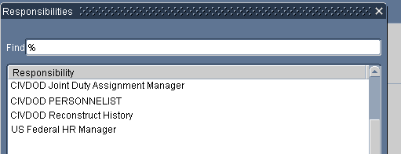

The CIVDOD Joint Duty Assignment Manager has access to ONLY the JDA DDFs and the JDA Reports.

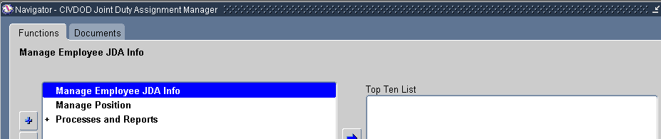

Screenshot below shows the two DDFs available under Manage Employee JDA Info.

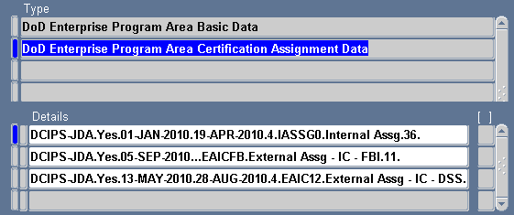

B. POSITION AREA:

Note: The CIVDOD Joint Duty Assignment Manager ONLY has access to the ‘DoD Enterprise Program Area Position Data’ DDF from within the position area; if any value in the DDF is updated or changed, the position will have to be re-validated. If the position has to be updated in any other DDF that would prevent the position from validating, the JDA Manager will not be able to make those updates/corrections and the position will remain invalid until the appropriate person is able to validate the position.

When the ‘Others’ button is clicked on the Position form, the ‘DoD Enterprise Program Area Position Data’ is available for the following Component Unique areas.

Others Button
Air Force Appropriated Fund
Army Appropriated Fund
Navy
Washington Headquarters
Defense Security Service
Screenshot below shows the newly created DDF:

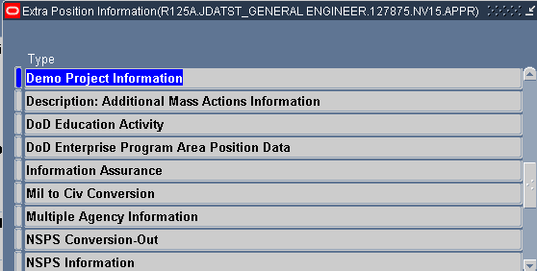

Screenshot below shows the values that have been created:

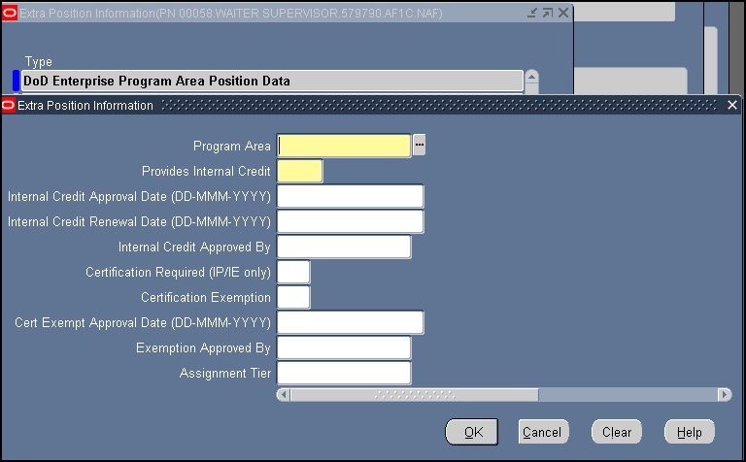

1. Data Element ‘Program Area’. (This is a Mandatory field)

Currently there is only one value in the LOV; DCIPS-JDA. In the future, more values may be added to this field, (ex: NSP, CEW etc); all business rules/edits associated with JD will be applied when the value of DCIPS-JDA has been selected in the ‘Program Area’ field.

A value of DCIPS-JDA in this data element designates that the position has been identified as providing the occupant with Joint Duty Assignment credit.

For a position to be identified as falling within the scope of a JDA and to allow the user to populate any of the fields related to DCIPS-JDA, the position must be coded with the following information: (‘Personnel System Indicator’ must contain a value of “02” (02 = Defense Civilian Intelligence Personnel System (DCIPS)) or the ‘Intelligence Position Ind’ = ‘2’ (2 = Defense Civilian Personnel Intelligence System (DCIPS)) and the Valid Grade of the position must equal GG-13 or above, IA-03 or above, or IP-00 or IE-00.

The ‘Personnel System Indicator’ field is located at: Position > EIT > US Federal Alternate HR System.

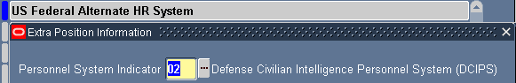

The ‘Intelligence Position Ind’ field is located at: Position > EIT >US Federal Position Group 2.

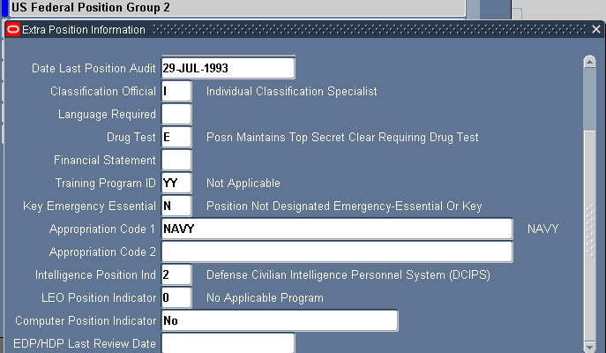

The Valid Grade is located at: Position > EIT > US Federal Valid Grade Info.

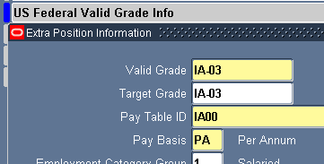

2. Data Element ‘Provides Internal Credit’. (This is a Mandatory field).

The values associated with this field are “Yes” or “No” and can be manually updated.

When the ‘Program Area’ has been updated with a value of “DCIPS-JDA” this data element will automatically default to a “No” value and the user can make the necessary change.

- Yes = the position does provides the occupant with JDA credit
- No = the position does not provide the occupant with JDA credit

- If this data element contains a value of “Yes”, then all the following fields must also contain a value: ‘Internal Credit Approval Date’; ‘Internal Credit Renewal Date’; ‘and ‘Internal Credit Approved By’.
- IF the position is IP-00 or IE-00, then the following additional fields must also contain a value: ‘Certification Required’ (see item 6 Data Element ‘Certification Required’ for additional business rules/edits that will be applied) and ‘Assignment Tier’.
- If this data element contains a value of “No”, then the following fields may not have a value: ‘Internal Credit Approval Date’; ‘Internal Credit Renewal Date’; and ‘Internal Credit Approved By’.
- If this data element is updated from a “Yes” value to a “No” value, then the ‘Internal Credit Approved By’ and the ‘Internal Credit Approval Date’ will Null out (values removed). The ‘Internal Credit Renewal Date’ will remain populated with a value in order to suspense the position for review by a JDA Manager.

3. Data Element ‘Internal Credit Approval Date’ (date format).

This data element documents the date that this position was approved as providing credit within the JD program.

- A value is required in this element if the ‘Provides Internal Credit’ field has a value of “Yes”.
- The value in this element will automatically be removed if the ‘Provides Internal Credit’ value is changed from a “Yes” to a “No”.

4. Data Element ‘Internal Credit Renewal Date’ (date format).

This data element documents the date the position is scheduled to be reviewed by the JDA Manager for determination of whether or not the position provides or continues to provide JD credit.

- The date value in this field must be later than the date value in the ‘Internal Credit Approval Date’ field.

5. Data Element ‘Internal Credit Approved By’

This data element documents the official that approved this position to provide JDA credit. At the present time, there is only one value associated with this field: JDA-USDI (Under Secretary of Defense for Intelligence).

- This field will automatically populate with the value of JDA-USDI if the ‘Internal Credit Approval Date’ contains a value.
- The value in this field will automatically disappear if the value in the ‘Internal Credit Approval Date’ field is removed.

The below Data Element(s) are mandatory for all positions with a grade of IP-00 or IE-00 and are not updateable for any other positions.

6. Data Element ‘Certification Required’

The values associated with this field are “Yes” or “No”.

- If this data element contains a value of “Yes”, the person occupying/or being appointed to this position must have completed the JD Certification requirements or has been granted a waiver or has been grandfathered in to occupy this position.
- If this data element contains a value of “Yes”, then the ‘Certification Exemption’ field must contain a value of “Yes” or “No”.
- If this data element contains a value of “No”, then ‘Certification Exemption’ cannot contain a value of “Yes”

7. Data Element ‘Certification Exemption’

The values associated with this field are “Yes” or “No”.

- A value of “Yes” means this position is exempted from requiring that the occupant has a JDA certification to occupy this position.
- A value of “No” means this position is not exempted; therefore the employee being appointed to or occupying this position must have completed a JDA Certification, a Waiver Approved, or Grandfathered In.

- If the ‘Certification Required’ field has a value of “Yes”, then this data element must also have a value.
- If the ‘Certification Required’ field has a value of “No”, then this data element cannot have a value of “Yes”.
- If this data element has a value of “Yes”, then the following fields must contain a value: ‘Cert Exempt Approval Date’ and ‘Exemption Approved By’.
- If the value in this field is changed from a “Yes” to a value of “No”, then the system will automatically remove the values in the ‘Cert Exempt Approval Date’ and ‘Exemption Approved By’ fields.

8. Data Element ‘Cert Exempt Approval Date’ (date format)

This data element documents the date that the position was granted an exemption from requiring that the occupant be certified in order to occupy the position.

- This field is only updateable if the ‘Certification Required’ has a value of “Yes” and ‘Certification Exemption’ field has a value of “Yes”.

9. Data Element ‘Exemption Approved By’

Currently there is only one value associated with this field: JDA-USDI (Under Secretary of Defense for Intelligence).

This data element documents the approving authority that approved the position is exempted from requiring certification.

- This field will automatically populate with the value of JDA-USDI if the ‘Internal Credit Approval Date’ contains a value.
- The value in this field will automatically disappear if the value in the ‘Internal Credit Approval Date’ field is removed.

10. Data Element ‘Assignment Tier’

This data element is applicable to IE-00 and IP-00 positions only AND must contain a value.

Values for this field are JDA Tier 1 (Tier 1), JDA Tier 2 (Tier 2) and JDA Tier 3 (Tier 3).

The Assignment Tier level for all IP and IE positions is supposed to be annotated on the position description. Please refer to the PD for this information.

Quick Copy Rules:

Users will receive warning messages notifying them that they are copying a position that had been identified as providing JDA credit but the new position will not automatically be populated with the values required to identify a JDA position.

If the position being copied is IP or IE and provided JDA credit, the new position will have to be updated to provide credit if applicable. When quick copied, the ‘Provides Internal Credit’ field will be flipped to a “No” and any other fields within the DEPA DDF will be nulled out. The user will have to update all applicable fields.

If the position being copied is not IP or IE (IA-03 or above, GG-13 or above) and it was coded to provide JDA credit, the new position will not have any of these values and the user will have to update all applicable fields.

C. PERSON :

Within the person record, the user will have the capability to annotate prior completed experience entries and code current assignments (ones that are not processed through an RPA) without moving the employee to a new position. Two DDFs have been created within the Person area.

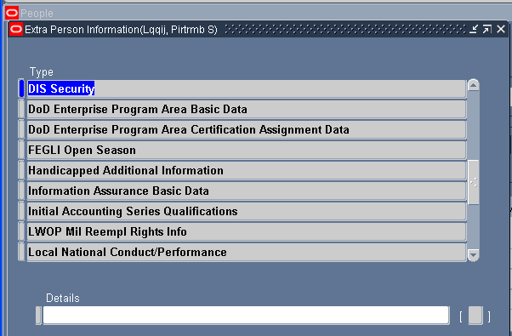

The DEPA Basic Data is a single occurrence DDF

This DDF may be updated manually or will be updated automatically with business rules that have been created when completed entries are annotated in the ‘DEPA Certification Assignment Data’ DDF and when certain RPA actions are processed.

This DDF displays certification completion entries, total time of credit earned based on entries in the ‘DEPA Certification Assignment Data’ DDF, and any Waiver information that has been updated via processing an RPA.

The DEPA Certification Assignment Data area is a multiple occurring DDF

This DDF can be updated manually or automatically through the RPA process if a JDA is being started, ended, or both. See RPA Section for more details.

Once an assignment is completed, the calculated time will flow over to the ‘DEPA Basic Data’ DDF > ’Total Months Earned’ field.

C.1 DoD Enterprise Program Area Basic Data:

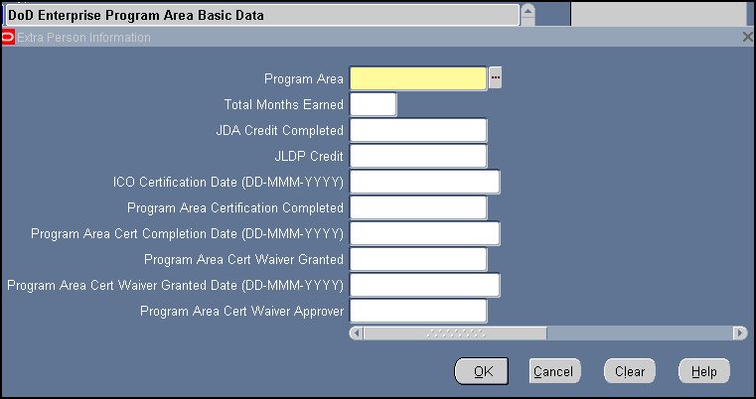

1. Data Element ‘Program Area’ (This is a Mandatory field)

Currently there is only one value in the LOV; DCIPS-JDA. In the future, more values will be added to this field (ex: NSP, CEW etc); all business rules/edits being implemented for JDA will be applied when the value of DCIPS-JDA is selected.

2. Data Element ‘Total Months Earned’

This data field documents the total months of accumulated time towards the 12 months required for completion of a Joint Duty credit. There is one exception to the 12 month requirement; when an employee is deployed for 179 days or more to a designated combat zone as a civilian. In addition, the time requirement will not be credited until a minimum of 90 days on the assignment has been completed.

- This data field will be systematically updated whenever the ‘Months Earned’ field has been updated and the ‘Assignment Rating Successful’ does not have a value of “No”.
- This data field is restricted from user input and is only updated systematically.
- The value in this data field will be accumulative.
- The value in this field will readjust if the ‘Months Earned’ field is subsequently changed or deleted or the ‘Assignment Rating Successful’ is changed to a value of “No”.
- The value in this field will be used as part of the equation for determining if the employee has met the requirement for completion of the Joint Duty Certification:
- ‘Total Months Earned’ equals 12 or greater and ‘JLDP Credit’ has a value of “Yes”.
- ‘Months Earned’ equals 6 and the ‘Assignment Location’ equals “CZCM00” (Combat Zone – Civilian Member) and ‘JLDP Credit’ has a value of “Yes”.
- The value in this field will be used for determining if the employee has met the requirement for completion of the Joint Duty Assignment Credit:
- ‘Total Months Earned’ equals 12 or greater.
- ‘Months Earned’ equals 6 and the ‘Assignment Location’ equals “CZCM00” (Combat Zone – Civilian Member).

3. Data Element ‘JDA Credit Completed’

The values associated with this field are “Yes” or “No”.

JDA credit completed indicates if the employee has served at least 12 months (or 6 months in a civilian combat zone) in a position that provides a qualifying Joint Duty experience.

- This field will be auto populated with a value of “Yes” when
  - ‘Total Months Earned’ has a value of 12 or higher
  - ‘Months Earned’ has a value of 06 or higher and ‘Assignment Type’ equals CZCM00 and the ‘Assignment Rating Successful’ does not equal “No”.

- Data Element ‘JLDP Credit’

The values associated with this field are “Yes” or “No”.

Completion of the JLDP is only part of the requirement for a JD Certification. The employee must also complete the appropriate time for a JDA credit to obtain a JD Certification.

The user will have to ensure that the JLDP course has actually been completed.

5. Data Element ‘ICO Certification Date’ (date format)

Completion of the ICO Certification, by itself, is creditable for completion of the JD certification without the required time completed for Joint Duty Credit (as needed for JLDP). This date should reflect the date the ICO Certification has been completed.

- ‘ICO Certification Date’ cannot be greater than the current date (not a future date).
- If this field is populated with a value, when the user saves the DDF the system will automatically populate the ‘Program Area Certification Completed’ with a value of “Yes” and will populate the ‘Program Area Cert Completion Date’ with the same date value from this field.

6. Data Element ‘Program Area Certification Completed’

The values associated with this field are “Yes” or “No”.

Joint Duty Certification is a mandatory qualification requirement for recruitment or movement of an employee into an IP or IE position.

- If this data element has a value of “Yes”, then ‘Program Area Cert Completion Date’ must have a value.

- This field will be auto populated with a value of “Yes” when
  - ‘JLDP Credit’ equals “Yes” and ‘Total Months Earned’ has a value of 12 or higher
  - ‘JLDP Credit’ equals “Yes” and ‘Total Months Earned’ has a value of 06 or higher and ‘Assignment Type’ equals CZCM00.
  - ICO field has a value

7. Data Element ‘Program Area Cert Completion Date’ (date format)

This field should only be updated once all the requirements have been fully met by an employee for certification OR DCPDS will auto populate based on business rules that have been established.

- This data element may not contain a value if the ‘Program Area Certification Completed’ field does not have a value of “Yes”.
- ‘Program Area Cert Completion Date’ cannot be greater than the current date (not a future date).
- This field will be auto-populated when:
- ‘Program Area Certification Completed’ has been automatically updated by the system based on business rules identified in #6 above.
- The value for this field will auto populate with the same as the ICO value OR as a result of the combination of the JLDP and JD credit time being fulfilled – whichever one of the two part requirement is the last to be met will be the date that populates in this field.

8. Data Element ‘Program Area Cert Waiver Granted’

The values associated with this field are “Yes”, “No” and “Grandfathered In”.

If the employee is occupying a position that has been identified as a position that provides credit for JDA and a JDA Certification is required, then the employee must be JDA Certified (‘Program Area Certification Completed’ or ‘JDA Credit Completed’ equals “Yes”) or this data element must be either “Yes” or “Grandfathered In” in order for the employee to occupy the position.
9. Data Element ‘Program Area Cert Waiver Granted Date’ (date format)

If an employee is occupying or being appointed to an IP-00 or IE-00 position that requires the employee to be certified (position is not exempted) and the employee has not yet obtained their certification, the employee may be granted a waiver to occupy this position. This field documents the date the certification waiver has been granted.

10. Data Element ‘Program Area Cert Waiver Approver’

Currently there is only one value associated with this field: JDA-USDI (Under Secretary of Defense for Intelligence).

This data element documents the approving official who has authority to waive the requirement of the employee to have Joint Duty Certification before being placed in an IP-00 or IE-00 position.

- This field will be automatically populated with the value of JDA-USDI if the ‘Program Area Cert Waiver Granted Date’ contains a value.
- The value in this field will automatically disappear if ‘Program Area Cert Waiver Granted Date’ value is removed.

C.2 DoD Enterprise Program Area Certification Assignment Data

NOTE: When updating an employee record with multiple past JDA entries, the user must save between each entry to ensure that the ‘Total Months Earned’ field updates correctly. If the user does not save after each entry is completed, then the system will not total up the months correctly.

This DDF can be populated manually or via an RPA being processed. If these fields are updated manually, the user may give the employee credit for a completed assignment entry (all required fields are populated) or the user can populate all the fields except the ‘End Date’ which will show that the employee is currently earning credit for a JDA. See RPA section for more details on how these fields can also be updated by processing an RPA.

To give the employee credit for a completed JDA, the user must populate all the fields in yellow plus input an end date. DO NOT manually update the ‘Months Earned’ field. When there is a start and end date (and all other appropriate fields are populated), the system will calculate the ‘Months Earned’ field with a value based on business rules established in DCPDS for calculating time.

To provide the employee with credit for being on a current JDA when an RPA is not processed, the user needs to ensure all the fields in yellow are populated and there is no end date. See example at the end of this section.

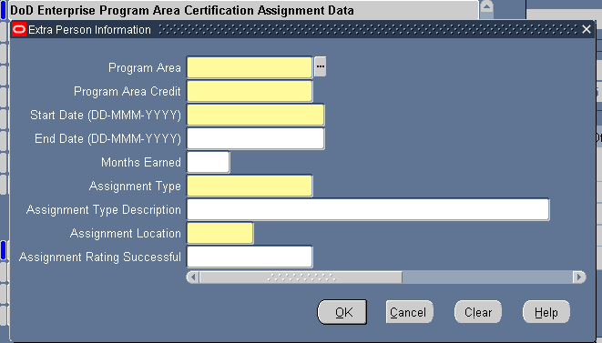

1. Data Element ‘Program Area’ (This is a Mandatory field)

Currently there is only one value in the LOV; DCIPS-JDA. In the future, more values will be added to this field, (ex: NSP, CEW etc); specific business rules/edits applicable to only JDA will be applied when the value of DCIPS-JDA is populated.

2. Data Element ‘Program Area Credit’ (This is a Mandatory field)

The values associated with this field are “Yes” or “No”.

JDA experience may be earned in increments; however, a minimum of 90 days has to be completed before the time can be credited. Experience entries will be captured in multiple rows of history entries to ensure that the appropriate amount of total time needed for completion of a Joint Duty Credit is met.

3. Data Element ‘Start Date’ (date format) (This is a Mandatory field)

This data element documents the date that a specific entry begins/began towards Joint Duty credit.

- ‘Start Date’ cannot be greater than the current date (not a future date).
- ‘Start Date’ should automatically update with a value through the RPA process when:
  - An action is processed that initially appoints an employee to a position that provides JDA credit.
  - An action is processed that moves an employee to a different position than currently occupying that provides JDA credit.

4. Data Element ‘End Date’ (date format)

This data field documents the date that a specific entry for time towards a Joint Duty credit ended.

- If there is no value in the “End Date’ field, this entry will be considered a current entry where the employee is earning time towards their JD credit.
- ‘End Date’ may not be prior to ‘Start Date’ and cannot be greater than the current system date (not a future date).
- ‘End Date’ should automatically update with a value through the RPA process if null when:
  - An action terminates an employee.
  - An action moves an employee to a position that does not provide JDA credit.
  - An action moves an employee to a different position than currently occupying that provides JDA credit and the employee currently has an entry that does not have an end date and a new entry is being created.

5. Data Element ‘Months Earned’

This field documents the number of months of experience for a specific assignment entry.

- If the ‘Start Date’ has a value and the ‘End Date’ does not have a value, then this data element field will be systematically updated during the end of month (EOM) suspense.
- Logic for adding an additional month is for the system to subtract the ‘Start Date’ from the EOM Date, round the month up when the days is equal or greater than 15 and round the month down when the number of days is less than 15.
- If the user enters both a ‘Start Date’ and an ‘End Date’ manually, the system will determine the months earned by subtracting the ‘Start Date’ from the ‘End Date’, round the months up when the days is equal to or greater than 15 and round the months down when the number of days is less than 15 and populate this data element with the value.
- The value in this data element will flow to the ‘Total Months Earned’ field ONLY if the ‘Assignment Rating Successful’ field does not have a value of “No”. If ‘Assignment Rating Successful’ has a value of “No”, the value will stay in this data element but will not be used in the calculation for time needed for completing a Joint Duty Credit.
- Minimum of 3 months is required before this time is included.

6. Data Element ‘Assignment Type’ (This is a Mandatory field)

There is a table that displays a list of Assignment Types attached to this data element.

7. Data Element ‘Assignment Type Description’

When a user selects value “ZZZZ00” with a description of “Other” from the ‘Assignment Type’ field, the user can manually overwrite that description to annotate this area with specific information. That information will be saved in this field.

CAUTION: If the user selects another value to replace the ZZZZ00, the clear text of the new value will not immediately display in the DDF. The user has to save the change, close the DDF and reopen it so that it refreshes with the new data.

8. Data Element ‘Assignment Location’ (This is a Mandatory field)

There is a table that displays a list of Assignment Locations attached to this data element.

9. Data Element ‘Assignment Rating Successful’

The values associated with this field are “Yes” or “No” or can be left Null.

- A “Yes” value or leaving the field Null triggers the value in the ‘Months Earned’ field to flow to the “Total Months Earned” field.
- If this field has a “No” value, the system will calculate the value for the ‘Months Earned’ field, but will NOT flow that value over to the ‘Total Months Earned’ field.
- If the value in this field is updated from a “Yes” to a “No” value, the system will determine if the previous time had been moved over the ‘Total Months Earned’ field and prompt the user to review the employee record to determine if the employee is still Certified based on this time being removed.

D. RPA PROCESSING

The following NOAs will provide the user with the newly created DEPA DDF from within the EIT area of the RPA:

170/T170 Excepted Appointment
171/T171 Excepted Appointment NTE
190/T190 Provisional Appt NTE (date)
570/T570 Conversion to Excepted Appointment
571/T571 Conversion to Excepted Appointment NTE
500/T500 Conversion to Career
501/T501 Conversion to Career-Conditional
590/T590 Conv to Provisional Appt NTE (date)
702/T702 Promotion
703/T703 Promotion NTE
713/T713 Change to Lower Grade, Level or Band
721/T721 Reassignment
730 Detail NTE
732 Term of Detail NTE
740/T740 Position Change
0921 Reassignment NTE
0922 Extension of Reassignment NTE
0923 Termination of Reassignment NTE
930 Detail NTE
932 Term of Detail NTE
002 Correction
Associated DoD Correction NOAs C702, C713, C721, C730, C732, C740, C921, C922, C923, C930, C932

- The same LOVs available when updating the Person record is available when updating the RPA. This DDF is available to the US Federal HR Manager, CIVDOD Personnelist and CIVDOD Reconstruct Manager responsibilities.

RPA Business Rules and Edits:

If the NOA is one identified above and the effective date is on or after 1 Oct 2010, then the following rules will be applied during the RPA process:

- If the ‘To’ Position reflects a value of “DCIPS-JDA” in the ‘Program Area’ and a value of “Yes” in the ‘Provides Internal Credit’ field within the position: AND
If the ‘From’ position is null OR the ‘From’ position does not equal the ‘To’ position, then the following fields on the RPA Extra Info DEPA DDF will auto populate:

    - ‘Start Date’ with the RPA “Effective Date”
    - “Program Area” with “DCIPS-JDA”
    - “Program Area Credit” with “Yes”
    - “Assignment Location” with the first two digits of the Duty Station

- If the ‘From’ position is null OR the ‘From’ position does not equal the ‘To’ position AND if the ‘Certification Required’ in the ‘To’ position equals ‘Yes’ and the ‘Certification Exemption’ in the ‘To’ position is not ‘Yes’, THEN the Person MUST reflect or be coded on the RPA EIT with the following:

- ‘Program Area Certification Completed’ must be “Yes” AND Program Area Cert Completion Date’ must have a value OR the ‘Program Area Cert Waiver Granted’ must have a value of either “Yes” or “Grandfathered In” OR ‘JDA Credit Completed’ must have a value of “Yes” in order for the RPA to process.

- IF the employee record nor the RPA Extra Info EIT does not reflect a “Yes” in the ‘Program Area Certification Completed’ AND a value in the ‘Program Area Cert Completion Date’ field OR the ‘Program Area Cert Waiver Granted’ field does not have a value of “Yes” or “Grandfathered In” OR the ’JDA Credit Completed’ field does not have a value of “Yes”, the RPA will not process.

3. If the ‘To” position equals IP-00 or IE-00 AND the ‘Program Area’ field in the position does not have a value of “DCIPS-JDA”, the RPA will not process.

4. If the employee is moving from a position that provided JDA Credit to a position that does not provide JDA Credit (‘Provides Internal Credit’ is “No” or null in the ‘TO’ Position) AND the ‘DEPA Certification Assignment Data’ DDF in the Person Record reflects a past date in the ‘Start Date’ AND the ‘End Date’ is Null, the system will update the ‘End Date’ to one day prior to the effective date of the RPA AND update ‘Months Earned’ provided the time equals 3 months or more.

5. If the employee is moving from a position that provided JDA Credit to a position that also provides JDA Credit (‘Provides Internal Credit’ is “Yes”) AND the DEPA Certification Assignment Data DDF in the Person Record reflects a past date in the ‘Start Date’ AND the ‘End Date’ is Null, the system will update the ‘End Date’ to one day prior to the effective date of the RPA and update ‘Months Earned’ provided the time equals 3 months or more.

6. If the RPA being processed has a ‘To Position’ that has a “Yes” in the ‘Certification Exemption’ field, the system will not verify any JDA Certification from within the employee record and the RPA will process.

7. If a CAO/Interagency Transfer is being processed, the system will add any population/retrieval of data elements listed in the DEPA Basic Data and the DEPA Certification Assignment Data to the existing CAO/Interagency Transfer process.

- If the ‘To’ Position on the RPA being processed reflects a value of “DCIPS-JDA” in the ‘Program Area’ and a value of “Yes” in the ‘Provides Internal Credit’ field within the position DEPA DDF, the system will auto populate the DEPA Basic Data DDF with information from the losing record to the RPA Extra Info DEPA DDF; the system will allow the user to override any of the information.
- Once the action processes, the data from the losing record for the ‘DEPA Certification Assignment Data’ should populate to the Person record as well as the data from the ‘DoD Enterprise Program Area Basic Data’ if this was not updated during the RPA process.
- If the DEPA Certification Assignment Data DDF in the person Record reflects a past date in the ‘Start Date’ AND the ‘End Date’ is Null, the system will update the ‘End Date’ to one day prior to the effective date of the RPA and update ‘Months Earned’ provided the time equals 3 months or more.

8. For Detail NOACs 730, 732, 930 and 932 the new DEPA DDF will be visible from within the RPA EIT;, however, none of the above edits are available at this time. The requirements for Details are still being worked.

9. If the NOA is a Separation Action (NOA = 3## or CAO) AND the DEPA Certification Assignment Data DDF in the person Record reflects a past date in the ‘Start Date’ AND the ‘End Date’ is Null, the system will update the ‘End Date’ to the effective date of the RPA being processed AND update ‘Months Earned’ provided the time equals 3 months or more .

E. SELF-SERVICE VIEWS:

This new information is available on a read only report through Self-Service for employees and managers.

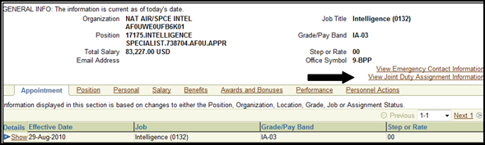

Once the employee clicks on the link for the ‘View Joint Duty Assignment Information’, a report is produced. Screenshot of the report the employee will be provided is shown below:

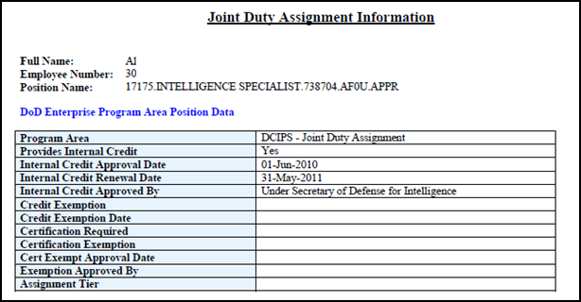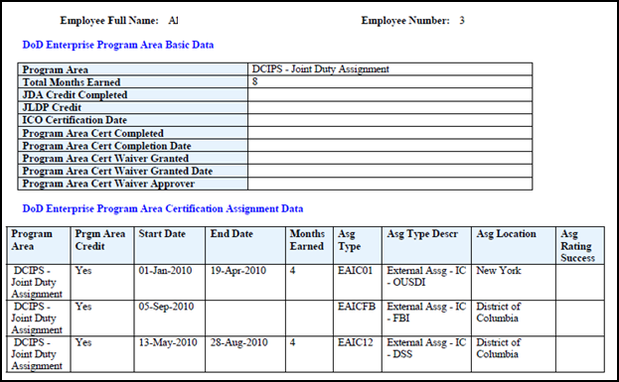

F. SHORT and SIMPLE Scenarios

Person:

1. Coding an employee record with past JDA entries:

From within the DEPA Certification Assignment Data DDF in the person record, the following fields must be updated to create a past JDA entry: Program Area; Program Area Credit; Start Date; End Date; Assignment Type; Assignment Location and Assignment Rating Successful if known, (not a mandatory field – if a value of NO is input here, this time will not count towards the time needed to achieve credit). NOTE: If multiple past entries are being updated at the same time, the user must save between each completed entry in order for the ‘Total Months Earned’ field to update accurately.

- There cannot be an end date with a value greater than a previous start date; no overlapping dates allowed.

2. Coding an employee record that is on a current JDA when no RPA is processed:

From within the DEPA Certification Assignment Data DDF in the person record the following fields must be updated: Program Area; Program Area Credit; Start Date; Assignment Type and Assignment Location. (No End Date indicates this is a current assignment entry.)

- There cannot be two open entries at the same time.
- When End of Month runs, it will calculate the ‘Months Earned’ field by following the calculations rules established in DCPDS.

3. Ending a JDA assignment in an employee record when no RPA was processed:

If the employee has a Current JDA entry in their record, you should only have to populate the ‘End Date’ to close this entry as long as all the required fields for coding an employee on a current JDA had previously been populated. If nothing was ever annotated in the employee record, then an entire JDA entry should be created in the employee record.

4. Deleting an erroneous entry in the DEPA Certification Assignment DDF:

Make sure to Red X the entry and save the DDF. The system will remove any months that may have been added to the ‘Total Months Earned’ field.

5. Appointing/Moving an employee to a position that is not IP/IE and the position has been identified as JDA:

When processing the RPA, the DEPA DDF from within the EIT area should auto populate the following fields: Program Area; Program Area Credit; Start Date and Assignment Location. The user will have to manually populate the ‘Assignment Type’ field. Once the action consummates, the DEPA Certification Assignment Data DDF in the employee record should reflect an entry with a Start Date that has the same value of the RPA that was processed; Program Area; Program Area Credit; Assignment Type and Assignment Location.

If the DEPA DDF from within the RPA does not auto populate the fields, review the position and ensure that it was identified with all the required JDA fields as of the effective date of your action.

6. Processing an RPA that moves an employee from a position that provided JDA credit (employee record had an open current JDA entry) to a different position that provides JDA credit:

When processing the RPA, the DEPA DDF from within the RPA EIT area should auto populate the following fields: Program Area; Program Area Credit; Start Date and Assignment Location. The user will have to manually populate the ‘Assignment Type’ field. Once the action consummates, the DEPA Certification Assignment Data DDF in the employee record should reflect in the previous open JDA entry a date of one day prior to the effective date of the RPA in the ‘End Date’ field; in the ‘Months Earned’ field the system will calculate the value for this field and move that value over to the ‘Total Months Earned field’ AND a new entry should have been created as described in #4 above.

7. Processing an RPA that moves an employee from a position that provided JDA credit (employee record had an open JDA entry) to a position that does not provide JDA credit:

When processing the RPA, the DEPA DDF will not populate with any values. Once the action consummates, the DEPA Certification Assignment Data DDF in the employee record should reflect a value of one day prior to the effective of the RPA in the ‘End Date’ field.

8. Processing a Termination Action on an employee who was occupying a position that provided JDA credit:

When processing the RPA, the DEPA DDF from within the RPA EIT will not populate with any values. Once the action consummates, the DEPA Certification Assignment Data DDF in the employee record should reflect the effective date of the RPA in the ‘End Date’ field.

9. Processing an RPA that moves an employee to an IP/IE position and the position is coded as requiring certification:

When processing the RPA, the following fields from within the DEPA DDF should auto populate: Program Area; Program Area Credit; Start Date and Assignment Location. If the employee record contains any values in the JLDP Credit, ICO Certification Date, Program Area Certification Completed, Program Area Cert Completion Date and JDA Credit Completed, those values will also auto populate.

Since IP/IEs require certification prior to being appointed, one of the following has to be met to process this action:

- the employee’s record must reflect a value of “Yes” in the ‘Program Area Certification Completed’ field and a value in the ‘Program Area Cert Completion Date’ OR reflect a value of “Yes” in the ‘JDA Credit Completed’ field (these values should auto populate in the RPA DEPA DDF – as long as they are in the employee record as of the effective date of the RPA).
- the user must manually update the RPA DEPA DDF ‘Program Area Certification Completed’ and ‘Program Area Cert Completion Date’ OR ‘JDA Credit Completed’.
- if there is no certification completed and there is a waiver to appoint this person, then the user needs to manually update the ‘Program Area Cert Waiver Granted’, ‘Program Area Cert Waiver Granted Date’ and the ‘Program Area Cert Waiver Approver’ fields with values OR if this person if grandfathered, then the user needs to manually update the ‘Program Area Cert Waiver Granted’ to reflect ‘Grandfathered In’.

Position:

1. Updating positions that have been identified as providing JDA credit:

If the position is an IA-03 or higher OR an GG-13 or higher (not IP-00 or IE-00), then the following fields should be updated with the appropriate values: Program Area; Provides Internal Credit; Internal Credit Approval Date; Internal Credit Renewal Date; Internal Credit Approved By (this field should auto populate when the Credit Approval date is populated).

If the position is an IP-00 or IE-00, in addition to the above fields that need to be completed the following fields need to be updated with the appropriate values (if applicable, based on rules identified in section 2 para 6 of this document): Certification Required; Certification Exemption; Cert Exempt Approval Date; Exemption Approved By (this field should auto populate when the Cert Exempt Approval date is populated). The Assignment Tier field is mandatory to be populated on ALL IP AND IE positions.

- If ‘Certification Required’ has a value of Yes, THEN ‘Certification Exemption’ must have a value of either “Yes” or “No”. IF ‘Certification Required’ has a value of “No”, then ‘Certification Exemption’ must also have a value of “No”.
- If ‘Certification Exemption’ has a value of “No”, then ‘Cert Exempt Approval Date’ and ‘Exemption Approved By’ should have no values. IF ‘Certification Exemption’ has a value of “Yes”, then ‘Cert Exempt Approval Date’ and ‘Exemption Approved By’ must have values.

NOTE: The Assignment Tier information is located on Position Descriptions for IP/IEs.

2. Changing a position from providing JDA credit to not providing JDA credit:

Update the position by changing the ‘Provides Internal Credit’ field from a “Yes” value to a “No” value. When the value is changed to a “No” value, the ‘Internal Credit Approved By’ field will automatically null out the value. When the user saves the position, the system will automatically null out the ‘Internal Credit Approval Date’ field.

G. REPORTS

Reports were created in both DCPDS and CMIS for use in tracking JDA information. For these reports, which are identified below, only active appropriated (APPR) records where the ‘Personnel System Indicator’ equals “02” or the ‘Intelligence Position Ind’ equals “2” will be included. In addition, those new data fields established for the position and person records as identified above were added to both the CSU and CMIS end user layers to allow users with access to CSU and CMIS to create any desired additional reports.

G.1 DCPDS JDA REPORTS

These reports are accessed through Processes and Reports > Submit Processes and Reports and are available to the US Federal HR Manager, CIVDOD Personnelist and CIVDOD Joint Duty Assignment Manager responsibilities. These reports will be created in a spreadsheet format which the user can then save to their computer.

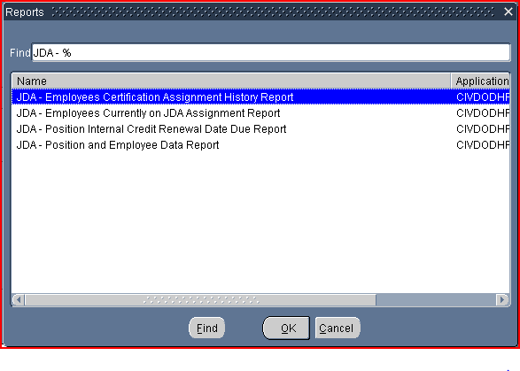
- Report ‘JDA - Employees Certification Assignment History Report’ lists all DCIPS employees with JDA Certification Assignment Data to include those currently on a JDA assignment as well as all history records; i.e., those entries with an ‘End Date’.

- Report ‘JDA - Employees Currently on JDA Assignment Report’ lists all DCIPS employees currently on a JDA Assignment; i.e., the ‘Program Area’ is “DCIPS-JDA” in the ‘DoD Enterprise Program Area Certification Assignment Data’ where the ‘Start Date’ is not null and the ‘End Date’ is null.

- Report ‘JDA - Position Internal Credit Renewal Date Due Report’ lists all DCIPS positions with either the ‘Internal Credit Renewal Date’ due within the days specified in the parameter provided or is past due.

- Report ‘JDA – Position and Employee Data Report’ lists all DCIPS positions as well as any JDA position data and employee basic data.

The report parameters that are available for these reports are listed in the table below. These parameters allow the user to further restrict the records that will be returned in the requested report. With the exception of the ‘Renewal Date Due within Days Indicated’ parameter, all other parameters are optional and if not used, all records on the database meeting the initial criteria will be displayed on the report. If more than one parameter is entered, ‘AND’ logic is applied.

Parameter | Additional Information
Employee Name | Limits report to a specific employee. This parameter only appears for the ‘JDA – Employees Certification Assignment History Report’.
Renewal Date Due within Days Indicated | This parameter only appears for the ‘JDA – Position Internal Credit Renewal Date Due Report’ and is mandatory. Enter ‘00’ to select records with past due dates or ‘30’, ‘60’, ‘90’ or ‘120’ to select records with future due dates within the days specified.
Agency Code | Limits reports to a specific Agency.
Agency Subelement | Limits reports to a specific Agency Subelement (Agency Group). An Agency Code must be entered before this parameter can be entered.
Personnel Office ID | Limits reports to a specific Personnel Office ID.
Servicing Office ID | Limits reports to a specific Servicing Office ID.
Organization | Limits reports to a specific Organization.
UIC | Limits reports to a specific UIC code.
PAS | Limits reports to a specific PAS code. Applies to Air Force records only.

Follow the steps below to run one of these reports:

 | Step | Action
 | 1 | Navigation Path Processes and Reports > Submit Processes and Reports.  The Submit New Requests window Opens: Accept default of Single Request and click the <OK> button.  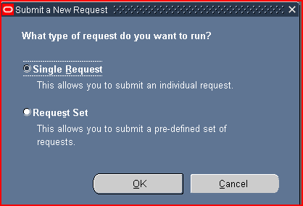
 | 2 | In this window that appears next, select the report you wish to run and then select the Parameters and Schedule Options. With the cursor in the ‘Name’ field, Click the ellipsis button on the right to display the report menu.  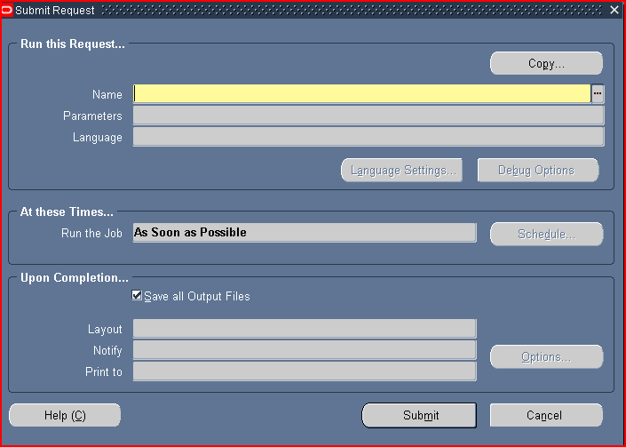
 | 3 | Select the Report you wish to run by utilizing the scroll bar to the right to make the selection. Then click the <OK> button
 | 4 | A Parameters window automatically opens. Use the ellipsis button icon in the parameters window to select a value for each data field. Then click the <OK> button.  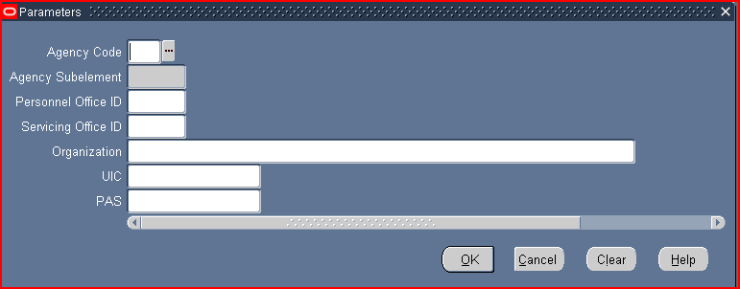
 | 5 | The Parameters window closes and the parameter values, if entered, display in the data field.  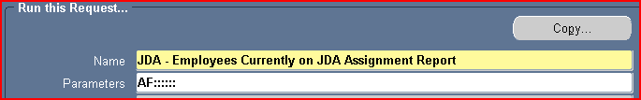
 | 6 | These reports are set to run ‘As Soon as Possible’.  If you wish to schedule the report, Click the <Schedule> button to open the Run Options window where you define when you want your request to run.  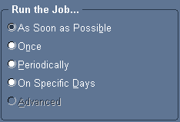  Options:  As Soon as Possible -This report will run according to priority of submittal.  Once -This report will run just once, unless specified to run again.  Periodically –This report will run according to specified times.  If the Periodically value is selected, an additional data screen will open.  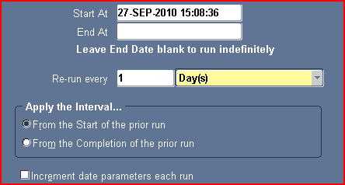  The Start At defaults to the current Date and Time. You can type in the time of day you want the report to run. This data field accepts values based on a 24-hour clock, using the format HH:MM:SS.  In the Re-run every data field you can specify the interval of minutes, hours, days, or months that you want to wait before the request is automatically resubmitted.  Click the <OK> button to close window.
 | 6 (Cont) | On Specific Days - If Specific Days value is selected a new data field window will open.  The Start At defaults to the current Date and Time to indicate when to submit the request. You can either type in a date and time or you can click the ellipsis button to use the calendar feature.  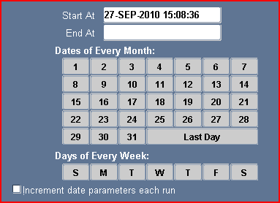  To select a specific period of time click and Highlight the Date or Days the request will run every day at the specified time until you cancel the request or enter a date and time in the End AT data field.  Click the <OK> button to close window.
 | 7 | 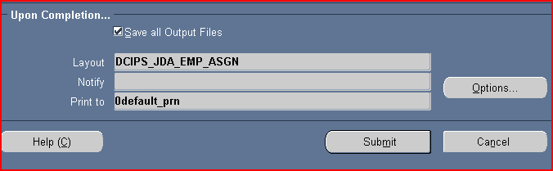  Click the <Submit> button to process the request.
 | 8 | After submitting the report, DCPDS will take you to the ‘Requests’ window. This window will display a Request ID, Name, Phase, Status, and the Parameters used to run the request.  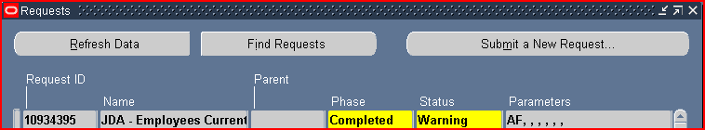  As no print file is created for these reports, the ‘Status’ field will always display as “Warning’ for a ‘Completed’ report.
 | 9 | Once the Phase shows as ‘Completed’, click on the ‘View Output’ button to view the report. The ‘File Download’ window should then appear. At this point you can either select ‘Open’ to view the report before saving to your PC or ‘Save’ without viewing first.  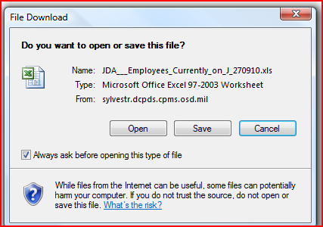
 | 9 (Cont) | If you select ‘Open’ first, you may see the below notice depending on your version of Microsoft Office. Select ‘Yes’ if this window appears.  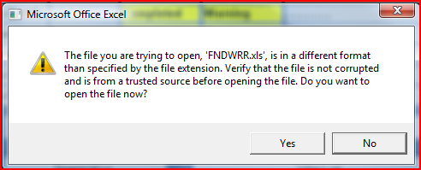  The report will then appear. At this point, recommend the report be saved to your PC for further viewing, expanding of the column headings and data, etc. Once saved, click the ‘X’ in the top right-hand corner to close the report in DCPDS.  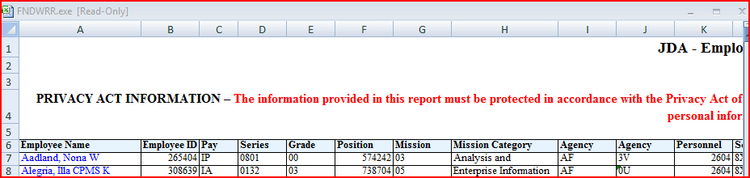
Since all reports are run as concurrent requests, you can navigate to the Requests window to view the progress of all of your concurrent requests at any time by following the steps below:

Step | Action
1 | Navigation Path Processes and Reports > View Requests  OR select ‘View’ and then ‘Requests’ from this menu:
2 | The Find Requests window opens. Either enter specific criteria in the Find Requests window and click the <Find> button. Or accept the default “All My Requests” to search for all the reports submitted.  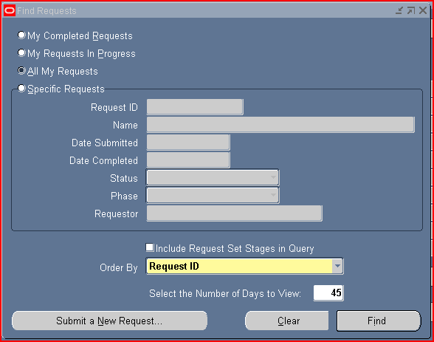
3 | The Request window will open displaying a Request ID, Name, Phase, Status, and Parameters used for your requests.  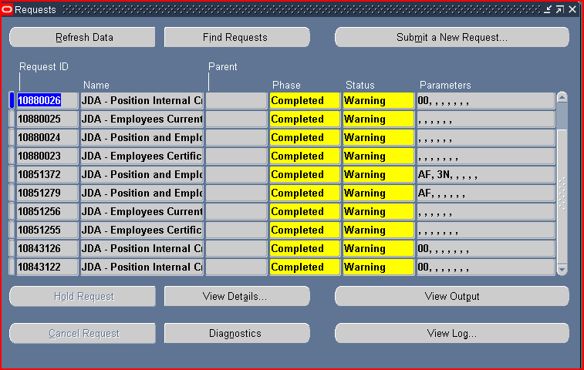  Refer to the tables below for additional information on this ‘Requests’ window.

Requests Window
Columns | Information Displayed
Request ID | The Request ID field represents a number generated by Oracle to distinguish each request
Name | The name field is the Report Name
Parent | Not Applicable for these reports
Phase | A concurrent request has a life cycle consisting of the following phases:  - Pending  - Running  - Completed  - Inactive
Status | The status column indicates normal completion or will give an error indicator
Parameters | Parameter selections used to run the concurrent request.

Requests Window
Phase | Status | Meaning
Pending | Normal | Request is waiting in queue to run.
 | Standby | Program to run the request is incompatible with other program(s) currently running.
 | Scheduled | Request is scheduled to start at a future time or date.
 | Waiting | A “child” request is waiting for its “parent” request to mark it ready to run. For example, a request in a request set that runs sequentially must wait for a prior request to complete.
Running | Normal | Request is running normally.
 | Paused | “Parent” request pauses for all its “child” requests to finish running.
 | Resuming | All requests submitted by the same “parent” request (in a request set) have completed running. The parent request resumes running.
 | Terminating | Request has been canceled (via Cancel Request button).
Completed | Normal | Request completed successfully.
 | Error | Request failed to complete successfully.
 | Warning | Request completed with warnings.
 | Canceled | Pending or inactive request has been canceled (via Cancel Request button).
Inactive | Disabled | Program to run request is not enabled. Contact your system administrator.
 | On Hold | Pending request has been placed on hold (via Hold Request button).
 | No Manager | No manager is defined to run the request. Check with your system administrator.

Requests Window
Task Flow Buttons | Information Displayed
Refresh Data | Use this button to refresh the data in order to display updated progress of your requests.
Find Requests | Use this button to search for additional requests.
Submit a New Request | Use this button to submit a new request.
View Details | Use this button to view detailed information about your requests; for example, submission date and scheduling.
Diagnostics | Displays diagnostic information such as when it ran and if it completes successfully.
View Output | Use this button to view your report.
View Log | Displays the log file containing information regarding arguments used and other technical information.
Hold Request | While a report is pending, the “Hold Request” button will allow the request to be held out of the processing pool.
Cancel Request | When a report begins running, the “Cancel Request” button will allow a request to be cancelled.

G.2 CMIS JDA REPORTS

The JDA reports in CMIS are located in the ‘Corporate Documents’ folder under the ‘Public Folders’ on the ‘Document List’. These reports will be created in a spreadsheet format which the user can then save to their computer.

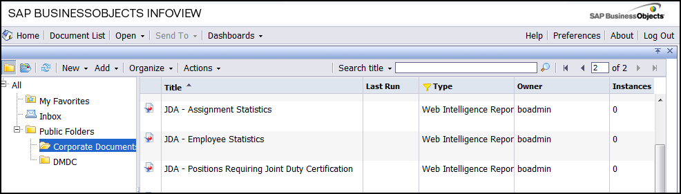

To run the report, double click on the report ‘Title’. Each report will have two worksheets. The ‘By Grade’ worksheet displays the data by pay plan/grade and the ‘By Mission Category’ worksheet displays the data by mission category.

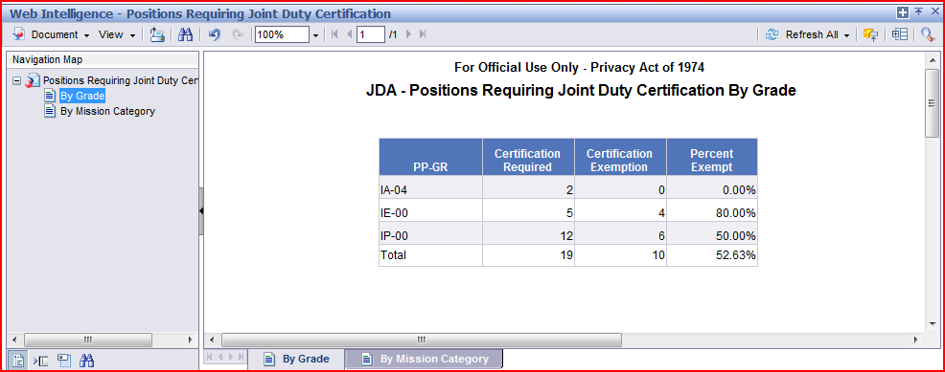

Once the report has finished, select ‘Document’, ‘Save to my computer as’, and then ‘Excel’ to save both worksheets of the report to your PC. When finished, select ‘Close’ to return to the ‘Corporate Documents’ folder.

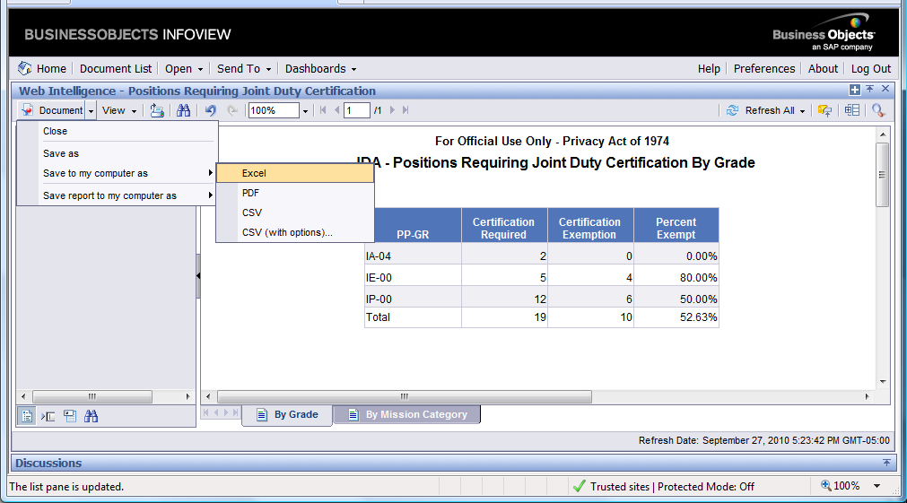

Below are the reports in CMIS along with the report columns displayed and the conditions used for the data that is displayed:

- JDA – Positions Requiring Joint Duty Certification

  - Certification Required = DCIPS positions where DoD Corporate Data > Position > JDA Position Info > Certification Required = “Yes”.

  - Certification Exemption = DCIPS positions where DoD Corporate Date > Position > JDA Position Info > Certification Exemption = “Yes”.

  - Percent Exempt = Number of Certification Exemption divided by Number of Certification Required with percentage carried out to two decimals; i.e. 17.97%.

- JDA – Employee Statistics

- Total Number of DCIPS Employees = active employees where ‘Personnel System Indicator’ equals “02” or the ‘Intelligence Position Ind’ equals ‘2’.

- Total Number Eligible for JDA Program = Employees above where the ‘Valid Grade ‘is GG-13 or above, IA-03 or above, IP-00 or IE-00.

- Percent Eligible = Total Number Eligible for JDA Program divided by Total Number of DCIPS employees with percentage carried out to two decimals; i.e. 17.97%.

- Total Number JDA Certified = number of employees eligible for JDA Program where ‘Joint Duty Certification Completed’ in JDA Employee Basic Data Info > JDA Employee Info > People > DoD Corporate Data = “Yes” and ‘Program Area’ in JDA Employee Basic Data Info > JDA Employee Info > People > DoD Corporate Data = “DCIPS-JDA”.

- Percent of Eligible Population Certified = Total Number JDA Certified divided by Total Number Eligible for JDA Program with percentage carried out to two decimals; i.e. 17.97%.

- Total Number Certified by ICO = number of employees eligible for JDA Program where ‘ICO Certification Date’ in JDA Employee Basic Data Info > JDA Employee Info > People > DoD Corporate Data contains a valid date and ‘Program Area’ in JDA Employee Basic Data Info > JDA Employee Info > People > DoD Corporate Data = “DCIPS-JDA”.

- Percent JDA Certified by ICO = Total Number Certified by ICO divided by Total Number Eligible for JDA Program with percentage carried out to two decimals; i.e. 17.97%.

- Total Number with JDA Credit Completed = number of employees eligible for JDA Program where ‘JDA Credit Completed’ in JDA Employee Basic Data Info > JDA Employee Info > People > DoD Corporate Data = “Yes” and ‘Program Area’ in JDA Employee Basic Data Info > JDA Employee Info > People > DoD Corporate Data = “DCIPS-JDA”.

- Percent of Eligible Population with JDA Credit Completed = Total Number with JDA Credit Completed divided by Total Number Eligible for JDA Program with percentage carried out to two decimals; i.e. 17.97%.

- Total Number with JLDP Credit = number of employees eligible for JDA Program where ‘JLDP Credit’ in JDA Employee Basic Data Info > JDA Employee Info > People > DoD Corporate Data = “Yes” and ‘Program Area’ in JDA Employee Basic Data Info > JDA Employee Info > People > DoD Corporate Data = “DCIPS-JDA”.

- Percent of Eligible Population with JLDP Credit = Total Number with JLDP Credit divided by Total Number Eligible for JDA Program with percentage carried out to two decimals; i.e. 17.97%.

- Total Number with JDA Cert Waiver = number of employees eligible for JDA Program where ‘JDA Cert Waiver’ in JDA Employee Basic Data Info > JDA Employee Info > People > DoD Corporate Data = “Yes” and ‘Program Area’ in JDA Employee Basic Data Info > JDA Employee Info > People > DoD Corporate Data = “DCIPS-JDA.

- Total Number with JDA Grandfathered In = number of employees eligible for JDA Program where ‘JDA Cert Waiver’ in JDA Employee Basic Data Info > JDA Employee Info > People > DoD Corporate Data = “Grandfathered In” and ‘Program Area’ in JDA Employee Basic Data Info > JDA Employee Info > People > DoD Corporate Data = “DCIPS-JDA.

- JDA – Assignment Statistics

  - Total Number Eligible for JDA Program = DCIPS Employees where the ‘Valid Grade’ is GG-13 or above, IA-03 or above, IP-00 or IE-00.

- Total Number JDA Credit Completed Not Certified = number of employees eligible for JDA Program where ‘Joint Duty Certification Completed’ in JDA Employee Basic Data Info > JDA Employee Info > People > DoD Corporate Data = “No” or null and ‘Program Area’ in JDA Employee Basic Data Info > JDA Employee Info > People > DoD Corporate Data = “DCIPS-JDA” and ’JDA Credit Completed’ in JDA Employee Basic Data Info > JDA Employee Info > People > DoD Corporate Data = “Yes”.

- Percent of Eligible Population Credit Completed Not Certified = Total Number JDA Credit Completed Not Certified divided by Total Number Eligible for JDA Program with percentage carried out to two decimals; i.e. 17.97%.

  - Total Number JDA Credit by Combat Tour = number of employees eligible for JDA Program where ‘Program Area’ equals “DCIPS-JDA” and ‘Program Area Credit’ equals “Yes” and ‘Months Earned’ equals “06” or greater and first two of ‘Assignment Type’ equals “CZCM00” and ‘Assignment Rating Successful’ is not “No”. These data fields are located in DoD Corporate Data > People > JDA Employee Info > JDA Employee Cert Assignment Info.

- Percent of Eligible Population with JDA Credit by Combat Tour = Total Number JDA Credit by Combat Tour divided by Total Number Eligible for JDA Program with percentage carried out to two decimals; i.e. 17.97%.

  - Total Number JDA Credit by Traditional Assignment = number of employees eligible for JDA Program where ‘Program Area’ equals “DCIPS-JDA” and ‘Total Months Earned’ equals “12” or greater and does not meet the condition for ‘Total Number JDA Credit by Combat Tour’. ‘Program Area’ and ‘Total Months Earned’ data fields are located in DoD Corporate Data > People > JDA Employee Info > JDA Employee Basic Data Info.

- Percent of Eligible Population with JDA Credit by Traditional Assignment = Total Number JDA Credit by Traditional Assignment divided by Total Number Eligible for JDA Program with percentage carried out to two decimals; i.e. 17.97%.

  - Total Number with Single JDA Assignment = those employees meeting either the Combat Tour or Traditional Assignment requirement with only one occurrence in the JDA Employee Cert Assignment Info.

  - Total Number with Multiple JDA Assignments = those employees meeting either the Combat Tour or Traditional Assignment requirement with more than one occurrence in the JDA Employee Cert Assignment Info.

- Percent of Eligible Population with JDA Credit by Single Assignment = Total Number with Single JDA Assignment divided by Total Number Eligible for JDA Program with percentage carried out to two decimals; i.e. 17.97%.

- Percent of Eligible Population with JDA Credit by Multiple Assignments = Total Number with Multiple Assignment divided by Total Number Eligible for JDA Program with percentage carried out to two decimals; i.e. 17.97%.

  - Total Number Currently on JDA Assignment = number of employees eligible for JDA Program where ‘Program Area’ = “DCIPS-JDA” and ‘Start Date’ contains a valid date and ‘End Date’ is null and ‘JDA Credit’ = “Yes”. These data fields are located in DoD Corporate Data > People > JDA Employee Info > JDA Employee Cert Assignment Info.

- Percent of Eligible Population Currently on JDA Assignment = Total Number Currently on JDA Assignment divided by Total Number Eligible for JDA Program with percentage carried out to two decimals; i.e. 17.97%.

  - Total Number Currently on JDA Assignment in DoD = those employees meeting condition for ‘Total Number Currently on JDA Assignment’ where the ‘Assignment Type’ in the same entry equals one of those identified in table ‘Assignment Type Codes for DoD’ listed below. ‘Assignment Type’ data field is located in DoD Corporate Data > People > JDA Employee Info > JDA Employee Cert Assignment Info.

  - Total Number Currently on JDA Assignment in non-DoD = those employees meeting condition for ‘Total Number Currently on JDA Assignment’ where the ‘Assignment Type’ in the same entry does not equal one of those identified in table ‘Assignment Type Codes for DoD’ listed below. ‘Assignment Type’ data field is located in DoD Corporate Data > People > JDA Employee Info > JDA Employee Cert Assignment Info.

  - Average Perf Rating for Employees on JDA Assignment = average of the current performance rating for those employees meeting the condition for ‘Total Number Currently on JDA Assignment’.

Assignment Type Codes for DoD
Code | Meaning/Description
CEWP00 | Civilian Expeditionary Workforce Program
CZCM00 | Combat Zone – Civilian Member
CZMM00 | Combat Zone – Military Member
EAIC01 | External Assg – IC – OUSDI
EAIC05 | External Assg – IC – DIA
EAIC11 | External Assg – IC – NGA
EAIC12 | External Assg – IC – DSS
EAIC28 | External Assg – IC – NSA
EAICAF | External Assg – IC – Air Force
EAICAR | External Assg – IC – Army
EAICMC | External Assg – IC – Marine Corps
EAICNR | External Assg – IC – NRO
EAICNV | External Assg – IC – Navy
EANI01 | External Assg – NonIC – Fed – DOD-OSD
EANI02 | External Assg – NonIC – Fed – DOD-Joint Chiefs of Staff
EANI04 | External Assg – NonIC – Fed – DOD-DISA
EANI06 | External Assg – NonIC – Fed – DOD-DSCA
EANI07 | External Assg – NonIC – Fed – DoD-Def Logistics Agcy
EANI08 | External Assg – NonIC – Fed – DoD-Court Appeals Armed Forces
EANI09 | External Assg – NonIC – Fed – DoD-AFIS
EANI10 | External Assg – NonIC – Fed – DoD-DCAA
EANI13 | External Assg – NonIC – Fed – DoD-DARPA
EANI16 | External Assg – NonIC – Fed – DoD-DoDEA
EANI21 | External Assg – NonIC – Fed – DoD-WHS
EANI23 | External Assg – NonIC – Fed – DoD-Ofc Economics Adj
EANI25 | External Assg – NonIC – Fed – DoD-Def Legal Svcs Agcy
EANI26 | External Assg – NonIC – Fed – DoD-Inspector General
EANI27 | External Assg – NonIC – Fed – DoD-Missile Def Agcy
EANI29 | External Assg – NonIC – Fed – DoD-DTSA
EANI34 | External Assg – NonIC – Fed – DoD-DeCA
EANI35 | External Assg – NonIC – Fed – DoD-DFAS
EANI36 | External Assg – NonIC – Fed – DoD-Army/AF Exchg Svc
EANI48 | External Assg – NonIC – Fed – DoD-Def Human Resources Actvy
EANI58 | External Assg – NonIC – Fed – DoD-Def POW/Missing Pers Ofc
EANI59 | External Assg – NonIC – Fed – DoD-Cons Met Tech Pers Ctr
EANI60 | External Assg – NonIC – Fed – DoD-TRICARE Mgmt Actvy
EANI61 | External Assg – NonIC – Fed – DoD-Def Threat Reduction Agcy
EANI63 | External Assg – NonIC – Fed – DoD-Def Contract Mgmt Agcy
EANI65 | External Assg – NonIC – Fed – DoD-Pentagon Force Prot Agcy
EANI68 | External Assg – NonIC – Fed – DoD-Test Resource Mgmt Ctr
EANI69 | External Assg – NonIC – Fed – DoD-National Def Univ
EANI70 | External Assg – NonIC – Fed – DoD-Armed Forces Radio Rsch Inst
EANI74 | External Assg – NonIC – Fed – DoD-Def Tech Info Ctr
EANI75 | External Assg – NonIC – Fed – DoD-Civ Pers Mgmt Svc
EANI77 | External Assg – NonIC – Fed – DoD-Business Transformation Agcy
EANIAF | External Assg – NonIC – Fed – Air Force
EANIAR | External Assg – NonIC – Fed – Army
EANIMC | External Assg – NonIC – Fed – Marine Corps
EANINV | External Assg – NonIC – Fed – Navy
IASSG0 | Internal Assg
ICP000 | ICO/ICAP

