Office of the Director of National Intelligence (ODNI)/Office of the Chief Human Capital Officer (CHCO)

Intelligence Community Joint Duty
Privileged User Guide
Version 1.0
February 2011

Privileged User Guide
CHANGE LOG
DOC | APPROVAL | REV | PARAGRAPHS | REMARKS
REV | DATE | BY | AFFECTED | RFC | APPROVAL
New |  | RRC | Entire Document

TABLE OF CONTENTS
1 BACKGROUND 4
2 FINDING HELP 4
3 ACCESSING JOINT DUTY ADMINISTRATION OPTIONS 4
4 MANAGE VACANCIES 5
5 ADD NEW VACANCY 7
6 UNAPPROVED VACANCIES 8
7 MANAGE OUTGOING APPLICATIONS 8
7.1 ACTIONS PERFORMED ON OUTGOING APPLICATIONS 9
8 MANAGE INCOMING APPLICATIONS 10
8.1 ACTIONS PERFORMED ON INCOMING APPLICATIONS 10
9 USER MANAGEMENT 11
10 ACCESSING JOINT DUTY SERVERS 12
11 DATABASE UPDATES 14
12 APPLICATION UPDATES 15
13 CONFIGURATION 16
14 BACKUPS 17
15 VACANCY IMPORTS 17

BACKGROUND

The Intelligence Community (IC) Civilian Joint Duty Web Application is a custom- developed .NET based tool used for posting and maintaining IC Civilian Joint Duty Assignments. Through a web-based interface, Joint Duty Program Managers from each IC Element are able to create, post, and manage their respective Joint Duty Assignment vacancy announcements. Employees from across the IC are able to browse, search, and apply for vacancies, and track the progress of their application. In addition, the Joint Duty Web Application is used for posting program policies and guidance documents as well as general news concerning the IC Civilian Joint Duty Program. System maintenance personnel are responsible for application updates, requirement modifications, system continuity, configuration, and data imports.

FINDING HELP

Users can send questions, concerns, and/or feedback regarding the website by clicking the “Contact Webmasters” or “Feedback” link.

ACCESSING JOINT DUTY ADMINISTRATION OPTIONS

To access the IC Joint Duty website, use the following URLs:
JWICS: http://icjointduty.ic.gov
Unclass: https://www.icjointduty.gov

Logging in with a user name that has administrative rights will display the Admin Options link on the navigation bar. Select “Admin Options” to access Administrative Options page (Figure 1).

Figure 1: Joint Duty Administrative Options

MANAGE VACANCIES

The Manage Vacancies link allows agency administrators to modify vacancies or to duplicate a vacancy. Select “Manage Vacancies” and the vacancies for your organization will be shown with a link to modify each vacancy (Figure 2).
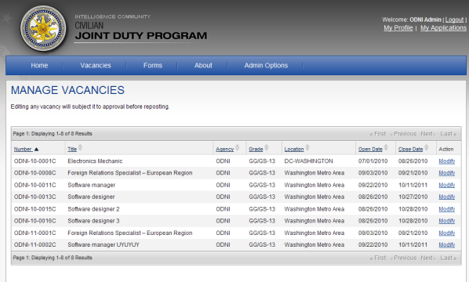
Figure 2: Manage Vacancies

- Modify a Vacancy
Select the “Modify” link for a vacancy and you will be redirected to the “Modify Vacancy” page (Figure 3).
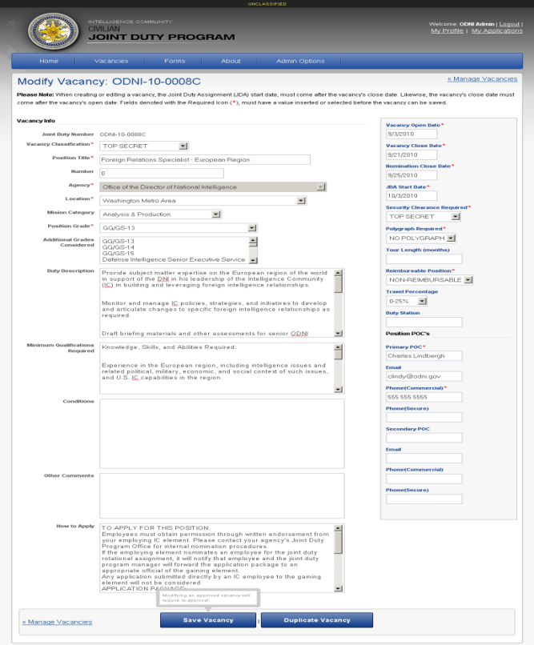
Figure 3: Modify Vacancy
This page displays the details of the selected vacancy. At this point, changes can be made to the vacancy and saved by clicking the “Save Vacancy” button.
If the selected vacancy has already been approved, modifying it will require re-approval of the vacancy in order for it to be displayed to general users of the site. To approve a selected vacancy after saving any changes, click the “Preview Vacancy” button. The vacancy will be shown as it will appear to users. Click the “Approve” button and the vacancy will now be shown to all visitors of the site.
- Duplicate a Vacancy
Select the “Modify” link for a vacancy. On the “Modify Vacancy” page, click the “Duplicate Vacancy” button. A vacancy with the same information as the initial vacancy is created with the only difference being an incremented Joint Duty number. This vacancy needs to be saved and will require approval to appear on the active vacancy listing.

ADD NEW VACANCY

From Administrative Options page select “Add New Vacancy”. Complete the vacancy details form (Figure 4) as directed. Fields marked with red asterisks * are required. Clicking the “Create Vacancy” button will create a new unapproved vacancy. To approve the new vacancy, click the “Preview Vacancy” button. The vacancy will be shown as it will appear to users. Click the “Approve” button and the vacancy will now be shown to all visitors of the site.

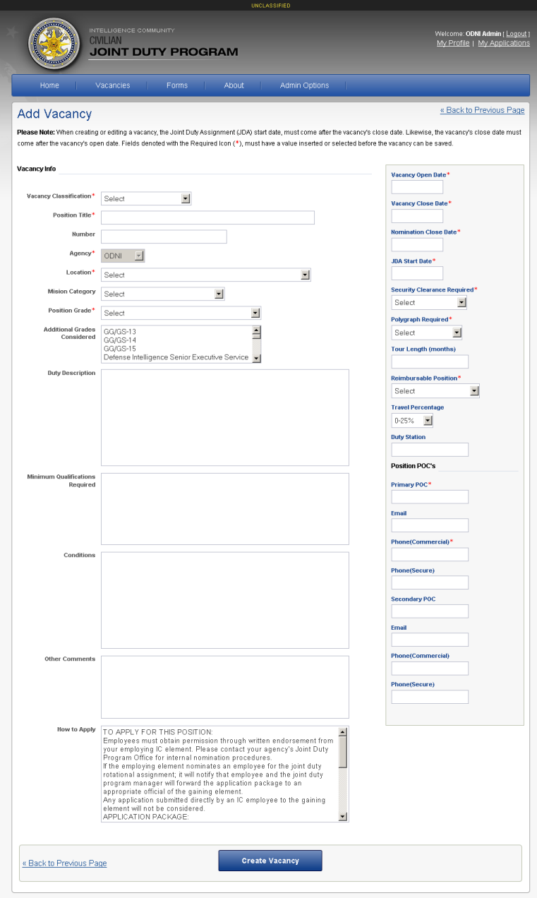
Figure 4: Add New Vacancy

UNAPPROVED VACANCIES

To view all of the vacancies that require approval for your organization click “Unapproved Vacancies” on Administrative Options page. Vacancies that have been created or modified, but not approved will be shown (Figure 5). To approve a vacancy, select a vacancy number and you will be redirected to a preview of the vacancy details page. Click the “Approve” button and the vacancy will now be shown to all visitors of the site.

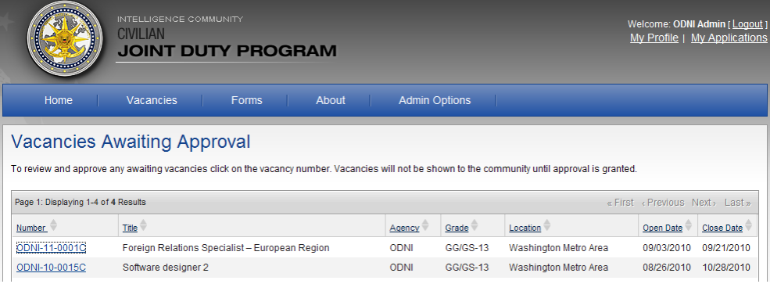
Figure 5: Vacancies Awaiting Approval

MANAGE OUTGOING APPLICATIONS

To view the applications for employees from your organization that have applied for a Joint Duty Assignment, click “Manage Outgoing Applications” from Administrative Options page.
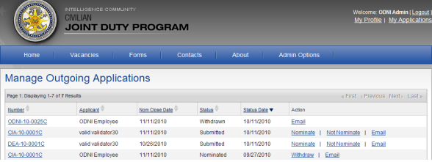
Figure 6: Outgoing Applications list
Select a vacancy number from the Manage Outgoing Applications list to view the details of the applicant and the vacancy (Figure 7). The Application tab shows the applicant’s information and the Vacancy tab shows the details of the selected vacancy.

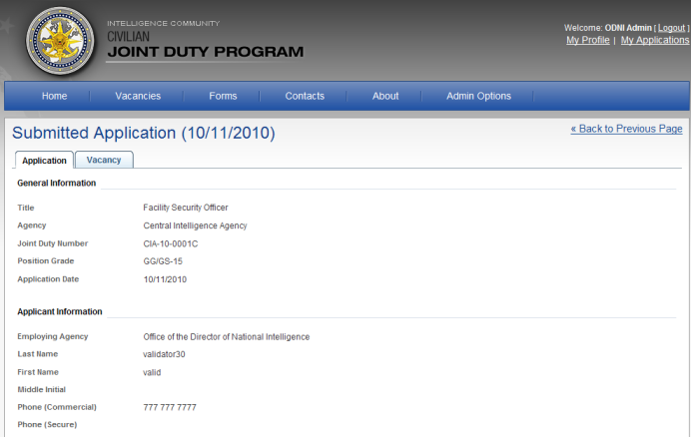
Figure 7: Application and Vacancy

ACTIONS PERFORMED ON OUTGOING APPLICATIONS

The following actions can be performed based on the status of the application.
Status | Action | Description
Withdrawn | Email | Email supervisors or applicant
Nominated | Withdraw, Email | Withdraw application or email supervisors or applicant
Not Nominated | Email | Email supervisors or applicant
Submitted | Nominate, Not Nominate, Email | Nominate an application, not nominate an application, or email supervisors or applicant
Figure 8: Status and Action on Outgoing Applications
When the action “Nominate”, “Not Nominate” or “Withdraw” is selected the user has to confirm their selection before changing status of the application. For the “Email” action, an Email page (Figure 9) will be shown with information pre-populated in the fields: To, From, Subject, Classification, and Message Body. The email can be modified before sending.
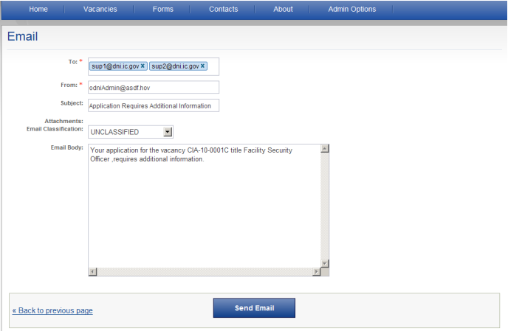
Figure 9: Email Page

MANAGE INCOMING APPLICATIONS

Application administrators can see a list of their vacancies and the number of nominated applicants (Figure 10) by selecting “Manage Incoming Applications” from Administrative Options page.

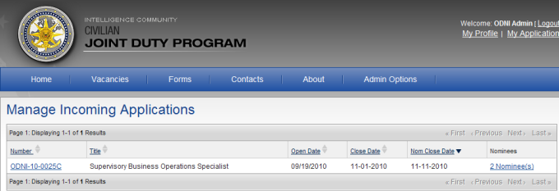

Figure 10: Incoming Applications List

ACTIONS PERFORMED ON INCOMING APPLICATIONS

To select an applicant for a vacancy, click on the “# Nominee(s)” link. This will display brief description of the vacancy and a listing of all the applicants who were nominated (Figure 11). To select a desired applicant from the Nominee list, click the “Select” action for that nominee’s name. After confirming the selection of the applicant, all other applicants for the vacancy will have their respective status set to ‘not selected’. To email any of the applications to a hiring manager, check the checkbox for the individual applicant’s name and click on the “Email” button on the top of the list. Alternatively, you can check the checkbox directly beneath the Email button and email all applicants the same message as necessary.

Action | Description
Select | Select an applicant for this vacancy.  Note: Selecting one applicant will change all others to “Not Selected.”
Email | Email an applicant
Figure 11: Action on Incoming Applications

USER MANAGEMENT

)Administrators can make changes to the profile of any user from their organization by selecting the “Manage Users” option. On the Manage Users screen, select a user from the drop down list and click the “Select User” button. The user’s profile and role is displayed (Figure14) and any desired changes can be made.
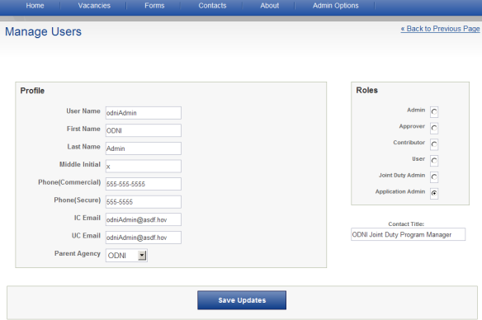
Figure 12: Manage Users

System Maintenance Section

ACCESSING JOINT DUTY SERVERS

The Joint Duty Web Application interface is provided via IIS6.0 Web Server and the back end operates on SQL Server. The Web application will consist of a test server and a production server, the test server will be located on a Virtual Machine with the production server separated on a similar Virtual Machine. Each virtual machine shall be running Windows Server 2003 with IIS6.0 installed and a web application instance of ‘Joint Duty’ installed. The web application files will be located beneath the inetpub directory and can be configured via the IIS6.0 web application instance properties tab. Verify that the web server is up and running as shown below. Verify the location of the web application directory as shown below (Fig 14). To ensure that the web application instance is up and operating correctly, login to the virtual machine and start the IIS Manager as shown below (Fig 13), select the web application instance and verify it is up and running by right click and browse.
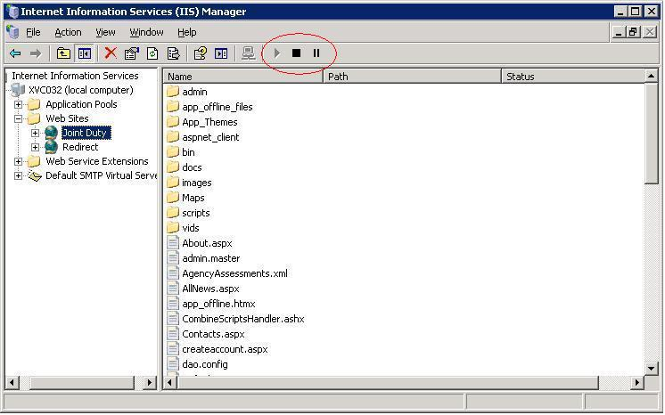
Figure 13: IIS 6.0 Joint Duty Web Application
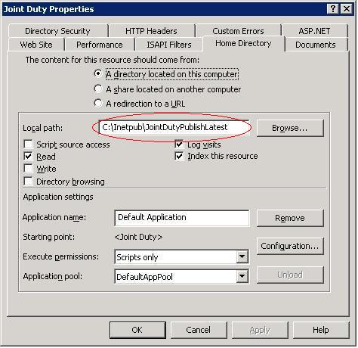
Figure 14: IIS 6.0 Home Directory

DATABASE UPDATES

To perform database updates: Create a .sql file that will affect the changes you require and submit the file to the DTO/Controlling authority to transfer the file to the appropriate virtual db test server. Log on to the virtual DB TEST instance and start SQL Server Management Studio. Locate and open the .sql file and ensure that the Database instance you want to make the changes to is utilized. Execute the file and ensure changes have occurred. To perform updates/queries against the production database instance, submit the file to the appropriate controlling authority and they will perform the update.
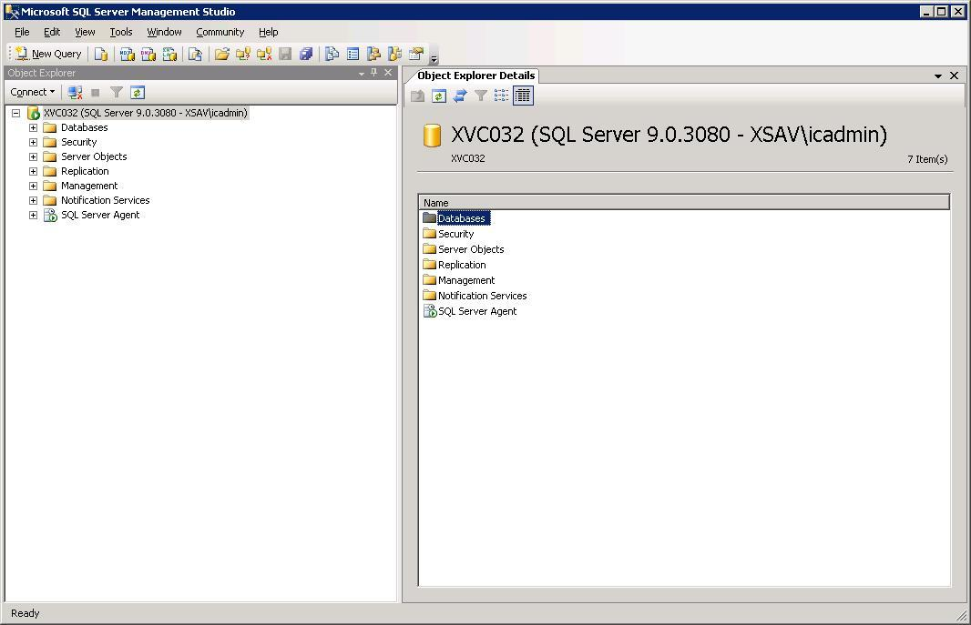
Figure 15: Microsoft SQL Management Studio

APPLICATION UPDATES

To perform an update against the test/production web application virtual machines, publish the latest modification and bring to ISG/NCCE DTO authority for validation. Pending successful transfer of files, log on to the test virtual machine and locate the correct directory for files via method described in step 10. Perform a backup of the application files as described in step 14, and remove/replace folders associated with the changes (typically: admin, bin, images, maps, scripts, app_themes) do not replace the .config files. Open the .config files and modify as necessary (web.config, sqlmap.config, dao.config). When complete perform an iisreset via the cmd console and verify web application is operating with your changes.
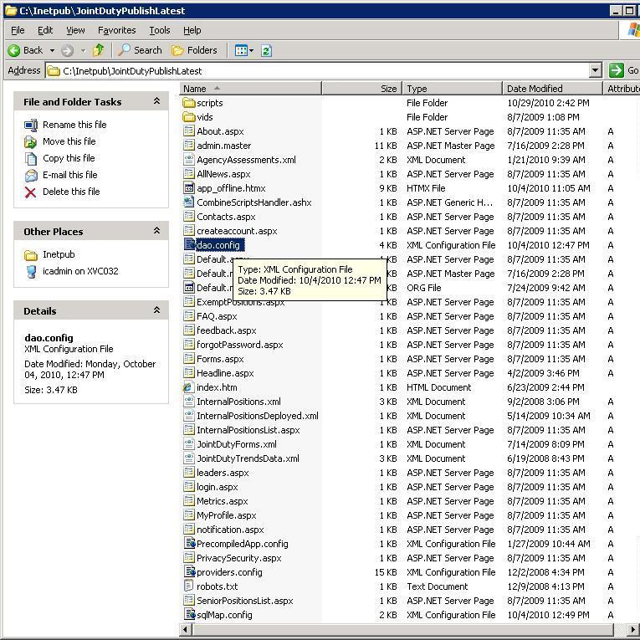
Figure 16: File structure

CONFIGURATION

Configuration updates require modification of the .config files located in the intepub directory of the web application instance. The sqlmap.config and dao.config require configuration to locate the database instance this web application uses. The web.config contains parameters necessary for operation and security of the web application. The second web.config file located beneath the uploads directory controls file upload/download parameters.

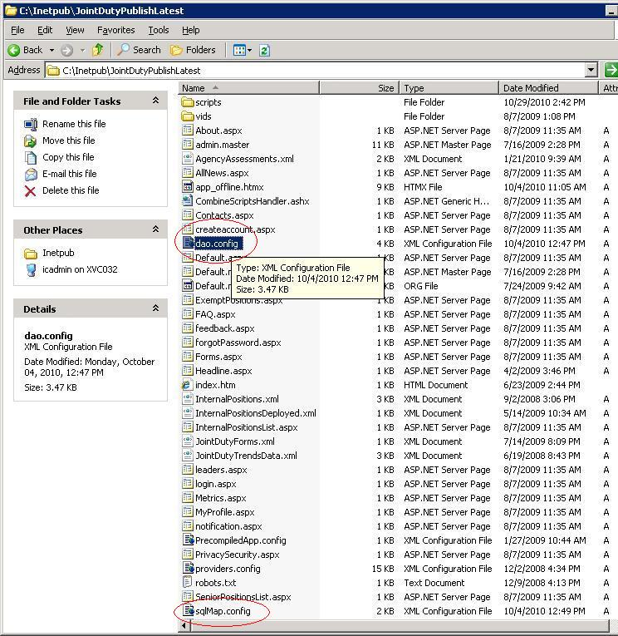
Figure 17: Configuration Files

BACKUPS

To perform a backup of the web application, simply zip all of the files associated with the latest file structure beneath inetpub as located in step 10. To perform a backup of the database instance, use the SQL management Studio and perform a backup of the existing db instance prior to performing modifications. (Note: these backups are also automated and performed by ISG staff on a daily basis)

VACANCY IMPORTS

The system has been designed to import vacancies from an xml file generated by the unclassified web application instance to enhance client efficiency by eliminating the need to create vacancies twice. The xml file is currently generated every Friday on the unclassified Joint Duty instance, using Glide, transfer the file from the unclassified instance and send to the appropriate ISG/NCCE DTO authority for deposit on the test/production application virtuals. Log on to the test virtual and ensure the file is in a directory with no other xml files. (eg: D:\JointDutyImport). Locate the DataTools directory and ensure that the sqlmap.config and dao.config files are pointing to the correct database instance. (Testdb for the testapp etc..) Now open a cmd console and navigate to the DataTools.exe file and execute with the following switches: DataTools.exe import D:\JointDutyImport. The vacancies contained in the xml file should now populate the db. Examine the Log file in the Log directory from the DataTools directory.
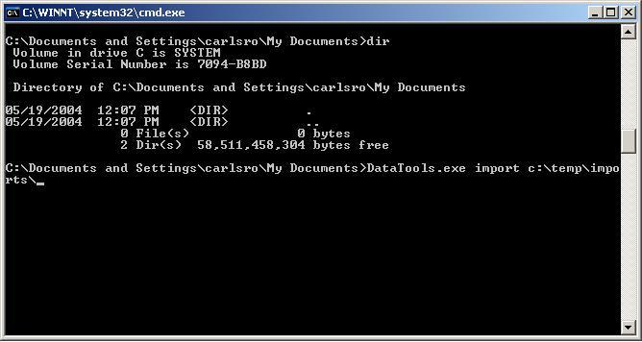Figure 18: DataTools import console application

