DCIPS is a Mission Focused Human Resources System
Empower Your Employee (EYE)
The EYE of DCIPS

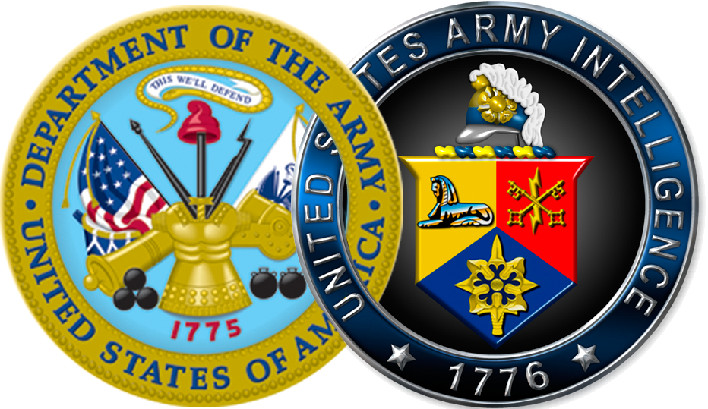

DCIPS is a mission focused human resources system that is management driven and not just an HR system.
Defense Civilian Intelligence Personnel System (DCIPS) is a mission focused human resources system that is management driven and not just an HR system. DCIPS is intended to strengthen the Intelligence Community’s ability to face its ever-changing demands and recognize and reward employees’ performance and contribution to the mission.
DCIPS can help create a line of sight showing how command/division, work unit, and individual performance contribute to the overall Army Intelligence functional and National Intelligence community results. When employees are able to see how their work is connected to the strategic plan and how it affects the entire Army Intelligence functional community, they are more committed to performing at a higher level. As the graphic below indicates, employee goals can be linked to each organization’s strategic goals throughout the Army Intelligence functional community up to the overall Defense Intelligence Strategy.

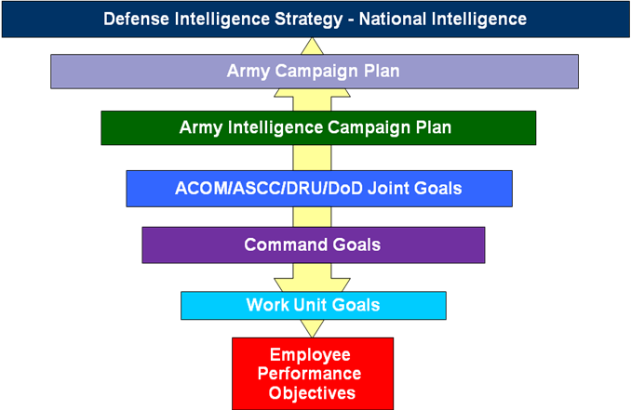

For goals and/or objectives to be achieved at any level, collaboration is critical. Collaboration should take place both within and across command boundaries, and most importantly, allowing employees to see the connection between their daily activities and Army Intelligence goals.
Mission-support employees can also connect to the strategic plan under relevant goals for their workstreams. A critical aspect is that each employee develops performance objectives that can be aligned with the needs of the organization. At the end of the appraisal cycle, employees can then see how their work benefited the overall mission.
Inside This Issue
1 DCIPS is a Mission Focused Human Resources System
2 DCIPS Performance Management Process
3 Upcoming Events
3 DCIPS Puzzle

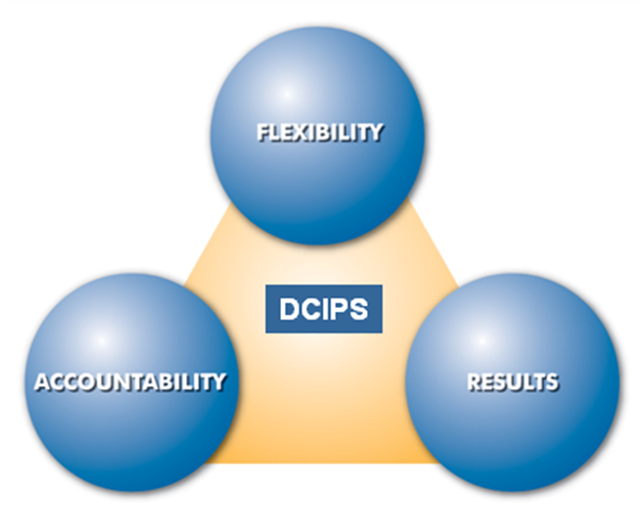
Source: USD(I)

DCIPS Performance Management Process
The performance management process is the heart of DCIPS because it provides a common framework and a fair and equitable process for evaluating the performance of eligible employees throughout the Department of Defense (DoD). Performance management is the process of planning, setting, aligning and communicating individual and organizational performance expectations to employees. It involves continuously monitoring and measuring employee performance, providing performance feedback on a regular basis, taking appropriate steps to improve performance and immediately addressing poor job performance.
Accurately rating and rewarding employee performance to reflect the accomplishment of individual and organizational goals and objectives is also a part of performance management. At the end of the annual review period, compensation determinations, career opportunities and other rewards are all based on individual, team and organizational performance levels.
DCIPS has three core goals in establishing its performance management process:
- Accountability: Hold managers/supervisors accountable for properly managing their employees, and hold employees accountable for achieving results.
- Flexibility: Create a process that is flexible enough to meet the needs of the Army Intelligence functional workforce.
- Results: Drive individual and organizational performance towards the accomplishment of the mission.
Performance management must be a priority for the Army Intelligence functional community in order for it, and subsequently DCIPS, to be successful.
The February issue of the Eye of DCIPS will include more detailed information on the performance management process. Additional performance management documents are being developed now that will be distributed to the Army functional and HR communities in February. These documents will cover many performance management topics including how to conduct performance review conversations at the beginning of the appraisal cycle, at the midpoint and at the end of the appraisal cycle.

Performance management must be a priority for the Army Intelligence functional community.

Upcoming Events
The HQDA-DCS, G-2 Intelligence Personnel Management Office (IPMO) Transition Team will be conducting DCIPS town halls at multiple locations across the country during the next few months. The purpose of these town hall meetings is to present a unified approach to communications throughout the Army Intelligence functional community as we work to implement DCIPS. While we realize that many commands have already held town halls, these events will allow employees to hear directly from either Ms. Yolanda Watson, Chief of IPMO, or Ms. Vieanna Huertas, Army DCIPS Implementation Lead, and will allow for an open forum for employees to submit and ask questions. The IPMO Transition Team has begun contacting the liaisons who will help coordinate these events. The town halls will be geographically-centric, rather than command-centric, meaning that if there are one or two employees in a location different than the majority of their command, they will be able to attend a local town hall if one is available. For those employees who cannot attend a local town hall meeting, we hope to set up VTCs at each town hall so that employees can virtually participate when necessary.

DCIPS Puzzle
Here is a puzzle for you to try to solve. It’s DCIPS Sudoku. Just like the Sudoko rules, use the 9 letters in “ARMY DCIPS” and complete each row, column, and 3-by-3 square using the letters only once. Good luck!

 |  |  |  |  | P |  | A
Y | C |  |  |  | R
 |  | S | D | C |  | I
 |  |  |  |  |  | M |  | P
A |  |  |  | Y |  |  |  | S
M |  | C
 |  | I |  | R | Y | A
 |  |  | M |  |  |  | C | I
 | S |  | P

You can find the solution to the puzzle on the DCIPS website.

NIPRnet: http://www.dami.army.pentagon.mil/site/dcips/
SIPRnet: http://www.dami.army.smil.mil/site/dcips
JWICS: http://www.dami.ic.gov/site/dcips

