Empower Your Employee (EYE)
The EYE of DCIPS

From the Desk of Ms Yolanda Watson, Chief of the Intelligence Personnel Management Office (IPMO)

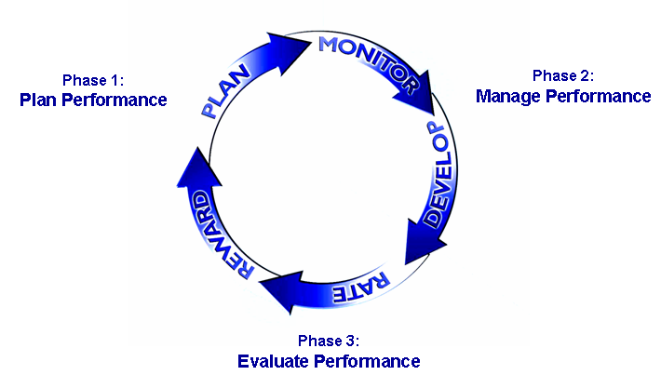


DCIPS Performance Management Cycle
Inside This Issue
1 From the Desk of Ms. Yolanda Watson, Chief of the Intelligence Personnel Management Office (IPMO)
1 DCIPS Performance Management Cycle
2 Writing SMART Objectives
3 Changes Affecting GG-13 Intelligence Professional Employees
5 DCIPS Policy Working Group
5 DCIPS BETA Implementation
6 Town Hall Update
6 Upcoming Events
DCIPS performance management is a cyclical and ongoing process comprising three distinct phases: (1) Plan, (2) Manage, (3) Evaluate. Within the phases, there are five primary activities that transpire during the performance management cycle. A description of the phases is presented below, followed by a synopsis of each of the five accompanying primary activities: (1) Plan (2) Monitor (3) Develop (4) Rate (5) Reward.

Phase 1: Plan Performance
During this phase, employees collaborate with their supervisors to develop three to six performance objectives and an Individual Development Plan (IDP) that outlines their developmental goals for the performance appraisal period. Employees and their supervisors also discuss performance elements and how they relate to their performance objectives.
The Reviewing Official is responsible for ensuring accuracy of performance management within the subordinate organizations and commands for which they are responsible. During the planning phase, the Reviewing Official is specifically responsible for approving the employee’s performance objectives and their IDP.
Continued on next page

Thank you for taking the time to read this newsletter. I am excited about the Defense Civilian Intelligence Personnel System (DCIPS) and the positive changes it will bring to the Army Intelligence functional and human resources communities. I appreciate the entire community standing ready to assist the IPMO Transition Team. We need to work together to ensure that the implementation and transition processes run smoothly. The Transition Managers serve as the gateway between leadership and the employees within their commands so they will be your primary source for information. The Transition Managers will inform you of the actions that need to be taken by you throughout this transition. In addition, the IPMO Transition Team will keep you informed through town halls and other communication mediums such as this newsletter. Our success depends on your assistance and we appreciate you helping us continue to be an Army of One.

Performance objectives are the core of the DCIPS performance management system…

DCIPS Performance Management Cycle (Continued)

Phase 2: Manage Performance
The managing phase consists of the monitoring and development activities. Monitoring employee performance throughout the performance year is a responsibility for both the employee and the supervisor. During this phase, employees engage in frequent performance discussions with the individual responsible for their performance appraisal, usually their supervisor. Employees also complete a self assessment of their performance at the midpoint of the appraised period, and they receive a formal midpoint review from their supervisor. Reviewing Officials must ensure supervisors provide performance feedback to their employees and complete a midpoint review.
Throughout the year, employees and supervisors should discuss performance to ensure the needs of both parties are met. It is a good idea for employees to keep a record of accomplishments to discuss throughout the cycle. A DCIPS Employee Performance Journal is currently being developed to help employees with this step of the process.
Phase 3: Evaluate Performance
The evaluating phase consists of the rating and reward activities. During the evaluating phase, employees complete a self assessment, are rated on their performance and receive an annual Rating of Record. Reviewing Officials review and approve the Rating of Records of the employees and they ensure consistency between and among the supervisors.
Employees will receive salary increases and bonuses based on their final overall rating of record. Proposed salary increases and bonus decisions are reviewed at several levels of the Army Intelligence functional community to ensure consistent standards are applied in an equitable manner.
More detailed information on the DCIPS performance management cycle is included in the DCIPS Performance Management Handbook which is currently being developed and will be released shortly.
During the planning phase of the performance management cycle, employees and their supervisors identify performance objectives that are measured during the evaluating phase. Performance objectives are the core of the DCIPS performance management system and therefore play a critical role in the successful implementation and execution of DCIPS. In preparing performance objectives, employees and supervisors should review the employee’s job duties and responsibilities in their position description (PD), as well as goals and objectives.
Continued on next page

Writing SMART Objectives

Throughout the year, employees and supervisors should discuss performance to ensure the needs of both parties are met.

Employees and their supervisors will utilize the SMART framework to help them write clear, concise, measurable statements that address the following questions:
Specific: What specific task needs to be accomplished?
Measurable: What measure will my supervisor and I use to know whether or not I met my objective?
Achievable: Is this objective challenging, yet attainable?
Relevant: Is this objective relevant to the organization’s mission?
Time-bound: By when will I complete this objective?
SMART objectives are used to ensure that employees can see a direct line of sight from their specific job to the overall mission of the agency. In addition, SMART objectives allow an employee and his or her supervisor to clearly see whether or not the objective was met, thus making performance reviews objective. Well-written performance objectives enable continuous evaluation by monitoring progress, resources, and effort while allowing for corrections while on the path of professional development. In the coming months, additional information on how to write SMART objectives will be provided to the Army functional and HR communities.

Writing SMART Objectives (Continued)

“…absent a waiver, all GG/GS-13 professional employees in steps 1 and 2 will convert to Pay Band 3, and all GG/GS-13 professional employees in steps 3 through 12 will convert to Pay Band 4.”

Changes Affecting GG-13 Intelligence Professional Employees

In the USD(I) memo dated April 8, 2008, Mr. James R. Clapper, Jr. stated that the allocation of positions to Pay Bands 4 and 5 at conversion will be limited to no more than 55% of the authorized GG/GS strength, with not more than 15% of positions allocated to Pay Band 5. These allocations are necessary to ensure each organization’s work and workforce is consistent with mission requirements as well as the budget.
If nothing is done, some of the Defense Intelligence organizations will convert to DCIPS with employee populations significantly beyond the 55% limitation. This would suppress the advancement of well qualified employees until an acceptable senior workforce distribution was reached. Therefore, the previously approved GG/GS-13 professional conversion criteria will be modified, such that absent a waiver, all GG/GS-13 professional employees in steps 1 and 2 will convert into Pay Band 3, and all GG/GS-13 professional employees in steps 3 and above will convert to Pay Band 4.
This decision was made on the assumption that employees in GG/GS-13, steps 1 and 2, are the most junior employees in the GG/GS-13 grade, are performing work that is consistent with their positions in Pay Band 3, rather than in Pay Band 4. If this assumption is incorrect, organizations may request a waiver on a case-by-case basis. Exceptions will also be considered for positions that include special mission requirements.
Continued on next page

Changes Affecting GG-13 Intelligence Professional Employees (Continued)

If your organization's management in the Army Intelligence community would like to request a waiver, they will need to follow the following guidelines.
First, the request for the waiver must come from the Commander to HQDA ODCS G-2, IPMO for review. The letter submitted by the commander must include the:
- Employee's full name,
- Position title,
- Complete organization's location including installation, Branch and Section,
- Information on the mission and structure of the organization,
- Organizational chart detailing the title, series, grade, and job number of all positions in the unit, including military positions.
This justification must indicate the work the employee is doing that is above and beyond what is included in their position description. In addition to the letter, there will be a format made available to the commands for the complete waiver request process. The letter and supporting documents must be submitted to the IPMO for review. The final approval authority is the USD(I).
Four business cases pertaining to the waiver are described below:
Supervisory - This business case addresses DCIPS conversion cases where upon conversion into DCIPS, the supervisor is assigned to Pay Band-3 and some or all of his/her subordinates are assigned to Pay Band-4 given their current GG-13 step at conversion (See DCIPS Conversion Policy Memorandum dated 8 Apr 08). Justification should include the total number of subordinates and identify the number of subordinates converting to Pay Band-3 and Pay Band-4 on an organizational chart.
Identical Additional (IA) Position Description - This business case addresses DCIPS conversion cases where multiple employees are assigned to the same position description, performing identical duties, but upon conversion will be placed in different DCIPS Pay Bands (both Pay Band-3 and Pay Band-4). The rationale provided must include supporting documentation as to why GG-13 step 1 or 2 employee should be placed in the higher Pay Band. The rationale that being assigned to an IA position itself is not sufficient to warrant placement in Pay Band-4.
Depth of Experience - This business case addresses DCIPS employees who will not reach GG-13/3 by the time of conversion in the GG-13 steps 1 or 2 who have a greater depth of experience (i.e., contractor; prior military or private industry experience) than reflected in being assigned to GG-13 step 1 or 2 level positions.
Other - This business case addresses situations not already addressed in the three other business descriptors listed above (i.e., Special Mission Requirements).

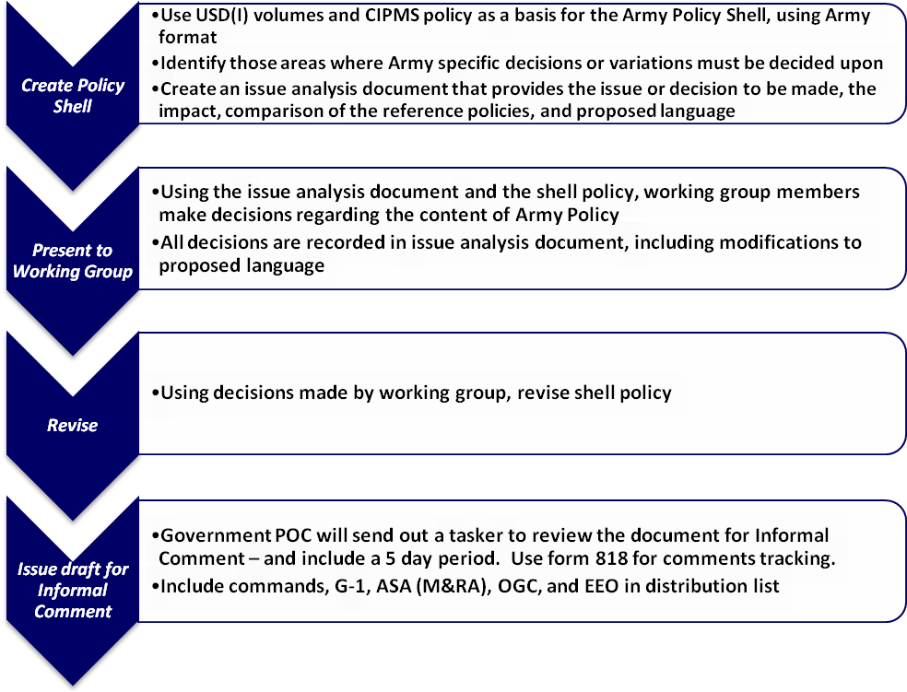
In April 2009, the IPMO Transition Team will be launching a DCIPS BETA to help facilitate a successful DCIPS performance management process for the Army Intelligence functional and HR communities. The BETA includes employees from HQDA ODCS, G-2, Army G2X, HQ INSCOM G-1 and the Army Crypological Office (ACO).
Specifically, the BETA will provide an opportunity for supervisors and employees to work with the Performance Appraisal Assessment (PAA) Tool, develop SMART performance objectives, and work under these objectives. As the BETA progresses through DCIPS performance management, the IPMO Transition Team will report implementation lessons learned through the EYE and other established communication vehicles. The IPMO Transition Team hopes to report participants’ experiences and suggestions as they develop performance objectives and become familiar with DCIPS. Key milestones for the BETA are shown on the next page.
Continued on next page

DCIPS BETA Implementation

DCIPS Policy Working Group
The IPMO has convened an internal Policy Working Group (PWG) to create the policy needed to support the DCIPS transition. The PWG has created an approach to prioritize the rewriting of the Civilian Intelligence Personnel Management System (CIPMS) policy chapters using the USD(I) DCIPS volumes prior to conversion in July 2009.
The PWG is currently drafting initial interim policies and will use two levels of review to ensure stakeholders have an opportunity to comment on each of the chapters. The first level of review will provide the chapters to commands for informal comment; the second level of review will be through the formal staffing process. Below is an illustration of the process that the PWG is following:

The IPMO Transition Team has identified the following dates in February and March for the special communication events listed below. The IPMO Transition Team is still in the process of scheduling additional town halls and executive road shows. These dates are subject to change.

Upcoming Events
Come one, come all! Thus far, our DCIPS town halls have proven very informative for employees that have attended. As of 13 February 2009, we have held 5 town halls including one at Ft. Myer, one at the Pentagon, one at Ft. Belvoir, and two in Key West, FL. Over 300 DCIPS employees, supervisors, and HR personnel have attended in order to have an opportunity to ask their questions directly to either Ms. Yolanda Watson, Chief of IPMO, or Ms. Vieanna Huertas, Army DCIPS Implementation Lead. Survey results have shown that employees have enjoyed this opportunity and found it very beneficial. According to the surveys, 90% of respondents believe the information provided to them at the town hall was beneficial, while 87% believe the experience was beneficial to them personally. In addition, 91% of attendees would recommend other DCIPS employees, supervisors, and HR personnel attend a town hall if available.
In February and March, we will be holding town halls at Ft Huachuca, Ft. Bragg, Ft. Monroe, and Redstone Arsenal. While we cannot go to every location that has DCIPS employees, we will be hosting VTCs from the Pentagon to reach those locations we are unable to attend. Please keep your eyes open for new town halls announcements and we look forward to answering your questions!

Town Hall Update
Town Hall | Executive Road Show | Location | Date
ü | ü | Fort Huachuca | 20 February
ü | ü | Fort Bragg | 3 March – 4 March
ü |  | Redstone Arsenal | 17 March
ü |  | Fort Monroe | 24 March

BETA Group Milestones
TAPES rating cycle ends - allows time to conduct close out and complete required training | 31 March 2009
Convert to New Performance Management | 1 April 2009
Performance Management Test Period - Lessons Learned (approx 3.5 months non-rated period) | 1 April 2009 through 18 July 2009
Conversion to Pay Bands | 19 July 2009
New rating cycle (approx 14 months) | 19 July 2009 – 30 September 2010

