Office of the Director of National Intelligence (ODNI)/Office of the Chief Human Capital Officer (CHCO)

Intelligence Community Joint Duty
General User Guide (GUG)

Version 2.0

October 2010

GENERAL User Guide
CHANGE LOG
DOC | APPROVAL | REV | PARAGRAPHS | REMARKS
REV | DATE | BY | AFFECTED | RFC | APPROVAL
New |  | RRC | Entire Document
2 |  | FRB | Entire Document

TABLE OF CONTENTS

1 IntROduction 4
2 Finding help 4
3 Accessing Joint Duty 4
4 How to search for a Vacancy 5
5 Advanced search 6
6 CREATING your profile 7
7 Apply for a Vacancy 8
8 WHERE IS MY APPLICATION? 9

IntROduction

The Intelligence Community (IC) Joint Duty program is a civilian personnel rotation system similar to joint duty in the military. The Joint Duty website’s purpose is to encourage and assist IC personnel interested in rotational assignments to national intelligence centers and between IC elements.

The Joint Duty website allows IC employees to search and view vacancies, apply for vacancies, and track the progress of their application. Employees are also able to view current Joint Duty directives, policies, and announcements. To further assist users, the website provides a Points-of-Contacts list for each IC element’s Joint Duty Program Office and a list of Frequently Asked Questions.

Finding help

Users can send questions, concerns, and/or feedback regarding the website by clicking the “Contact Webmasters” or “Feedback” link.

Accessing Joint Duty

To access the IC Joint Duty website, use the following URLs:

JWICS: http://icjointduty.ic.gov
Unclass: https://www.icjointduty.gov

The Joint Duty home page (Figure 1) contains a navigation toolbar at the top, a sidebar to the right with the latest vacancies, and a menu of additional links at the bottom of the screen.

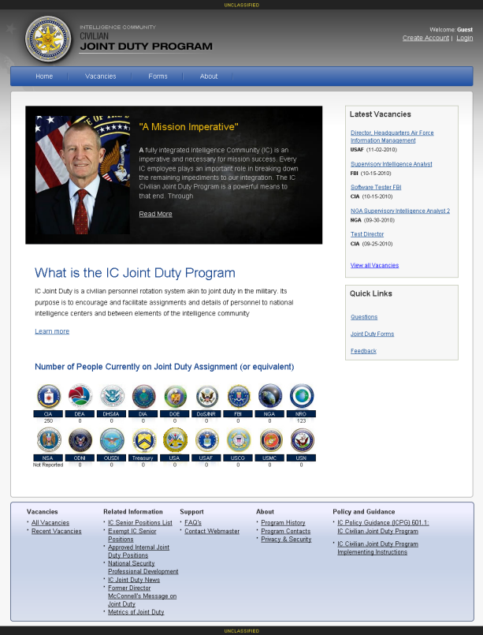
Figure 1: Joint Duty Home Page

On the Joint Duty home page, users are able to:

- Create a Joint Duty account or login using the links at the top right of the page

- Use the navigation toolbar to move to a specific page in the application

- Use the sidebar to see the most recently posted vacancies or navigate using the quick links

- Check the bottom of the screen to see how many people are currently on Joint Duty assignment

- Use the links at the bottom to view current Joint Duty policies, announcements, and related information

How to search for a Vacancy

Select “Vacancies” on the Navigation Bar or “All Vacancies” on the sidebar to view a listing of all open vacancies (Figure 2).

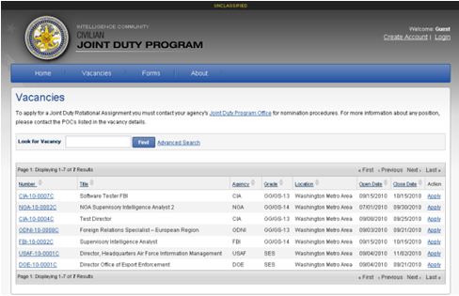
Figure 2: Vacancy Listing Page

On the vacancies page, users can:

- Use the “Look for Vacancy” field to search by key word

- Click on a column’s title to sort and view the vacancies by number, title, agency, grade, location, open date, or close date

- Click on the vacancy number to view the vacancy details

- Apply for a vacancy using the Apply link.

Advanced search

Users can search for vacancies by Mission Category, Agency, Title, Keyword, Vacancy Number, Location, Grade, Reimbursable Type, or any combination of these fields.
Note: To select multiple items in a single field, hold down Ctrl and click each item.

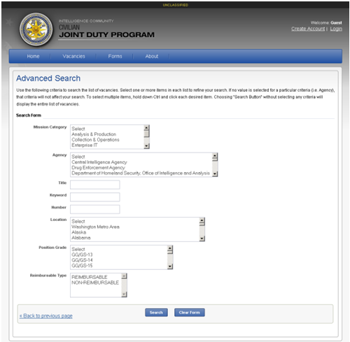
Figure 3: Advanced Search Page

CREATING your profile

Before applying for a vacancy, you must create a profile. Click Create Account, located at the top right of each screen, and you will be redirected to the Create Profile page (Figure 5).
Note: Once completed, profiles can be updated at any time using the My Profile link at the top of each page.

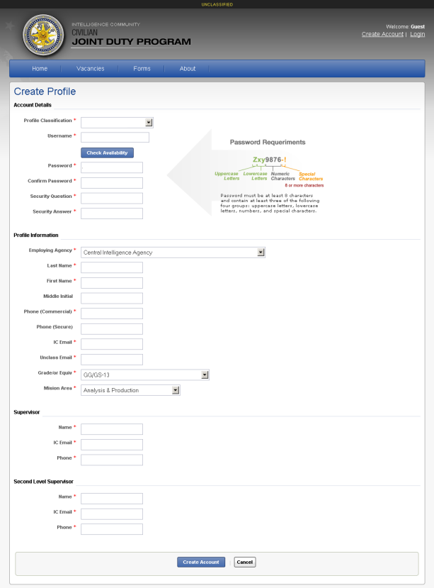
Figure 4: Create Profile Page

Fill out the form as directed, taking care to choose the correct classification. Fields marked with red asterisks * are required. Select “Create Account” when complete and this information will be stored and used each time you apply for a vacancy.

Apply for a Vacancy

Once you have selected a vacancy, click the “Apply Now” button on the top right corner or at the bottom of the vacancy and you will be redirected to the “Apply for this Vacancy” page (Figure 6).

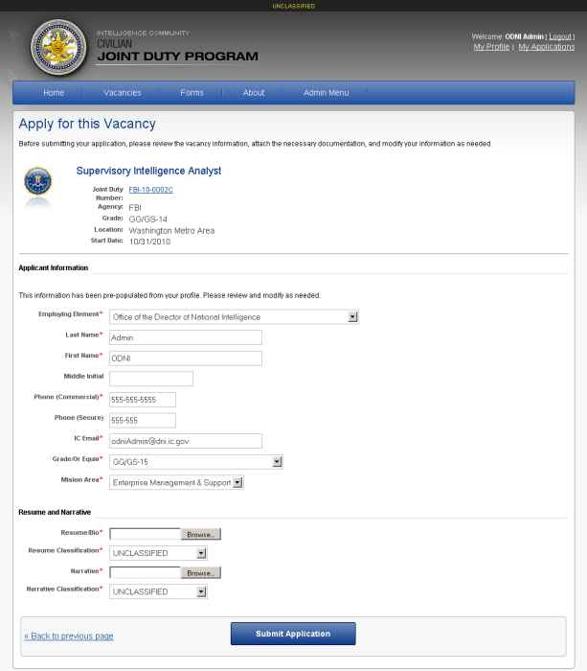
Figure 5: Apply for a Vacancy

- Most of the fields will be populate with the data you provided in your Profile. At this point, you can manually change the data if needed.
Note: These changes are for the application and will not be saved in your Profile.

- Attach your resume and narrative. Select a classification for each of these documents.
Note: Supported formats are pdf, doc, docx, txt, and rtf.

- Press the Submit Application button.

WHERE IS MY APPLICATION?

Once submitted, your application will go to your organization’s Joint Duty Program Office for nomination. Upon supervisor approval, it will be forwarded to the Joint Duty Program Office for the vacancy’s posting organization.

To find out where your application is in this process, click the My Applications button located in the top right hand corner of each page. To view the vacancy, click on the vacancy number. To withdraw your application, click the Withdraw action.

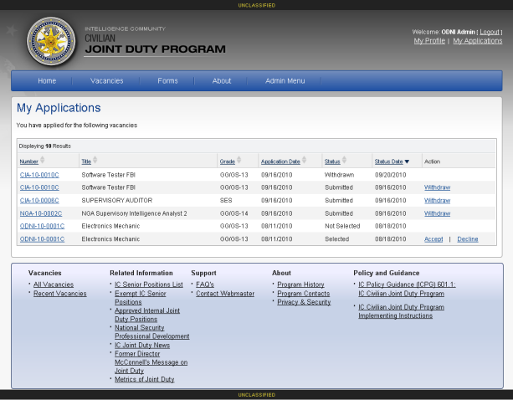
Figure 6: My Applications

Under the status column, you will see one of the following possible statuses:

Status | Description
Submitted | Your application has not yet been nominated for the position.
Nominated | Your application has been forwarded to the agency who posted the position.
Selected | You were selected for the position.
Not Selected | You were not selected for the position.
Accepted | You were selected for the position and accepted.
Declined | You were selected for the position and declined.
Withdrawn | You or your Joint Duty Program Manager has withdrawn your application.
Figure 7: Application Status

