RASS Guidance - How to Create your SF 182 in RASS

1. A Resource Allocation Selection System (RASS) account must be created by the CP35 FCR POC / CPM before you are able to create your SF 182 in RASS. Contact your ACPM if your account has not been created.

*Ensure SF 182s are input into RASS 25 days prior to training start date. TRV
analysts will add the LOA to the SF 182 within 10 days.

* SF 182 - Input one SF 182, in RASS, to cover the duration of training which begins in FY 12 and ends in FY 13.

2. SF 182 will route electronically from Careerist, to Supervisor, to CP35 CPM to G3 – all are notified electronically when signatures/approvals are required

3. Corps of Engineer (COE): COE employees will use RASS to submit all training (SF 182) and travel requests (DD 1610) and to submit all TDY and local travel requests.

4. WHAT IS RASS: Resource Allocation Selection System (RASS)

* The Resource Allocation Selection System (RASS) is an automated financial system that centrally manages the Army Civilian Training, Education and Development System (ACTEDS) resources for the Intern and Competitive Professional Development (CPD) training programs.

* RASS is a real time, web-based life-cycle management system for centralized management of funds for ACTEDS-approved DA Intern and CPD training. RASS "ELIMINATES" manual procedures, for training and travel documents.

* Students participating in CPD training opportunities must utilize the Resource Allocation Selection System (RASS) for the purpose of requesting ACTEDS resources for FCR approved training.

* RASS enables the creation, submission, and approval of the following forms: A Request, Authorization Agreement, Certification of Training and Reimbursement Form (SF 182), Request, and Authorization for TDY Travel Orders (DD Form 1610), and a Claim for Reimbursement for Expenditures on Official Business (SF1164). You may access RASS at the following website:

http://cpol.army.mil/library/train/rass/

* This site also contains a quick reference guides and screen movies to help students learn how to use RASS. Help with technical problems (unable to login, locked out) contact the HQDA Civilian Human Resources System (CHRS) Help desk at 1-888-253-1836.

* The student is responsible for accessing RASS and completing a SF 182 and/or DD Form 1610. (whichever applies – agencies which do not have RASS access must complete the DD Form 1610. Documentation must contain the signatures of the supervisor, FCR POC (Sharon Fowler) and a G-3 Budget Analyst prior to students beginning an ACTEDS training assignment.

* Students who attend a CPD training assignment prior to receiving a SF 182 or DD Form 1610, certified and approved with the signature of a G-3 Budget Analyst and an ACTEDS fund cite signed and dated by a budget analyst in the G-37/TRV office may be responsible for costs associated with the training assignment. Students should ensure there is sufficient lead time for the processing of training documents prior to the start date of the training assignment. Contact your CPM for creation of a RASS Account - if you have never used RASS before. You will not be able to access the RASS application until you have an established account.

5. Screen shot of SF 182 in RASS (with “YES” checked for ADT):
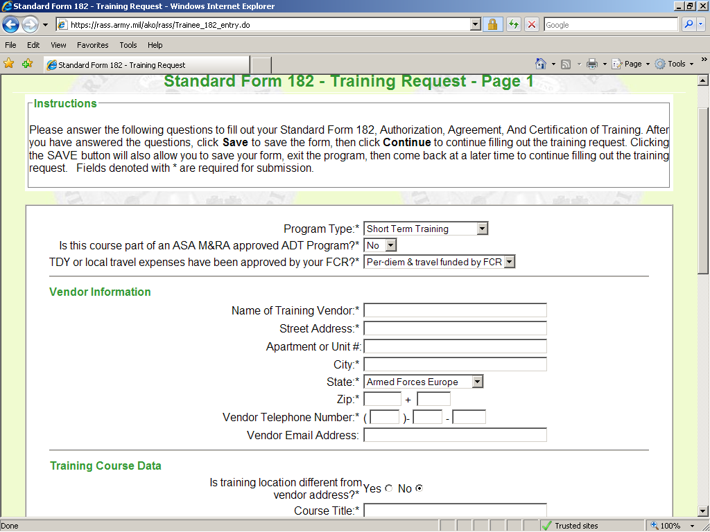
Program Type: Short Term Training
ADT Program: YES
TDY……FCR: “Per-diem & travel funded by FCR”
Fill out ALL fields that have asterisks or the request will NOT PROCESS.
All this information should be copied from your request memo, including the Training objective.

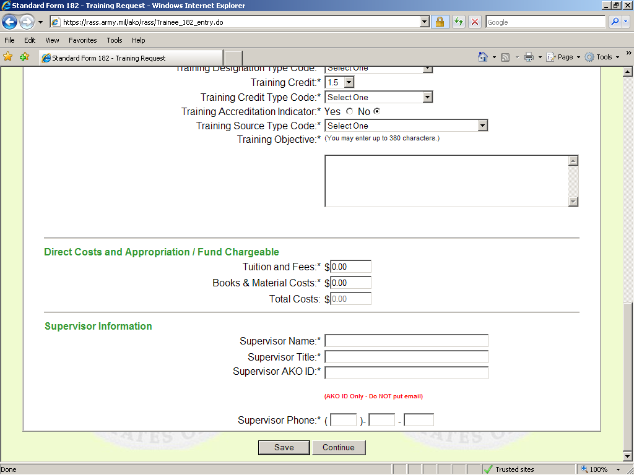
Supervisor Name: Jane Doe
Supervisor Title: Training Coordinator
Supervisor AKO ID: Jane.Doe
Phone: 123-456-7890
All the cost information should be copied from your request memo, including the Total cost.

6. Point of contact this action is: CP35/Career Program Manager - Sharon Fowler - Email: Sharon.fowler@us.army.mil Commercial Phone: 703-695-3661 (DSN – 225).

