The DCIPS news feed contains frequently updated content that can be automatically delivered to a user’s computer. Users can elect to subscribe and have content automatically delivered via Microsoft Internet Explorer or Outlook depending on personal preference. When users subscribe to this feed, content will be delivered to Internet Explorer, in Favorites under “Feeds” and/or Microsoft Outlook under “RSS Feeds” in the DCIPS News folder. To subscribe, follow the subscription instructions below.

Add a RSS Feed through DCIPS News Feed webpage
When you use Windows Internet Explorer 7 and Office Outlook 2007, you can add RSS Feeds from either program as well as view the feeds in either program.
- Access the Army DCIPS website by entering the URL http://www.dami.army.pentagon.mil/site/dcips/
- Click on DCIPS News icon on the far right of the homepage
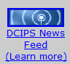
- Click on Subscribe to this feed on the DCIPS News Page
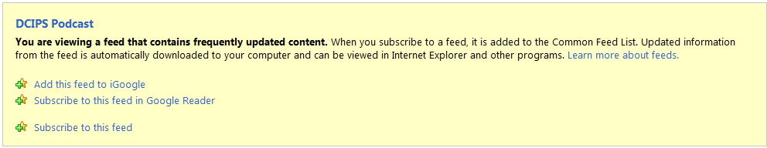
- On the RSS Feed pop up box, select Subscribe
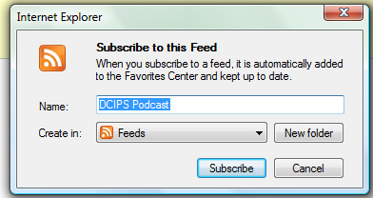
- Click Favorites and select RSS to view the DCIPS News Feed
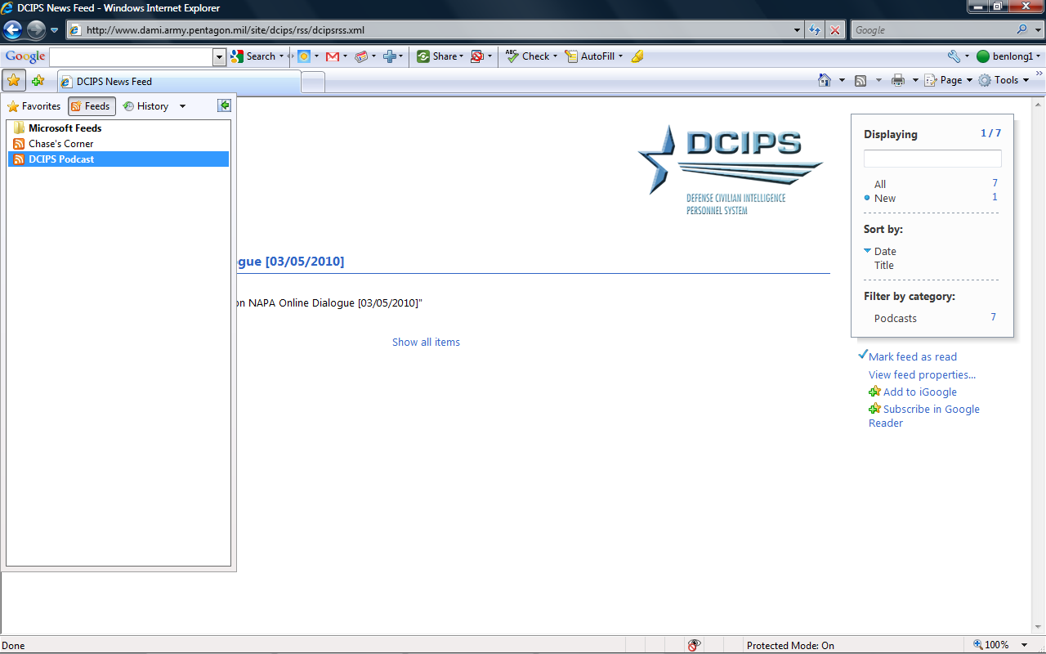
- Users will be taken to the DCIPS News Feed page that shows all recent website updates in one central location

Add a RSS Feed through the Microsoft Office Outlook 2007 Account Settings dialog box
- On the Tools menu, click Account Settings.
- On the RSS Feeds tab, click New.
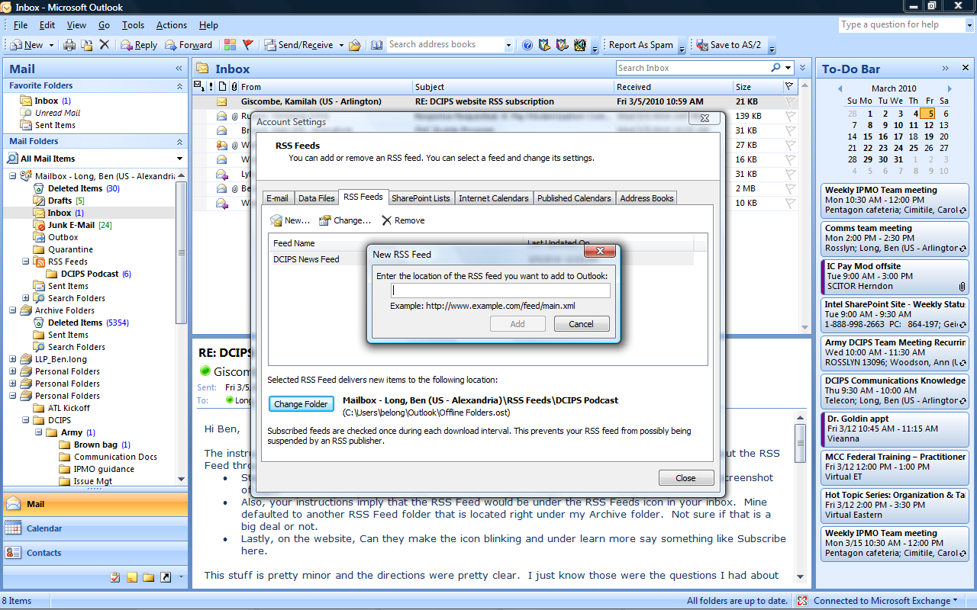
- In the New RSS Feed dialog box, type http://www.dami.army.pentagon.mil/site/dcips/rss/dcipsrss.xml
- Click Add.
- Click Change Folder and select RSS feed on the right. A new folder titled DCIPS Podcast will be created
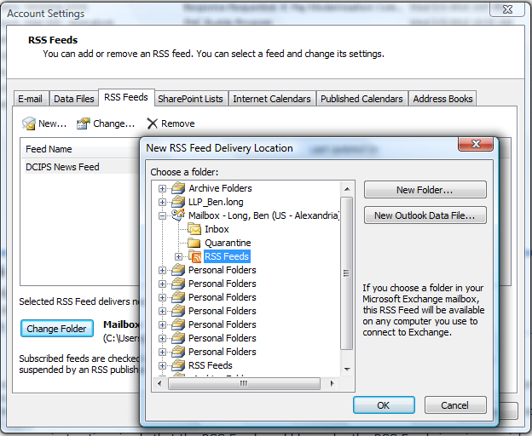
- Click OK.
- New content will be automatically delivered to your DCIPS RSS Feeds folder similar to how you receive new e-mails


