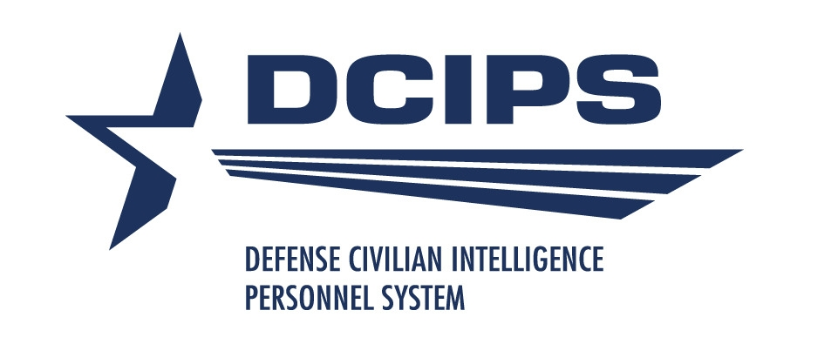

September 2009
Performance
Management
Handbook
DCIPS is a Title 10 Excepted Service civilian human capital management system
for the DoD Intelligence Community. The new features of DCIPS emphasizes
recognizing employees, developing individuals and rewarding performance.

Volume I
Army intelligence
Performance Management Handbook
The Defense Civilian Intelligence Personnel System (DCIPS) is a management system that compensates and rewards employees based on performance and contribution to the mission. DCIPS provides flexibility to move more freely across a range of work opportunities. DCIPS gives the Department of Defense (DoD) the tools to foster a culture that values and recognizes talent. The entire DoD Intelligence Community is using a common performance management system where each employee is similarly evaluated and rewarded.

Table of Contents

Performance Management: Overview

Understanding Performance Management 4
Performance Management Terms 5
DCIPS Goals 7
The Performance Management Cycle 8
Army DCIPS Performance Management Timeline 11
Roles And Responsibilities 12

Phase I: Plan
Writing Performance Objectives 14
Performance Elements 21
Creating An Individual Development Plan 25

Phase II: Manage
Monitoring Performance 29

Phase III: Evaluate
Preparing the Employee Self-Report of Accomplishments 34
Performance Appraisal 38
How To Rate Performance Objectives And Performance Elements 39
Effective Feedback 44
Other Resources and Contact Information 49

Appendices
Appendix A: Suggestions for Wording SMART Performance Objectives 51
Appendix B: Additional Examples and Tips on How to Write SMART Objectives 53
Appendix C: Intelligence Community Performance Standards 56

KEY
Graphic Element | Description
 | Calls attention to information or requirements for Army DCIPS supervisors (military and civilian)
 | Identifies useful tools, tips and suggestions
 | Highlights contact information

Performance Management: Overview
Understanding Performance Management
Performance management is one of the key components of DCIPS. So what exactly is performance management?
Performance management is the process of planning, setting, aligning and communicating individual and organizational performance expectations to employees. It involves continuously monitoring and measuring employees’ performance, providing performance feedback on a regular basis, taking appropriate steps to improve employee performance and addressing poor performance immediately.
Performance management also includes accurately rating and rewarding employee performance to reflect the accomplishment of individual and organizational goals and objectives. At the end of the annual review period, compensation determinations, career opportunities and other rewards are all based on individual, team and organizational performance.
Performance management encompasses far more than any single process, such as the performance appraisal. Performance management must be a priority for the Army Intelligence functional community in order for it, and subsequently DCIPS, to be successful.
Performance Management Terms
Individual Development Plan (IDP) — A document prepared jointly by the supervisor and employee as part of the annual performance planning process that outlines development objectives for the employee. IDPs may include training, education, individual coaching, work assignment, or other activities designed to improve the employee’s capability within his or her career field.
Performance Management Terms

Midpoint Performance Review — A mandatory review of an employee's performance conducted approximately midway through the performance evaluation period.

Performance Evaluation — The written or otherwise recorded evaluation of performance and accomplishments rated against DCIPS performance elements and objectives.

Performance Elements — A standard set of behaviors for all DCIPS positions, derived from analysis of the work being performed by employees, that are necessary for successful performance of that work.

Performance Objectives — Information that relates individual job assignments or position responsibilities and/or accomplishments to performance elements and standards and to the mission, goals, and objectives of the Army.
Performance Management Performance Review Authority (PRA) — The PM PRA provides oversight of the rating process to assure consistency in the application of principles and criteria and resolves employee requests for reconsideration.

Performance Standards — Descriptors by performance element of “Successful” performance thresholds, requirements, or expectations for each career path and pay band.

Rating Of Record — The summary performance rating, derived from the employee’s ratings on his or her performance elements and performance objectives, assigned during the annual appraisal of employee performance that is used for official purposes. The rating drives pay increases as part of the annual review process under DCIPS. The rating of record constitutes the “official rating of record.”
Rating Official — The official in an employee’s chain of command, generally the supervisor, responsible for conducting performance planning, managing performance throughout the evaluation period, and preparing the end-of-year performance evaluation on an employee.

Reviewing Official — An individual in the rating official’s direct chain of supervision designated by the Head of the DoD Component to assess supervisor preliminary performance ratings for accuracy, consistency, and compliance with policy. The reviewing official is the approving official for each performance evaluation within his or her purview.

SMART Framework — Allows employees to write clear, concise, measurable statements (Performance Objectives) that describe the specifics of what the employee plans to accomplish. The acronym stands for Specific, Measurable, Achievable, Relevant and Time-bound.

Supervisor — This includes both civilian and military supervisors who are responsible for DCIPS employees.

Closeout Performance Evaluation — A narrative description and numeric evaluation of an eligible employee’s performance under an approved performance plan when there is a change in the rating official. The closeout performance evaluation is completed by the supervisor or rating official and conveys information regarding the employee’s progress toward completion of performance objectives and performance against the performance elements. A closeout performance evaluation is not an evaluation of record but shall be used to inform the rating official of employee accomplishments and/or needed improvement for the period covered by the evaluation.

Work Category — The work you do falls into one of three categories: Supervisory/Management, Professional or Administrative/Technician. Each work category broadly defines the responsibilities of each.

Work Levels — Describes the complexity and scope of work for supervisor/ manager, professional and administrative/technician: Entry/Developmental, Full Performance, Senior and Expert.

DCIPS Goals
DCIPS has three core goals in establishing its performance management process:
- Accountability: Hold managers/supervisors accountable for properly managing their employees, and hold employees accountable for achieving results.
- Flexibility: Create a process that is flexible enough to meet the needs of the Army Intelligence functional community.
- Results: Drive individual and organizational performance towards the accomplishment of the mission.

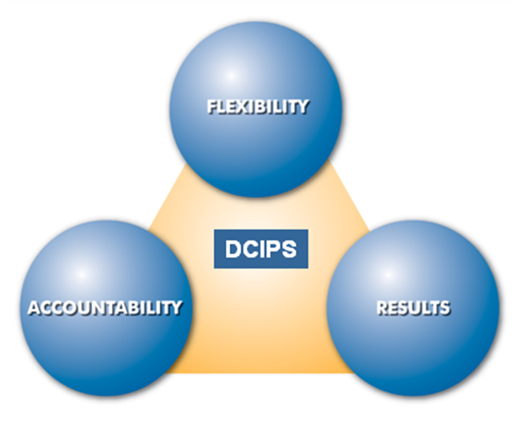
Source: USD(I)

The Performance Management Cycle

Performance management is a cyclical and ongoing process comprising three distinct phases: (1) Plan, (2) Manage, (3) Evaluate. Within the phases, there are five primary activities that transpire during the performance management cycle. A description of the phases is presented next, followed by a synopsis of each of the five primary activities: (1) Plan (2) Monitor (3) Develop (4) Rate (5) Reward.

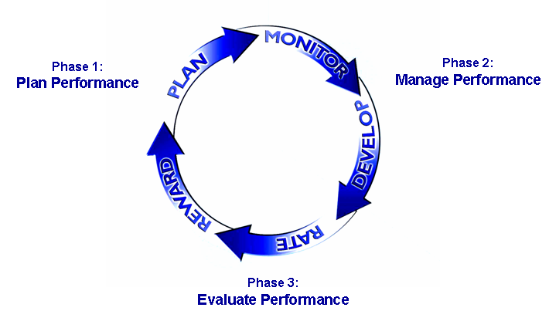

Performance Management Cycle

Source: USDI

Phase 1: Plan Performance

Activity 1: Plan — In the planning phase, employees collaborate with their supervisors to develop three to six performance objectives and an Individual Development Plan (IDP) that outlines their developmental goals for the performance appraisal period. Employees and their supervisors also discuss performance elements and how they relate to their performance objectives.

Phase 2: Manage Performance

The managing phase consists of the monitoring and development activities. During this phase, employees engage in frequent performance discussions with the individual responsible for their performance appraisal, usually their supervisor. Employees also complete a self-report of accomplishments at the midpoint of the appraised period and receive a formal midpoint review from their supervisor. Throughout the year, employees and supervisors should discuss performance. In fact, it is a good idea to keep a record of accomplishments to discuss throughout the cycle.
Activity 2: Monitor — Monitoring employee performance throughout the performance year is a responsibility for both the employee and the supervisor. The midpoint review process is a good opportunity for both employees and supervisors to:
The Performance Management Cycle
- Discuss progress towards achieving performance objectives and to identify ways to succeed in achieving them.
- Verify the performance objectives are still appropriate.
- Modify performance objectives if work priorities have changed since the start of the year.
At the midpoint of the performance period, the following actions take place:
- Employees assess their accomplishments against each performance objective and performance element to date.
- Raters provide their assessment of employee performance for each performance objective and performance element on the same form in the relevant area.
- Raters specifically address areas where the employee needs improvement and documents areas for development.
Activity 3: Develop — Developing and enhancing skills is a critical component to employee success. Employees should:
- Review their IDP to identify if there are additional areas they would like to develop.
- Discuss additional training and development opportunities with their supervisor that may be available and how these opportunities would enhance their skills and their value to the organization.
- Discuss mentoring and coaching programs and professional and technical development opportunities.

Phase 3: Evaluate Performance
The Performance Management Cycle
During the evaluating phase, employees complete a self-report of accomplishments, are rated on their performance and receive an Overall Performance Rating.
Activity 4: Rate — Rating activity begins at the end of the appraisal period. Supervisors rate employee performance based on what the employee accomplished and how they accomplished it. Employees continue to document their achievements in their self-assessment.
Activity 5: Reward — Rewarding employee performance is the final step in the performance management cycle and enables organizations to recognize and reward individual and team accomplishment. During this phase, employees receive salary increases and/or bonuses based on their performance rating. Proposed salary increases and bonus decisions are reviewed at several levels of the organization to ensure consistent standards are applied in an equitable manner.

Army DCIPS Performance Management Timeline

The table below provides time frames and the associated actions for Army Intelligence’s implementation of DCIPS performance management. The performance period may not be a calendar year but can begin when the employee begins a new assignment or project.

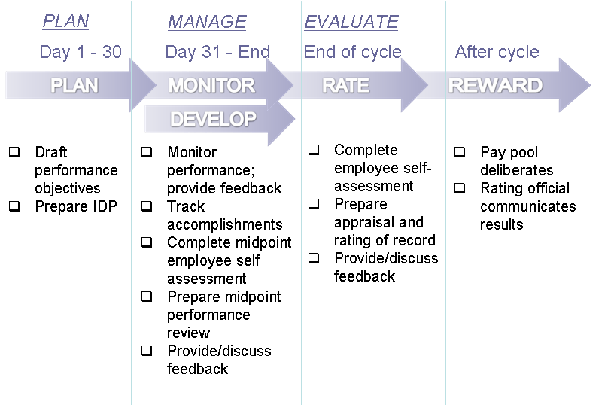

Roles and Responsibilities
The following table offers a snapshot of the roles and responsibilities of the four key participants of the Performance Management Cycle.

Employee | Rating  Official | Reviewing Official | PM PRA
Phase 1: Plan Performance
- Collaborate with the rating official (usually their supervisor) to develop 3 – 6 relevant performance objectives and Individual Development Plan  - Provide perspective and input on assignments  - Be fully committed to accomplishing their performance objectives | - Define employee roles and responsibilities  - Collaborate with the employee to develop 3 – 6 relevant performance objectives and Individual Development Plan  - Communicate organizational mission | Approve employee performance objectives and Individual Development Plan | Not Applicable
Phase 2: Manage Performance
- Maintain personal records of achievement  - Complete midpoint self-report of accomplishments  - Engage rating official in ongoing performance feedback discussions | - Document achievements  - Engage employee in ongoing performance feedback discussions  - Provide employee with a midpoint review | Ensure Rating Officials provide employees feedback and have completed a midpoint review | Not Applicable
Phase 3: Evaluate Performance
- Complete final self-report of accomplishments  - Provide input on accomplishment | - Complete employee Rating of Record (performance appraisal)  - Discuss final performance feedback | - Review and approve employee Rating of Record (performance appraisal)  - Ensure consistency between and among Rating Officials | - Review employee Ratings of Record for consistency  - Return out of scope ratings to Reviewing Official for second review  - Resolve employee requests for reconsideration

Phase I:
Plan
Writing Performance Objectives
Performance Objectives – “What” you do

During the planning phase of the performance management cycle, employees and their supervisors identify performance objectives that are measured during the evaluating phase. Performance objectives are the core of the DCIPS performance management system and therefore play a critical role in the successful implementation and execution of DCIPS. In preparing performance objectives, they should review the employee’s job duties and responsibilities in their position description (PD); relevant competencies; as well as goals and objectives.
The initial performance cycle will run from 19 July 2009 to 30 September 2010, an additional 2 months over the normal performance period due to the timing of Army Intelligence’s DCIPS implementation. All future performance cycles will run from 1 October to 30 September.
Employees should have between three and six performance objectives that identify their major responsibilities and describe what is expected of them.
Fundamentals of DCIPS Performance Objectives
Writing performance objectives is a collaborative effort between a supervisor and employee. Effective objectives should:
- Link to mission and organizational goals – Performance objectives must make sense in the context of the organization. They should support and align with the mission and goals of the National Intelligence Strategy, Undersecretary for Defense (Intelligence) (USD(I)) Strategy, Army Campaign Plan, Army Intelligence Campaign Plan, and the strategic goals of the ACOM, ASCC, DRU, and other appropriate measures of performance.
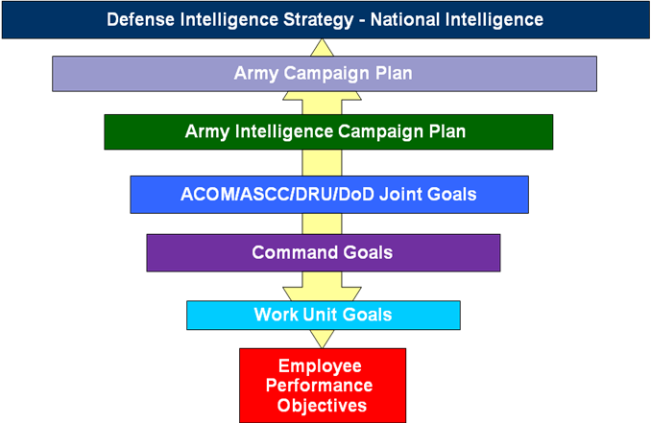
Writing Performance Objectives
By cascading an employee’s performance objectives from the higher-level objectives, employees should be able to draw a “line of sight” between their individual performance and organizational success. An explicit alignment allows employees to see the connection between their daily activities and organizational goals. It is important to individual and organizational performance that employees understand this relationship. Supervisors and higher level reviewers will ensure that objectives support the organization’s mission and goals.
It is critical that managers and supervisors communicate the organizational strategic plan to the Army Civilian Corp members (Army civilian workforce) and military personnel, and emphasize the alignment to the Department’s mission and goals. Supervisors in the performance management chain should engage in a dialogue with employees on the alignment of the mission and goals to performance objectives and performance expectations.
- Describe the expected results – Performance objectives are results-oriented and define the outcomes employees are expected to achieve by the end of the evaluation period. Objectives are not task lists. Employees should consider using words such as "accomplish" or "complete" to phrase an objective instead of "prepare, provide, plan, etc.” Refer to Appendix A: Suggestions for Wording SMART Performance Objectives for additional suggestions. Performance objectives should not be a lengthy list of tasks or define all expected results or outcomes. Supervisors and employees are expected to have continuing communication during the rating cycle to discuss expectations of particular tasks/projects as needed.
- Address the major responsibilities – Performance objectives communicate the major responsibilities and most important work activities and are not intended to cover all tasks. There are usually 3 to 5 major responsibilities (key functions) for a job. For example, an Administrative Assistant may have three key functions - office management, correspondence, and travel coordination. Meaningful objectives should cover the key functions in a job and avoid addressing the small daily tasks of the job.
- Serve as an Appraisal/Management Tool – Performance objectives serve as a basis to assess accomplishments and are appropriate to the work category and work level.
Writing Performance Objectives
Well-written performance objectives enable continuous evaluation by monitoring progress, resources, and effort while allowing for corrections on the path to accomplishment.

Establishing DCIPS Performance Objectives
To develop performance objectives, three preparation steps can help employees to organize their thoughts.
First, employees should become familiar with the most recent versions of the following documents:
- The President’s Management Agenda (http://www.whitehouse.gov/omb/budget/fy2002/mgmt.pdf)
- Current Quadrennial Defense Review (QDR) 2006 (http://www.defenselink.mil/pubs/pdfs/QDR20060203.pdf)
- National Defense Strategy (http://www.defenselink.mil/news/Mar2005/d20050318nds1.pdf)
- The Army Game Plan (http://www.army.mil/features/2005ArmyGamePlan/)
- Army Strategic Planning Guidance (http://www.us.army.mil/)
- Army Campaign Plan (http://www.army.mil/thewayahead/acp.html)
Next employees should review the Command and organizational strategic plans and ensure that the alignment of the goals and objectives to the Army strategic documents is understood.
Second, employees should gather and review standard operating procedures (SOPs), guidance, and directives which may provide information on quantity, quality, or timeframe measures that employees need to achieve. Employees may be able to find useful information from position descriptions and previous evaluations as well.
Third, employees must decide how to group the work they do into large categories or functions. These groupings will serve as the basis for the performance objectives. Employees should ask themselves the following questions to get an idea of what their performance objectives should focus on:
- What are my key job responsibilities and why are they important to the organization?
- If I were not here, what would not get done?
Writing Performance Objectives
- On what do I spend the majority of my time working?
Guidelines for Writing SMART Performance Objectives

After considering the questions above in preparing performance objectives, employees and their supervisors rely on the SMART framework to help them write clear, concise, measurable statements that describe the specifics of what the employee plans to accomplish:
- Specific - Clearly state the expected accomplishment that can be observed. To be specific, an objective must define an observable action, behavior, or achievement; link to a level of performance, frequency, percentage, or other number. Specific is related to the result, not the activities to achieve that result.
- Measurable (or observable or verifiable) - State the criteria for measuring accomplishments. Provide a method to allow tracking, recording, and validation of quality of a specific behavior, action, or outcome. Define quantity (how many), quality (how good), resources (how much), and time (how long, how often).
When defining the measurability aspect of a performance objective, employees need to set it at a performance level of 3 (Successful). Employees do not want to set the expectation of their result so high that they have no opportunity to exceed expectations. When possible, employees should avoid absolute standards (e.g., work must be completed within 7 days). Although there may be times when absolute standards are necessary (e.g., Accomplish safety checks of Blackhawk helicopters with 100% accuracy at all time), they make it difficult to assign any other performance rating than a 3 (Successful) or a 1 (Unacceptable). If an employee includes in their performance objective that they will complete the work within 5 to 7 days, this allows supervisors to use 3 to 4 days as the standard for assigning a 4 (Excellent).
But employees also do not want to set the expectation of their result so low that it is too easy to accomplish. The goal of performance objectives is to drive performance within an organization.
- Achievable - Examines capacity and conditions required to accomplish an objective. An objective must be appropriate for the employee’s experience, skill and work level.
- Relevant - Expected accomplishments should be commensurate with the major responsibilities of the employee.
- Time-bound - State the timeline for expected results. For long-term projects that require more than one rating cycle to accomplish, performance objectives should identify what results are expected within the rating cycle. The time component can be specific (by 1 July, end of 4th quarter), relative to another event (six months after…), or recurring (quarterly).
Writing Performance Objectives
For more information on writing SMART performance objectives, please refer to Appendix B: Additional Examples and Tips on How to Write SMART Objectives. You can also review USD(I)’s iSuccess for DCIPS interactive training module at http://dcips.dtic.mil/index.html for a step-by-step approach to writing performance objectives and the Employee Self-Report of Accomplishments.

Sample SMART Performance Objectives
Writing Performance Objectives
1. Provide accurate, timely customer service
Upon receipt of requests, provide accurate responses in the agreed-upon timeframes, as defined by ICD 24.8, using the appropriate format identified in SOP25 during the evaluation period ending September 30, 2009. This supports the organization’s commitment to be responsive to customers and clients. Meet suspenses 90% of the time. Provide accurate responses with no more than 2 errors per request.

Specific
Time-Bound
Achievable
Measurable
Relevant
Achievable
Measurable

Specific
2. Provide relevant, timely, all-source intelligence reporting
Complete analysis of effects of UN-imposed sanctions on Iraqi industrial sector and present results in appropriately coordinated intelligence report for release to policy-making community by 31 August. Product will reflect engagement with other analysts and stakeholders and incorporate their coordinated views. The completed product will make use of available intelligence from at least 90% of relevant sources as dictated by ICD 203.2 and reflect engagement with other stakeholders in the subject of the analysis

Achievable
Measurable
Time-Bound
Relevant
Relevant
Changing Objectives
Employees and supervisors may work together to change performance objectives during the course of the year. In a dynamic environment, one strategy may be to write 3-4 objectives covering the first part of the performance period and update performance objectives at the midpoint.
Writing Performance Objectives
If an employee is on a new assignment or a temporary assignment anticipated to last for a period of 90 days or more, the employee needs to work with his/her new direct supervisor to establish a new set of performance objectives. Note that employees must have a minimum of 90 days to accomplish a new objective. The supervisor should work with the employee to ensure that the new objective is appropriate to the shortened time period.
Performance Planning Meeting
Supervisors — are required to meet with employees within 30 days of the beginning of their appraisal cycle, or upon arriving in a new assignment. Supervisors should prepare for the meeting by:
- Reviewing performance elements of employee for particular work category and work level.
During the meeting, supervisors should discuss the following topics:
- Organizational goals
- Performance objectives and work priorities
- Performance standards
- Performance elements
- Individual Development Plan (IDP)
- Potential barriers to success (optional discussion topic)
- Tasks, timelines and milestones (optional discussion topic)
Employees — prepare for the performance planning meeting by:
- Creating a list of recurring tasks, major projects and milestones.
- Drafting goals or accomplishments for the upcoming performance cycle and set dates for achieving those goals.

Performance Elements
Performance Elements – “How” you do it

Performance elements are attributes and behaviors significant to the accomplishment of performance objectives; they explain how the performance objectives should be accomplished. They reinforce the notion that accomplishing performance objectives at any cost is not acceptable. Accomplishment must be within the framework of acceptable and desired work traits, such as good communication and collaboration. Performance elements create a high-performing culture. While performance objectives may change, performance elements remain the same and preserve the culture.
There are six performance elements; four of which are the same for both employees and managers/supervisors. These elements are consistent across the Intelligence Community for non-supervisory employees and supervisory employees. During the planning phase, employees should consider these performance elements in developing their individual development plans (IDPs).
Non-Supervisory
Accountability for Results
Communication
Critical Thinking
Engagement and Collaboration
Personal Leadership and Integrity
Technical Expertise
Supervisory

- Accountability for Results
- Communication
- Critical Thinking
- Engagement and Collaboration
- Leadership and Integrity
- Managerial Proficiency

The chart below defines each performance element for employees and supervisors within the Department of Defense Intelligence Community:
Performance  Element * | For All Employees
Accountability for Results (Core Competency) | Defense Intelligence employees are expected to take responsibility for their work, setting and/or meeting priorities, and organizing and utilizing time and resources efficiently and effectively to achieve the desired results, consistent with their organization’s goals and objectives. In addition, IC supervisors and managers are expected to use these same skills to accept responsibility for and achieve results through the actions and contributions of their subordinates and their organization as a whole.
Communication  (Core Competency) | Defense Intelligence employees are expected to effectively comprehend and convey information with and from others in writing, reading, listening, and verbal and non-verbal action. Employees are expected to use a variety of media in communicating and making presentations appropriate to the audience. In addition, IC supervisors and managers are expected to use effective communication skills to build cohesive work teams, develop individual skills, and improve performance.
Critical Thinking  (Core Competency) | Defense Intelligence employees are expected to use logic, analysis, synthesis, creativity, judgment, and systematic approaches to gather, evaluate and use multiple sources of information to inform decisions and outcomes. In addition, IC supervisors and managers are expected to establish a work environment where employees feel free to engage in open, candid exchanges of information and diverse points of view.
Engagement and Collaboration  (Core Competency) | Defense Intelligence employees have a responsibility to provide information and knowledge to achieve results. They are expected to recognize, value, build, and leverage organizationally appropriate diverse collaborative netoworks of co-workers, peers, customers, stakeholders, and teams within an organization and/or across the Defense Intelligence Components and the IC. In addition, Defense Intelligence supervisors and managers are expected to create an environment that promotes engagement, collaboration, integration, and the sharing of information and knowledge.

Performance  Element * | Non-Supervisory  Employees | Supervisory  Employees
Personal Leadership and Integrity or Leadership and Integrity  (Core Competency or Leadership Competencies) | Defense Intelligence employees are expected to demonstrate personal initiative and innovation, as well as integrity, honesty, openness, and respect for diversity in their dealings with coworkers, peers, customers, stakeholders, teams and collaborative networks across the IC. Defense Intelligence employees also are expected to demonstrate core organizational, DoD and IC values, including selfless service, a commitment to excellence, and the courage and conviction to express their professional views. | Defense Intelligence supervisors are expected to achieve organizational goals and objectives through effective leadership, creating a shared vision and mission, and mobilizing employees in  support of their objectives. Leaders are also expected to demonstrate  core organizational and IC values, including selfless service, a  commitment to excellence, and the courage and conviction to express  their professional views. In addition, they must establish and promote  equal opportunity and collaboration and reward and recognize  individual and team accomplishments.
Technical Expertise or Managerial Proficiency  (Occupational or Leadership Competencies)  Source: USD(I) | Defense Intelligence employees are expected to acquire and apply knowledge, subject matter expertise, tradecraft, and/or technical competency necessary to achieve results. | This performance element measures an  employee’s technical proficiency as it relates to his or her mission area and to his or her role as supervisor or manager. Leaders and managers are expected to leverage their skills in planning for, acquiring, organizing, integrating, developing, and prioritizing human, financial, material, information, and other resources to accomplish  objectives. Managers are expected to focus on the development and productivity of their subordinates by setting clear expectations and objectives, providing ongoing coaching and feedback, evaluating contributions, and linking peformance ratings and rewards to accomplishments.

Each Performance Element consists of several sub-elements with baseline definitions of what constitutes successful and outstanding for each work level and work category. For instance, successfully meeting the sub-element for Accountability for Results for Pay Band 2 is to: work toward goals and outcomes defined by senior staff or supervisors. For Pay Band 3, successfully meeting that same sub-element is to: define goals and outcomes of work assignments.
Performance Elements
Remember, rating officials rate an employee’s performance against each performance element by comparing the employee’s performance to the performance element behavioral descriptor specific to your work category and pay level.
Refer to Appendix C: Intelligence Community Performance Standards for more detailed information on the performance elements. Additionally, the performance standards describe the expected behaviors for how employees achieve specific results. They are useful for both employees and supervisors because they provide examples of factors that distinguish “Achieved Expectations” from “Outstanding” performance across levels and work categories.

Creating an Individual Development Plan
What is an IDP?

The Individual Development Plan (IDP) is an action plan that specifies development goals which can enhance individual skills, performance and success. IDPs can help employees plan out the steps needed to develop skills and advance their career.

When do I complete an IDP?

The IDP is completed during the first 30 days of the performance cycle. Employees are required to discuss development and career goals with their supervisor during the performance planning process and review again at midpoint performance feedback.

Creating an IDP
Employees should consider the following questions when developing their IDP:
- What training courses, deployment options, or other opportunities could I pursue to gain more experience in those needed areas?
- Are all of my capabilities being utilized in my present position? If not, how can I work with my supervisor to be better utilized?
- What are my long-term plans? What type of work do I see myself doing in 2 years or 5 years? How am I preparing myself for this future work?
- What are the specific tasks or additional responsibilities that I can seek out to meet my development goals for the coming year?
- Based on a review of the competencies for my job, where do I need more experience and/or training?

What is included in an IDP?
- Learning opportunities.
Creating an IDP
- Developing /gaining additional technical skills.
- Engaging in career development activities and apprenticeships.
- Participating in experiences outside specialty areas through rotations in other commands or deployments.
- Contributing to the needs of the organization and team.
- Discussing career progression with management.
- Participating in a mentoring program.

Review of Roles and Responsibilities
Phase 1: Plan Performance
Employee | Rating  Official | Reviewing Official | PM PRA
- Collaborate with the Rating Official (usually their supervisor) to develop 3 – 6 relevant performance objectives and Individual Development Plan  - Provide perspective and input on assignments  - Be fully committed to accomplishing their performance objectives | - Define employee roles and responsibilities  - Collaborate with the employee to develop 3 – 6 relevant performance objectives and Individual Development Plan  - Communicate organizational mission | Approve employee performance objectives and Individual Development Plan | Not Applicable

Phase II: Manage
Monitoring Performance
Monitoring performance is an ongoing effort throughout the performance year. Both employees and supervisors are involved in the Monitoring phase.
Supervisors should consider the following questions when preparing for feedback discussions:
SUPERVISOR CHECKLIST:  Monitoring Performance | ✓
Did I plan for/schedule periodic reviews with my employee to review performance during the appraisal cycle?
Did I plan for/schedule periodic meetings with the reviewing official to update him/her on employee’s performance?
Have I provided feedback and — if necessary —revised performance objectives in consultation with employee?
Do I know about the employee’s performance to date?
Have I informed employee about specific areas of improvement and given suggestions on how to improve?
Have I documented instances of exceptional or unsatisfactory performance for my records and use during the midpoint and final review? Is my documentation accurate, consistent, and focused on employee job performance rather than personality?

Employees can use the STAR framework to concisely capture their accomplishments.
STAR
Situation. What was the situation I faced?

Task. What was the overall task in that situation?

Action. What specific action did I take?

Result. What result did my action produce?

MIDPOINT REVIEW
Monitoring Performance
Rating officials are required to provide employees with a midpoint review 180 days (or at the midpoint of an extended/truncated cycle) into the performance management cycle. Rating officials are encouraged to use the employee’s midpoint input as part of discussion, especially where their input diverges from the rater’s. To obtain the most of the midpoint performance review, supervisors should apply the following guidelines during the midpoint:
SUPERVISOR GUIDELINES:  Midpoint Review | ✓
Last year’s reviews – If previous comments or disciplinary acts are still applicable, they should be identified and discussed.

Ongoing feedback – Revisit the feedback given and determine if the employee has acted on it.

Honest assessment – The only way an employee knows they are doing a good job is if they receive honest criticism and encouragement.

Performance focus – Supervisors must rate employee based on observed facts, not abstract conclusions or assumptions based on personality. Supervisors should discuss with the employee the progress that the employee has made toward achieving their objectives.

Employees are highly encouraged to contribute to the midpoint review by assessing their progress. The midpoint review is an appropriate time for employees to review performance objectives set at the beginning of the cycle, as well as goals set in the IDP. In addition, employees should also consider how they are performing by reviewing performance elements and competencies for their level. Employees should consider the following issues and discuss them at the midpoint:
EMPLOYEE GUIDELINES:  Midpoint Review | ✓
Your midpoint accomplishments and how they correlate to your goals in your IDP.

Any job-related barriers/obstacles that prevent you from living up to your potential.

Possible add-on responsibilities you can take on to help your career development.

Upcoming training opportunities that interest you and align to your IDP goals.

Note that at the midpoint, employees and the rating official or raters use the following scale (not the same as the final performance appraisal scale) for rating the employee on his/her performance objectives and the performance elements:
- Meets Objective.
Monitoring Performance
- Exceeds Objective.
- Needs Improvement.
- Not Yet Started.
- No Longer Applicable.
The selection of “Needs Improvement” requires the rating official to establish feedback sessions and a course of action for improving performance.
The midpoint review is an opportunity for the employee and rater to discuss potential differences in the perception of progress. For example, an employee may have rated an objective at an “exceeds” level, while the rater disagrees. In this instance, the employee and rater should have an open and honest discussion about their differences. Employees can provide the rater with additional updates to progress that the rater may not have considered OR the rater may provide the employee with additional feedback on how to make improvements.
The midpoint review also provides an opportunity for the employee and the rater to update performance objectives as necessary.
Review of Roles and Responsibilities
Phase 2: Manage Performance
Employee | Rating  Official | Reviewing Official | PM PRA
- Maintain personal records of achievement  - Prepare midpoint self-report of accomplishments  - Engage rating official in ongoing performance feedback discussions | - Document achievements  - Engage employee in ongoing performance feedback discussions  - Provide employee with a midpoint review | Ensure Rating Officials provide employees feedback and have completed a midpoint review | Not Applicable

Phase III: Evaluate
Preparing the Employee Self-Report of Accomplishments
Employees prepare a self-report of accomplishments at the end of the performance period that addresses all of their performance objectives. The self-report provides their supervisor/rater with a written statement, in the employee’s own words, of their accomplishments related to their established performance objectives and the performance elements. It also facilitates a review of performance during the discussion about a performance rating. When writing these, it is helpful to consider the following questions:
- What were my major accomplishments during this performance period? (You may wish to systematically track your accomplishments throughout the performance period in a spreadsheet, table, or a list).
- How did my accomplishments support my organization’s mission?
- What was the impact of my accomplishments on the Army Intelligence and Security, Command or unit mission?

While writing an effective self-report of accomplishments takes some effort, it does not have to be lengthy; however, the self-report should provide the supervisor/rater with a clear picture of the employee’s perception of his or her own performance and contributions. An employee should not document everything they have accomplished during the performance period. Employees are encouraged to keep notes throughout the performance period to record significant activities as they occur. The notes make the self-report of accomplishments activity easier to complete and keeps the self-report specific and relevant to the performance objectives.

When writing your self-report of accomplishments, support each accomplishment by not merely repeating the performance objective, but citing specific examples of behavior to clearly support the assigned rating:

- Think back over the entire performance cycle to identify noteworthy products, activities, events, or relationships where you played a significant role or had a positive impact.
- Consider the situation and circumstances faced—what was the challenge or most significant problem you had to overcome? What limitations, complexities, deadlines were you up against?
Preparing the Employee
Self-Report of Accomplishments
- Describe the role or actions you took to address the challenge or expectation faced—what input did you use (e.g., program or agency documents, agency databases)? What action did you take—what did you specifically do? What output resulted?
- Cite instances where your actions or conduct exemplified your performance elements.
Support the impact of each accomplishment by describing not only what you did, but how well you did it:
- Detail the result or outcome of your accomplishment either qualitatively or quantitatively, e.g., what benefit was achieved (e.g., customer satisfaction)? What cost was reduced (e.g., program or process improvement)? In what timeframe did you accomplish each? Highlight how the Army Intelligence, command or unit is better off because of your accomplishment by describing the tangible and in some cases intangible benefit.
- Align your accomplishment with relevant strategic objective(s).
Here are some additional tips on how to write your self-report of accomplishments:
- Draft your report in a word processing program so you can use the character count, check for spelling and grammatical errors, and incorporate any feedback you may have sought from your supervisor.
- You do not need to show how you accomplished all six performance elements for all of your performance objectives. You only need to show that you regularly exhibited the performance element behaviors; therefore, you can list the cases where your behaviors made a more significant than usual impact on the achievement of the objectives.
- You may use the same performance objective to demonstrate how you accomplished multiple performance elements. It does not need to be a one-to-one relationship.
- Self-reports of accomplishments should address the connection between what you did and why that helps the organization. If you are not able to see this connection, you should discuss this with your supervisor/rater.
- Do not use acronyms or terms which may not be understood by others.
- Do not cite accomplishments which occurred in earlier rating cycles.
- Avoid using flowery phrases that do not talk to the specifics about what you actually did. Sentences like “I did a great job managing the project” are less believable than sentences like “I kept the project on schedule by reviewing progress against the work plan on a weekly basis. When tasks started to slip, I contacted the responsible party and discussed why it was behind schedule and what help he or she needed to get back on schedule.
Preparing the Employee
Self-Report of Accomplishments
Sample Employee Self-Report of Accomplishments
The following is a performance objective for a Travel Specialist, Pay Band 2:
Preparing the Employee
Self-Report of Accomplishments
Performance Objective: Process at least 80 percent of travel requests per month in accordance with standard operating procedures, with no more than one error per request and within 24 hours of receipt. Ensure that all obligated TDY funds are within the allocated cite budget.
The following is an example of a self-report of accomplishments based on the performance objective above:
- Each month I processed between 81 and 189 travel requests. Of those, each month I had a percentage of requests with 0-1 errors at 80%. I processed 80% of the requests within 24 hours of receipt. I met my performance objective, even when I was on leave, by prioritizing my time. October was my best performance, with 132 requests that I processed on time (98%) with high accuracy (99%).
- For TDY fund obligations, I documented and implemented an additional step to the standard operating procedure to verify that funds are within the allocated fund site budget prior to making the obligation. I made this change in collaboration with travel specialists in other divisions. By implementing this step, I have been able to ensure that the obligations are proper, keeping the fund audit-ready.
Here are the bullets that relate to the performance elements:
- Accountability for Results: I met my performance objective, even when I was on leave.
- Communication: I talked with other travel specialists to resolve discrepancies.
- Critical Thinking: I documented and implemented an additional step in the SOP.
- Engagement and Collaboration: I collaborated with the travel specialists in other divisions to make the changes.
- Personal Leadership and Integrity: I implemented a new step for all travel specialists.
- Technical Expertise: I processed 81-189 travel requests each month.

Performance Appraisal
As depicted below, performance appraisals include:
- Performance Objectives — Three to six SMART objectives unique to each employee that describe what is expected of them. There is a requirement to map each objective to the goal it supports.
- Performance Elements — Competencies that describe how one is to successfully perform their job.
As depicted below, the overall rating on the performance appraisal is calculated as an average of the performance objective rating and the performance element rating.
Performance Appraisal
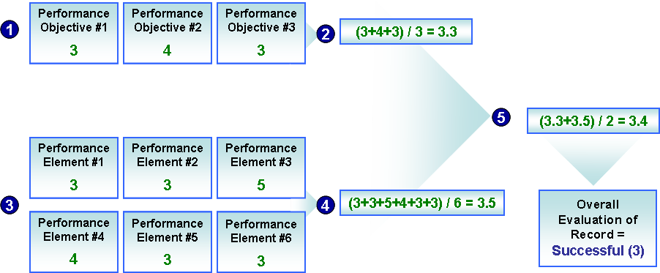
How to Rate Performance Objectives and Performance Elements

Employees are rated on each of their performance objectives and each of the six performance elements. The table below describes the performance level that should be demonstrated for the objectives and elements.

Performance Rating | Performance Objective Descriptions | Performance Element  Descriptions | Overall Summary Rating
Outstanding (5) | The employee far exceeded expected results on the objective such that organizational goals were achieved that otherwise would not have been. At the summary level, the employee far exceeded expected results on all performance objectives such that organizational goals were achieved that otherwise would not have been. Such exemplary achievements serve as a role model for others. | The employee consistently performed all key behaviors at an exemplary level on the element. At the summary level, the employee consistently performed at an exemplary level on all performance elements. The employee served as a role model for others. | The employee’s overall  Contribution, both in terms of results achieved and the manner in which those results were achieved, has extraordinary effects or impacts on mission objectives that would have otherwise not been achieved.  Overall Summary Rating  4.6 – 5.0
Excellent (4) | The employee surpassed expected  results in a substantial manner on the objective. At the summary level, the employee surpassed expected results overall and in a substantial manner on most of the objectives. | The employee surpassed the behavioral standards described in all performance elements. At the summary level, the employee demonstrated mastery-level performance on most key elements. | The employee's overall contribution, both in terms of results achieved and the manner in which those results were achieved, has significant impact on mission objectives.  Overall Summary Rating  3.6 – 4.5
Successful (3) | The employee achieved expected results on the assigned objective. At the summary level, the employee achieved expected or higher results overall and on most assigned objectives. | The employee fully demonstrated effective, capable performance of key behaviors for the performance element. At the summary level, the employee demonstrated effective, capable performance or higher on key behaviors on most performance elements. | The employee’s overall contribution, both in terms of results achieved and the manner in which those results were achieved, has made a positive impact on mission objectives.  Overall Summary Rating  2.6 – 3.59
Minimally Successful (2) | The employee only partially achieved expected results on the performance objective. At the summary level, the employee only partially achieved expected results for assigned objectives. | The employee’s performance requires improvement on one or more of the key behaviors for the element. At the summary level, the employee’s behavior requires improvement. | The employee's overall contribution to mission was less than expected.  Overall Summary Rating  2.0 – 2.5
Unacceptable (1) | The employee failed to achieve expected results in one or more assigned performance objectives. | The employee failed to adequately demonstrate key behaviors for the performance element. At the summary level, the employee received a rating of “unacceptable” on average for the performance objectives. | The employee received an unacceptable rating on one or more performance objectives.  Less than 2.0 on any objective
Not Rated (NR) | The employee did not have the opportunity to complete the objective because is became obsolete due to changing mission requirements or because of extenuating circumstances beyond the control of the employee and supervisor (e.g., resources diverted to higher priority programs, employee in long-term training, deployed, on leave without pay, etc.). | Not used for performance elements. | Not used for overall summary rating.

Source: USD(I)
Preparing for the Evaluation
To be effective in conducting meaningful performance reviews, rating officials must recognize any bias tendencies and take steps to compensate for them. These types of errors can occur both consciously and sub-consciously—that is, a rater may not even realize that he/she is providing erroneous ratings. One of the best ways to avoid making these types of rating errors is simply to know they exist.
How to Rate Performance Objectives and Performance Elements
Performance Elements

Common Rating Errors | How To Avoid The Error
Halo—ratings based on a global impression (either positive or negative) of the individual rather than on an individual’s performance relative to each performance objective/element. | Evaluate performance on each objective/element independently from other objectives/elements.
Primacy—ratings based only on positive or negative performance early in the performance cycle rather than on performance exhibited throughout the cycle.  Regency—ratings based only on positive or negative performance toward the end of the performance cycle rather than on performance exhibited throughout the cycle. | Try keeping notes on individual’s performance throughout the cycle so that you can recall a particular individual’s full performance more easily at the end of the cycle.
Overemphasis on positive or negative performance—relying too heavily on either the positive or negative aspects of an individual’s performance when assigning ratings rather than considering both aspects equally. | Because all of an individual’s actions on the job are important, be sure to consider both positive and negative performance from the entire performance cycle.
Similar/different from me—assigning higher or lower ratings for an individual based on certain qualities or characteristics of him/her that are similar or to or different from the rater. | Make a conscious effort to ignore any similarities or differences you may have with particular individuals.
Stereotyping—basing ratings of an individual on his/her group membership (e.g., ethnicity, gender, religion) rather than on his/her performance. | Be aware of the stereotypes that you hold about different groups, and make a conscious effort to ignore these stereotypes when assigning performance ratings.
Contrast—basing ratings of an individual on a comparison of that individual to others previously rated rather than on the performance objectives/elements. | Interpret and apply performance objectives/elements specifically and consistently to ensure that differences in ratings reflect difference in performance.
Central tendency—giving average ratings to all individuals, despite differences in their performance.  How to Rate Performance Objectives and Performance Elements  Performance Elements  Severity—giving low ratings to all individuals, despite differences in their performance.  Leniency—giving high ratings to all individuals, despite differences in their performance. | Since the purpose of conducting performance appraisals is to accurately reflect and differentiate an individual’s performance through ratings, you should strive to provide fair and accurate ratings.

When evaluating employees, rating officials should consider the following:
Effective Evaluation

DO’S
Do revisit any feedback you have provided to determine if the employee has acted on it.

Do give employees honest encouragement and criticism.

Do rate employees based on observed facts, not abstract conclusions or assumptions based on personality.

Do review notes and documentation recorded throughout the year.

Effective Evaluation
DON’TS
Don’t permit friendship with any employee to influence the ratings.

Don’t make quick guesses regarding an employee’s performance.

Don’t jump to conclusions or base judgments of an individual on one instance of behavior.

Don’t let first impressions influence later judgments of an employee.

Don’t let personal references, prejudices, and biases influence the appraisal.

Use the chart below to help assess and resolve performance issues. If the rating official thinks initiating a performance improvement plan is appropriate for an employee, they should contact Human Resources for guidance.
How to Rate Performance Objectives and Performance Elements
Performance Problem Analysis Tool
Source | Physical | Emotional | Intellectual
Personnel | Does the employee have the ability to perform the requirements? | Does the employee care about the work being performed? | Does the employee have the adequate skills and knowledge to perform the task?
Environment | Is the employee missing any resources? | Does the employee view the incentives system as fair? | Have you communicated all procedures to the employee?
Information | Are task requirements clearly defined? | Does the employee understand the relationship between her/his performance and the mission of the organization? | Is the information flowing to the employee in a timely and/or effective manner?

Review of Roles and Responsibilities
Phase 3: Evaluate Performance
Employee | Rating  Official | Reviewing  Official | PM PRA
- Complete final self-report of accomplishments  - Provide input on accomplishment | - Prepare employee Rating of Record (performance appraisal)  - Discuss final performance feedback | - Review and approve employee Rating of Record (performance appraisal)  - Ensure consistency between and among rating officials | - Review employee Ratings of Record for consistency  - Return out of scope ratings to Reviewing Official for second review  - Resolve employee requests for reconsideration
Effective Feedback
Performance feedback should be an ongoing process throughout the performance year. Feedback can be given informally —“You did a great job on that presentation just now. I was really impressed by your technical knowledge and presentation style.” Feedback is also formally given twice a year within DCIPS during the midpoint and final appraisal processes.

PREPARING FOR A FEEDBACK SESSION
Because providing and receiving feedback can be stressful for some people, it is important that both employees and supervisors are prepared. Feedback sessions are an opportunity for employees and supervisors to exchange information about employee performance -- both positive and developmental. Consider the following when preparing for a feedback session:
- Key strengths, achievements, and developmental areas.
- Strategies for improving in development areas.
- Any issues or concerns with job/work in general.
- Job/career options to pursue given employee’s skills, interests, and career goals.
- How supervisor can help with employee performance and career progress.

CONDUCTING A FEEDBACK REVIEW SESSION

As a supervisor, it is important to set aside a designated time for holding employee feedback sessions without other interruptions, such as answering phone calls or allowing drop-by visits. Let employees know that providing feedback is part of the job as a supervisor and also an opportunity for employees to communicate their achievements and concerns.

Consider the following when holding a feedback session:
Effective Feedback
- Two-way dialogue between supervisor and employee:
  - Session is NOT a negotiation about ratings.
    - Recognize positive performance:
      - Provide specific behavioral examples.
- Discuss any performance issues:
  - NOT a first notice of poor performance or time for discipline.
  - Provide specific, behavioral examples.
  - Discuss developmental areas, strategies for improvement, and long-term goals as appropriate.
- If possible, review IDP and/or next year’s performance objectives.

Effective feedback allows the receiver to walk away understanding EXACTLY what he or she did and the impact it had on you and/or the situation. The more specific, direct and timely in providing feedback, the more likely it is that the person receiving the feedback is motivated to change. When entering performance conversations with employees, rating officials should:
- Put the employee at ease, tailoring the approach to the individual.
- Give their perspective on each performance objective and performance element.
- Ask the employee for her/his performance on the performance objectives and performance elements.
- Ask the employee how to help them do a better job.
- Encourage the employee to discuss concerns and questions.
- Be open to addressing the employee’s concerns and be sure to address all of them.
- Be open to the employee’s input and ideas.
- Keep notes on agreed upon support, and set up a method for periodically reviewing employee’s progress.
Here are some tips for providing effective feedback:
- Keep feedback constructive. Be specific and objective. Use facts to support the feedback, rather than generalizations about the employee’s character or attitude. When possible, offer support and training to correct these problem areas.
Effective Feedback
- Focus on professional development. Performance reviews are an excellent time to discuss opportunities for an employee’s growth in his/her current position.
- Look ahead and develop mutually agreeable goals for the next performance period. Make these goals measurable and designate timelines for each.
- Communicate and assess progress toward goals regularly. Periodic tracking of progress toward goals helps keep behavior on target and enhances the employee’s commitment to effective performance.

Below are some additional tips for providing effective feedback:
Effective Feedback

Effective Feedback

DO’S
Do be specific when describing the situation.
Do be specific when describing the behavior.
Do acknowledge the impact on you.
Do judge the behavior.
Do pay attention to body language.
Do use verbatim quotes.
Do recreate the behavior, if appropriate.
Do give feedback in a timely manner.
Do give your feedback, check for understanding, and then STOP.
Do say “I felt” or “I was” to frame your impact statement.
Do focus on a single message.
Do be sensitive to the emotional impact of your feedback.

Effective Feedback

DON’TS
Don’t assume.
Don’t be vague.
Don’t use accusations.
Don’t judge the person.
Don’t pass along vague feedback from others.
Don’t give advice unless asked.
Don’t psychoanalyze.
Don’t qualify your feedback by backing out.
Don’t generalize with words like “always” or “never.”
Don’t label your feedback in advance.
Don’t sandwich your feedback message with words like “but.”

RECEIVING FEEDBACK
Effective Feedback
The act of receiving feedback requires careful listening, consideration and evaluation to do something positive with it. Receiving critical performance feedback can sometimes be difficult to hear. However, listening to valid critical feedback is important to help us learn from our mistakes and make adjustments in our performance and behavior. As an employee, here are some tips for receiving critical feedback:
- Thank your supervisor for bringing the problem to your attention.
- Paraphrase the performance issue described by your supervisor.
- Request specific feedback that helps you clearly understand.
- Accept the feedback as valid but do not fall into exaggerated put-downs and negative self-talk.
- Avoid too much apologizing or overcompensating for any error(s).
- Ask your supervisor to provide potential solutions to help resolve the problem, instead of dwelling on mistakes.
Other Resources and Contact Information
Additional resources include:
- Army Interim Policy, Volume 2011
- DCIPS Performance Management Supervisor’s Checklist
- DCIPS FAQ Master List
- DCIPS Employee Performance Journal
- DCIPS Performance Management Job Aids

Please visit the DCIPS website for additional information.
NIPRnet
http://www.dami.army.pentagon.mil/site/dcips/
SIPRnet
http://www.dami.army.smil.mil/site/dcips
JWICS
http://www.dami.ic.gov/site/dcips

If you have additional questions, please contact
Ms. Yolanda Watson
Chief, Intelligence Personnel Management Office (IPMO)
703-695-2443/DSN: 225-2443

Mr. Mark Johnson
Deputy Chief, Intelligence Personnel Management Office (IPMO)
703-695-3689/DSN: 225-3689

Appendices

Appendix A: Suggestions for Wording SMART Performance Objectives
Appropriate verb usage can help make performance objectives clearer. By using specific words, you ensure less misinterpretation by your rating officials. Listed below are descriptive verbs commonly associated with specific field areas and skills. These lists are not exclusive or exhaustive, so feel free to add your own verbs. These verbs are also useful when describing accomplishments at the end of the year.
Field Area/Skills | Examples of Associated Action Verbs
Management/Leadership Skills | Achieve, administer, arrange, articulate, assign, attain, author, chair, compete, conceive, conduct, contract, convene, coordinate, create, delegate, design, develop, direct, earn, effect, employ, execute, facilitate, initiate, institute, instruct, intervene, invent, investigate, manage, master, model, organize, oversee, plan, present, preside, protect, recommend, regulate, represent, resolve, shape, solve, specify, supervise
Research & Writing Skills | Analyze, annotate, appraise, assess, author, brief, calculate, catalogue, categorize, chart, code, collect, compare, compile, compose, compute, conduct, consolidate, contact, correspond, create, critique, define, derive, design, determine, develop, devise, diagnose, direct, discover, dispense, display, distribute, draft, edit, elicit, estimate, evaluate, examine, exhibit, expand, experiment, explore, forecast, formulate, identify, illustrate, inquire, inspect, interpret, interview, inventory, investigate, measure, model, observe, outline, predict, present, process, produce, publish, question, record, regulate, report, reproduce, research, review, revise, search, solicit, solve, study, summarize, survey, synthesize, test
Teamwork & Interpersonal Skills  Suggestions for Wording SMART Performance Objectives | Articulate, arrange, brief, clarify, collaborate, communicate, contact, convene, coordinate, delegate, elicit, employ, encourage, enlist, exchange, explain, facilitate, foster, influence, initiate, inquire, instruct, interpret, interview, introduce, mediate, motivate, negotiate, participate, represent, resolve, respond, shape, share, solicit
Financial Skills | Acquire, activate, administer, analyze, apply, assess, brief, calculate, catalogue, categorize, code, compile, compute, conduct, define, deliver, derive, design, develop, devise, draft, formulate, implement, inspect, install, master, monitor, operate, process, program, protect, provide, publish, record, regulate, repair, report, reproduce, respond, search, share, simulate, solve, test, train, translate, tutor, update, write

Appendix B: Additional Examples and Tips on How to Write SMART Objectives
In the handbook, there are specific instructions on how to write SMART objectives. Here are additional examples and tips to help you write SMART objectives:
Specific
- Ask yourself these questions to decide if the content of your objective is specific:
  - Is the result observable?
  - Can my supervisor verify the result?
  - What would the result look like?
- Instead of writing “To type all correspondence effectively”, write “ To format correspondence correctly to comply with the department style guide for formatting, grammar, and usage as determined by managerial review.”
- Avoid using words that can be misinterpreted, such as:
  - Effective
  - Efficient
  - Appropriate
  - Oversee
Measurable
- Here are two different ways that measurements can be added to an objective. The choice depends on what is important to accomplishing the objective.
  - Example of an objective with a quality measure: “Format at least 90% of correspondence correctly to comply with the department style guide for formatting, grammar, and usage on the first review as determined by managerial review.”
  - Example of an objective with a time measure: “ 90% of correspondence formatted correctly and in compliance with the department style guide for formatting, grammar, and usage within one day of assignment.”
- Good phrases to use include the following:
  - At least 50%
  - No less than 25 per week
  - Not to exceed
Achievable
- Ask yourself these questions to verify that the performance objective is achievable:
  - Can you achieve the objective with the available resources and personnel and within the given time?
  - Is the work in the performance objective within your control to complete? You should not include work or goals over which you have no control.
  - Is the performance objective appropriate for your experience, skill, and work level?
  - Is this performance objective appropriate for this position?
Relevant
- Here is an example of how to make your objective relevant: “Format 90% of logistics depot supply order correspondence and comply with the department style guide for formatting, grammar and usage within one day of assignment. This supports our organization’s goal of increasing volume of requisitions filed on time by 15% by the end of the year.”
Time-bound
- You may express the date component in two ways: relatively or specifically. While you may use either, the best practice is to use specific dates because there is a greater tendency to push out repeatedly relative deadlines.
  - Relative uses time spans, such as “in six months.” The date is relative to today.
  - Specific uses hard dates, such as “on March 15th.”
- Other time designations such as “end of the quarter,” “end of the evaluation period,” or “throughout the evaluation period” are also options.
- Here is an example of an objective with specific dates: “From 1 October to 30 September, format at least 90% of correspondence correctly to comply with the department style guide for formatting, grammar, and usage on the first review as determined by managerial review.”
- Here is an example of an objective that indicates that the action occurs throughout the year: “Format 90% of correspondence to comply with the department style guide for formatting, grammar, and usage within one day of assignment throughout the performance period.”
- If a project has many steps and deliverables, it may be appropriate to set interim dates for when various steps will be completed. These dates serve as milestones to help the employee track their progress on the project. For example, a sample performance objective related to accomplishment of performance management requirements might read, in part, as follows: “Accomplishment of performance management requirements are measured by entries in the automated tool in according with the following milestones:
  - By 30 October, 95% of employee performance plans are entered;
  - By 30 June, 97% of employee midpoint performance review are noted; and
  - By 30 September, 98% of employee ratings are entered.”
- Make sure all timeframes are within the current rating period.

Appendix C: Intelligence Community Performance Standards

