
Employee
Performance Journal
DCIPS is a Title 10 Excepted Service civilian human capital management system
for the DoD Intelligence Community. The new features of DCIPS emphasizes
recognizing employees, developing individuals and rewarding performance.



February 2009

This performance journal is personal property and a tool for you to keep a record of your accomplishments and achievements during this performance cycle. The information you write in the journal has no bearing on your performance and/or your performance rating.

Employee Information
Employee Name:
Job Title:
Manager(s):
Date: | to | Review Period: | to

This document includes:

- Highlights of the DCIPS performance management process (for more detailed information, please refer to the Army Intelligence DCIPS Performance Management Handbook).
- A performance journal where you can keep track of your accomplishments throughout the performance cycle.

Internet resources include:

DCIPS Website:

NIPRnet
http://www.dami.army.pentagon.mil/site/dcips/

SIPRnet
http://www.dami.army.smil.mil/site/dcips

JWICS
http://www.dami.ic.gov/site/dcips

USD(I) iSuccess and DCIPS 101:
http://dcips.dtic.mil/index.html

There are also links to the training courses listed above on the DCIPS website.
The Three Phases of the DCIPS Performance Management Cycle

1 October – 30 September (First DCIPS cycle begins in July 2009)
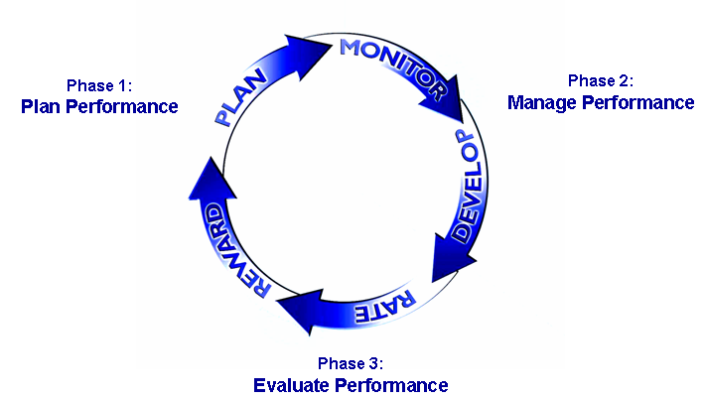
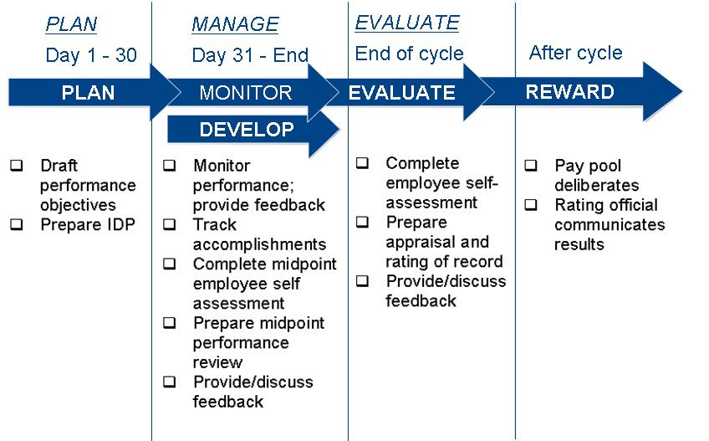
Roles and Responsibilities of the Key Participants in the Performance Management Cycle

Employee | Rating  Official | Reviewing  Official | Performance Review Authority
Phase 1: Plan Performance
- Collaborate with the rating official (usually your supervisor) to develop 3 – 6 SMART performance objectives and Individual Development Plan  - Provide perspective and input on assignments  - Be fully committed to accomplishing performance objectives | - Define employee roles and responsibilities  - Collaborate with the employee to develop 3 – 6 SMART performance objectives and Individual Development Plan  - Communicate organizational mission | - Approve employee performance objectives and Individual Development Plan | - Not Applicable
Phase 2: Manage Performance
- Maintain personal records of achievement  - Complete midpoint self assessment  - Engage Rating Official in ongoing performance feedback discussions | - Document achievements  - Engage employee in ongoing performance feedback discussions  - Provide employee with a midpoint review | - Ensure Rating Officials provide employees feedback and have completed a midpoint review | - Not Applicable
Phase 3: Evaluate Performance
- Complete final Self-Report of Accomplishments  - Provide input on accomplishments | - Complete employee Rating of Record (performance appraisal)  - Discuss final performance feedback | - Review and approve employee Rating of Record (performance appraisal)  - Ensure consistency between and among rating officials | - Review employee Ratings of Record for consistency  - Return out of scope ratings to Reviewing Official for second review  - Resolve employee requests for reconsideration

Phase 1: Plan Performance

In the planning phase, you collaborate with your supervisor to develop three to six SMART performance objectives and an Individual Development Plan (IDP) outlining your developmental goals for the performance appraisal period. You and your supervisor should also discuss the six performance elements and how they relate to your overall performance.

Performance Objectives
Performance objectives are a set of three to six SMART performance goals that relate your job assignments and position responsibilities. They are also linked to Intelligence Community and Army Intelligence community goals.
Performance Objectives should always be SMART.

- Specific describes an observable action, behavior, or achievement.
- Measurable (or observable or verifiable) describes a method or procedure to assess and record the quality and/or quantity of the outcomes.
- Achievable examines capacity and conditions required to accomplish an objective.
- Relevant examines significance, value and applicability.
- Time-bound describes the performance objective start and end points.

Performance Elements
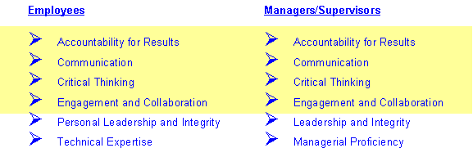
Performance elements are a set of standards or behaviors that describe how your work is accomplished. They are:

Performance  Element | For All  Employees
Accountability for Results | Take responsibility for work. Organize and utilize time and resources efficiently and effectively.
Communication | Effectively comprehend and convey information.
Critical Thinking | Use logic, analysis, synthesis, creativity, judgment, and systematic approaches to complete their work.
Engagement and Collaboration | Recognize, value, build and leverage collaborative and constructive networks.

Performance  Element | Non-Supervisory Employees | Supervisory  Employees
Personal Leadership and Integrity or  Leadership and Integrity | Demonstrate personal initiative, honesty, openness, and respect. | Create a shared vision and mission, establish a diverse, equal opportunity environment, and mobilize, recognize, and reward employees.
Technical Expertise or  Managerial Proficiency | Acquire and apply knowledge, subject matter expertise, tradecraft, and/or technical competence. | Possess the technical proficiency in their mission area appropriate to their role.
Phase 2: Manage Performance

The managing phase consists of monitoring and developing your performance. During this phase, you should engage in frequent performance discussions with your supervisor. You also need to complete a self-assessment of your performance at the midpoint of the appraisal period. Your supervisor also provides you with a formal midpoint review.

Here are some guidelines you can follow when you are preparing for your Midpoint review with your supervisor:

EMPLOYEE GUIDELINES:  Midpoint Review | ✓
Discuss my mid-year accomplishments and how they correlate to my goals in my IDP.
Discuss any job-related barriers/obstacles that prevent me from living up to my potential.
Discuss possible add-on responsibilities I can take on to help my career development.
Discuss upcoming training opportunities that interest me and align to my IDP goals.
Discuss/document any significant changes to SMART objectives.

Phase 3: Evaluate Performance

During the evaluating phase, you complete a Self-Report of Accomplishments.

Using a five-point scale, your supervisor rates your achievement towards each performance objective and each of the six performance elements. The average score of your performance objectives and performance elements form your Overall Performance Rating.

Documenting Your Accomplishments
The Midpoint and Final Reviews offer you the opportunity to highlight your accomplishments and point out how they contributed to the achievement of the Army, command, or unit intelligence and security community goals. When you explain the significance of your contributions, the STAR approach can help:

STAR
Situation. What was the situation I faced?

Task. What was the overall task in that situation?

Action. What specific action did I take?

Result. What result did my action produce?

Self-Report of Accomplishments Checklist
At the end of the year, you are required to formally document your accomplishments and how you went about achieving them. After writing your narrative, the following checklist is useful to review when ensuring you have effectively represented your accomplishments.

Does your Self-Report of Accomplishments:
- Match your performance objectives?
- Include clear references to each performance element?
- Make the connection between what you did and why it helps the Army, command, or unit intelligence and security goals?
- Note challenges you faced and how you fared?
- Include any additional accomplishments?

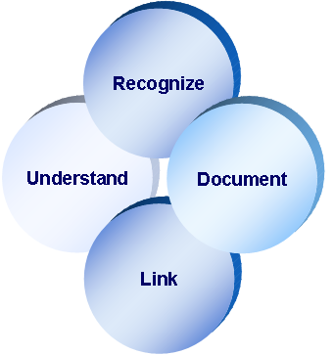
Effective self-reporting enables an accurate and full representation of accomplishments and behaviors. Keep these points in mind:
… my accomplishments.
Self-Report of Accomplishments – More Tips
The Self-Report of Accomplishments is an important tool in telling your story. It helps your supervisor understand what you did and how your actions/performance contributed to the overall success of the organization's mission.

This is your opportunity to prepare a strong, well thought out report that helps your supervisor fully recognize your accomplishments.

A few additional things to keep in mind:
- Your report will be more effective if it is specific, concise, and outcome focused
- Give yourself adequate time to prepare your report; this is not a ten minute exercise
- Restate your understanding of your performance objectives

- Identify your most significant accomplishments for each performance objective; stick with what you believe mattered most
- Tie your accomplishment to the Army, command, or unit intelligence and security mission
- Address how you incorporated each of the Performance Elements
- Draft your report in a word processing program so you can use the character count, check for spelling and grammatical errors, and incorporate any feedback you may have sought from your supervisor (copy and paste final version into the Performance Appraisal Application (PAA) online tool)
- Review USD(I)’s iSuccess for DCIPS interactive training module at http://dcips.dtic.mil/index.html for a step-by-step approach to writing performance objectives and the Self Report of Accomplishments
Calculating Your Evaluation of Record
As depicted below, performance appraisals include:

- Performance Objectives — Three to six SMART objectives unique to you that describes what is expected of you.
- Performance Elements — Standard behavioral descriptors that describe how you are to successfully perform your job.
The overall rating on your performance appraisal is calculated as an average of the performance objective rating and the performance element rating.

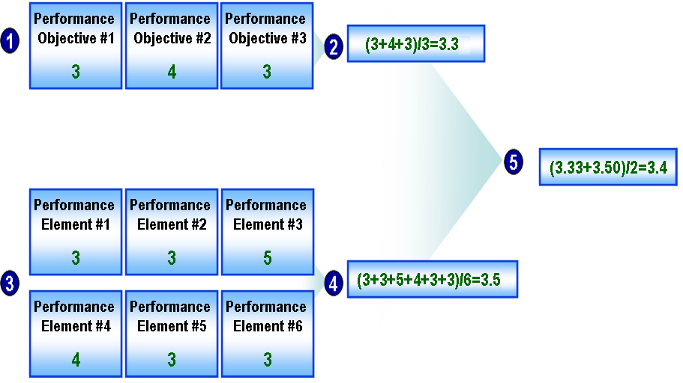

Use the following pages to write down your accomplishments towards each of your performance objectives. Also keep in mind – and cite specific examples – how your performance elements were demonstrated in achieving those objectives.

This journal is just for you.

You should use this journal in a way that benefits you when you sit down to write your Self-Report of Accomplishments at the end of the performance cycle.

There is no right or wrong way to use this journal.

Performance Objective #1:

Performance Objective #2:

