DCIPS Performance Management
Supervisor’s Checklist

You should utilize this checklist to ensure you complete all of the phases of the DCIPS performance management process. As a reminder, there are three phases in the process and they are shown in the graphic below.

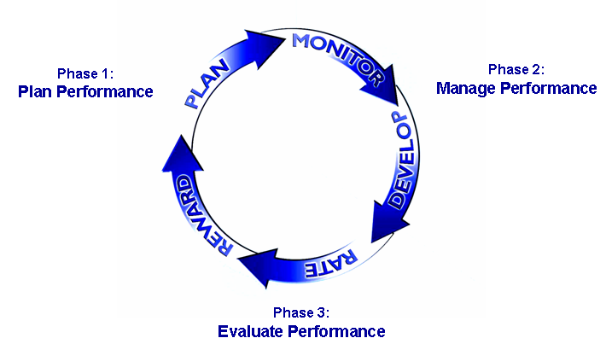

Phase 1: Plan Performance
During this phase, you should collaborate with your employees to develop three to six performance objectives and an Individual Development Plan (IDP) that outlines the developmental goals of your employees for the performance appraisal period. You should also discuss with your employees the performance elements and how they relate to the employee’s performance objectives.
Phase 2: Manage Performance
During this phase, you should engage in frequent performance discussions with your employees. Employees also complete a self assessment of their performance at the midpoint of the appraised period, and they receive a formal midpoint review from you.
Phase 3: Evaluate Performance
During the evaluating phase, employees complete a self assessment. Then you provide your employees feedback on their performance and provide them an Overall Performance Rating at the end of the appraisal period. Employees receive salary increases and bonuses based on their performance rating from you.

Refer to the DCIPS Performance Management Handbook for more detailed information on the entire process.

Actions for Phase 1: Plan Performance
Complete all performance appraisals for the previous performance cycle

Complete Performance Management training for Supervisors

Work with your employee to complete 3-6 SMART performance objectives
- Meet with your employees to discuss the new performance cycle, and what their focus will be
- Ensure that objectives align with the goals of the Army Intelligence community, your Command and your work unit
- Ensure objectives adhere to the SMART framework
- Ensure that objectives are appropriate for the employee’s position work category and work level
- Ensure employee knows that you will communicate their final objectives to them once the objectives have been approved by the Reviewing Official

Work with your employees to develop an Individual Development Plan (IDP)
- Establish and discuss your employees’ career goals
- Identify gaps in knowledge, skill, and/or ability
- Identify and select training to address gaps
- Identify assignments for on the job training

Submit your employee’s performance objectives and IDP to the Reviewing Official for approval
- Communicate the performance objectives and IDP to your employee once they are approved.

Actions for Phase 2: Manage Performance
Document your employee’s achievements
- Document instances of exceptional and unsatisfactory performance

Engage employee in ongoing performance feedback discussions
- Revise performance objectives in consultation with your employee
- If necessary, inform employee of specific areas of improvement and give suggestions on how to improve performance

Provide your employee with a midpoint review
- Review performance objectives and IDP with your employee
- Discuss progress your employee has made toward achieving their objectives

Actions for Phase 3: Evaluate Performance
Prepare your employee’s Rating of Record (performance appraisal)
- Utilize the documentation you kept throughout the performance period to accurately rate your employee’s performance
- Utilize the employee self-assessment provided by your employee

Submit your employee’s Rating of Record to the Reviewing Official and the Performance Review Authority (PRA) for approval

Discuss rating of record as approved by the reviewing official
- Identify key strengths, achievements, and developmental areas of your employee
- Discuss strategies for improving developmental areas
- Discuss your employee’s career goals as appropriate
- Discuss how you can help with your employee’s performance and career progress
- Work with employee to complete activities required in the Planning Phase for the next performance period

