Determination of GG Equivalent (GGE) Fact Sheet

This fact sheet covers how an employee’s GG Equivalent (GGE) will be determined during the DCIPS Interim period from October 28, 2009 through December 31, 2010.

During the DCIPS Interim period, all DCIPS employees will be aligned to a GS/GG grade, known as a General Grade Equivalent (GGE). GGEs will be the Army Intelligence community’s “virtual crosswalk” to the GG pay plan during the DCIPS Interim period. Because employees remain in pay bands (and not grades), these markers will enable employees to better understand how future pay adjustments are being made in accordance with the General Schedule/General Grade (GS/GG) pay setting rules.

How GGE’s are Determined
If an employee… | Then…
- Was on board at the time of conversion to DCIPS (19 July 2009), and  - Has not had a promotion since conversion. | Your local CPAC will assign a GGE that is equivalent to what your GS/GG grade was at the time of conversion to DCIPS.
Example: You’ve been an Army Intelligence employee since 2005. Prior to conversion, you were a GG 12 Step 4 and transitioned to Pay Band 3. Since then, you have not had a promotion. Your GGE will be GG 12.
If an employee… | Then…
- Was on board at the time of conversion to DCIPS (19 July 2009), and  - Has had a promotion since conversion. | Your local CPAC will use the representative rate method (*this is explained on the following page) to establish your GGE.
Example: Before the conversion to DCIPS, you were a GG 14 Step 3, transitioned to a Pay Band 4. On 21 September 2009, you received a promotion to Pay Band 5. A GGE will be assigned using the representative rate method.
If an employee… | Then…
- Was hired after conversion to DCIPS (19 July 2009) but before October 28, 2009  - Regardless of whether he/she has had a promotion. | Your local CPAC will use the representative rate method to establish your GGE.
Example: You became an Army Intelligence employee on 24 August 2009, after the Army Intelligence community had already converted to DCIPS. A GGE will be assigned using the representative rate method.
If an employee… | Then…
- Was hired after 28 October 2009, the enactment of the 2010 National Defense Authorization Act (NDAA). | Your GGE will be determined based upon your qualifications for the position.
Example: You became an Army Intelligence employee on 16 November 2009. A GGE was/will be provided to you by your local CPAC.

The Representative Rate Method
The representative rate method is used by Title 5 organizations to determine how to set base pay for employees who move between agencies that operate under different pay setting systems.

You ONLY need to refer to the GGE Determination Chart and the bullets on this page if the table above indicated that the CPACs would be using the representative rate method to establish your GGE.

GGE Determination Chart
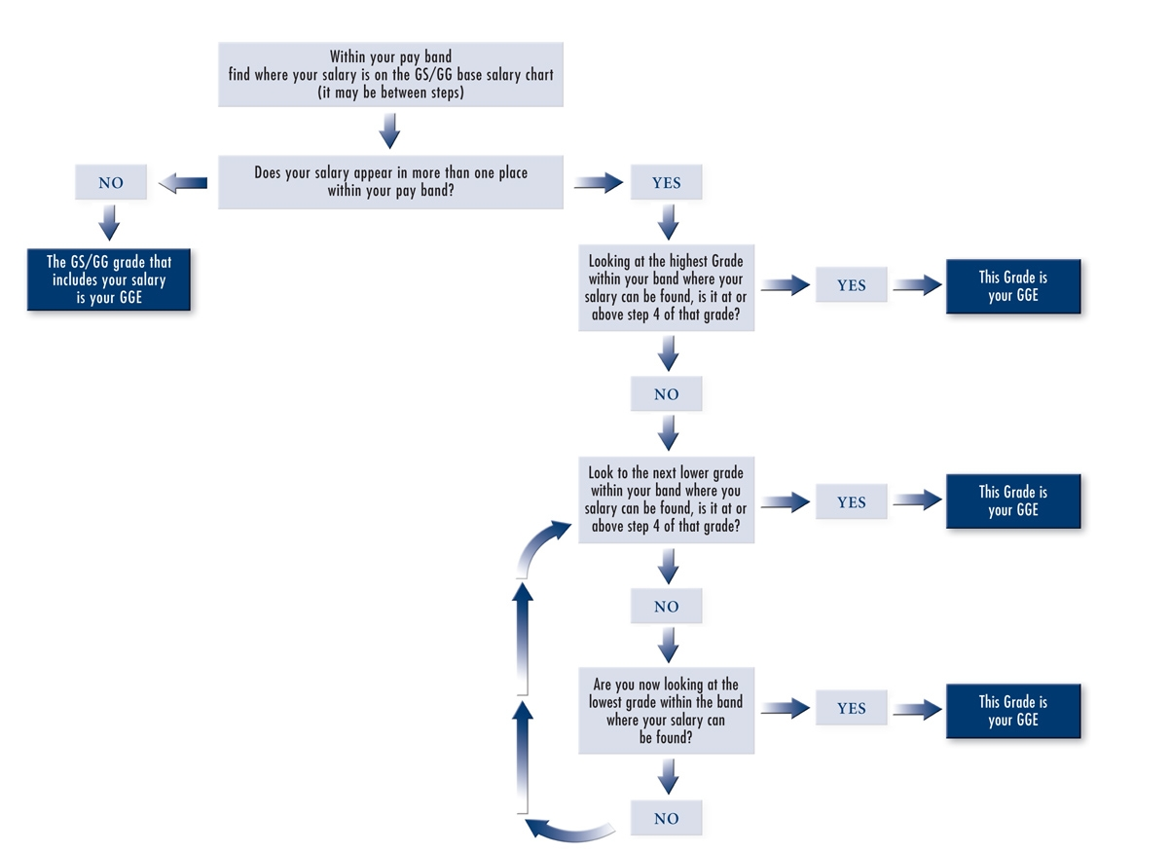

- If your pay band encompasses only one GS/GG grade, that grade will be your GGE.
- If your salary is found only at one GS/GG grade in your pay band, that grade will be your GGE.
- If your pay band encompasses more than one GS/GG grade, your GGE is the highest GS/GG grade at which your base salary is at or above step 4 of that grade.
- If your base salary is less than step 4 of the lowest GS/GG grade in your pay band, the lowest grade in the band is your GGE.
- If you held a GS/GG grade immediately prior to your DCIPS appointment, your GGE will be no lower than the GS/GG grade previously held in your pay band.

For additional information, please visit the Army DCIPS website: http://www.dami.army.pentagon.mil/site/dcips/

